What's the Frequency, Roy G. Biv?
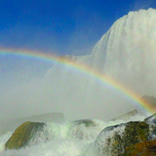

Data Table

Summary

Use the following data table to keep track of your frequency trials.

 | Trail 1 |  | Trail 2 |  | Trail 3
 | Tally | Total | Tally | Total | Tally | Total
Red
Green
Violet
Average
Time
Frequency

