What's the Frequency, Roy G. Biv?

Wrap-up Worksheet
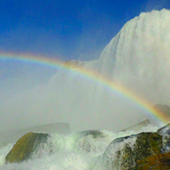
Today you examined the relationship between wavelength and frequency of light. Fill out this worksheet with the results of your experiments. Each student is responsible for completing this worksheet.

- Compare the wavelengths and frequencies of the three waves. Write about any patterns you notice in their relationship.

- Which color has the shortest wavelength?

Which color has the longest wavelength?

- Which color has the highest frequency?

Which color has the lowest frequency?

- What is the relationship of the red wavelength to the green?

Red to the violet?

- What is the relationship of the red frequency to the green?

Red to the violet?

- From your answers to the questions above, name the relationship between wavelength and frequency in waves that travel at the same velocity like the waves measured in this lab.

- Remember that velocity = distance / time. What was the velocity of the waves in this lab?

Note: the actual velocity of light c = 2.99 x 10⁸ meters per second, but for our purposes in this lab, it will appear only as fast as the Time Keeper is pulling the adding machine tape.

- Multiply the wavelength of the red wave by its frequency. Do this for the blue and green waves also and write the answers below.

red ________________

green ______________

violet ______________

- What do you notice about the results?

- Write a new equation for the velocity of waves in terms of wavelength and frequency instead of distance and time.

