Supernova Chemistry
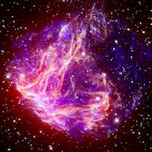

Wrap-up

Summary
You have just observed the spectra of several different light sources. Answer the following questions about your observations. Each student is responsible for answering these questions.

Questions to Answer
- Helium was discovered in the Sun's corona during the eclipse of 1868. In 1888, traces of helium were isolated here on Earth. How could scientists determine that this was the same gas that had been identified on the Sun?

- Compare the results of the various gas tube spectra with the spectrum observed using the standard fluorescent light tube. Based on your results, what gas do you think is used in fluorescent light tubes?

- Was there any difference between the spectra of the standard fluorescent light tube and the compact fluorescent light fixture? Why do you think this is so?

- Compare the results of the incandescent light bulb with the spectra of the fluorescent light tube and the compact fluorescent light fixture. Based on the observed spectra, can you think of a reason why the fluorescent lights are considered as more energy efficient? Could there be a disadvantage to this?

- Now that you know more about what gases are contained in fluorescent lights, why do you think there is a concern about the breakage and improper disposal of these tubes?

- What colors dominated the spectrum of the "Plant Grow" light? How was this different from the regular light bulb? Can you think of a reason why this light might be better for plants (hint: plants are usually green...)?

