Part III: What tools are used to identify elements? What importance do X-rays have to astronomy?

From: X-ray Spectroscopy and
the Chemistry of Supernova Remnants
A Series of Lesson Plans by
Allie Hajian and Maggie Masetti (NASA/GSFC, Greenbelt, MD)
Rick Fowler (Crossland High School, Temple Hills, Maryland)
Angela Page (Hyattsville Elementary School, Hyattsville, Maryland)

Objectives
Students will read and write about the chemistry and spectroscopy of stars and supernova remnants, as well as understand their relevance and impact on human life. Students will also learn about cutting edge technology that will help us to build better instruments with which to study the Universe.

Each section has several pages of background material relevant to the associated activities and the lesson plan as a whole. The background sections include short exercises or thought questions developed to help the student reach a better understanding of the material presented. Each section also has activities developed by real teachers - designed to bring important concepts in astronomy right into the classroom. Each activity is correlated to national science and math standards for grades 9 - 12. These activities show how interrelated chemistry, physics, and astronomy really are.

Outline of Unit

Part I: How and Where are Elements Created?
- Background: The Life Cycles of Stars: How Supernovae Are Formed – Describes the life of a high-mass star - as well as its death in a giant supernova explosion.
- Background: The Dispersion of Elements – Describes how supernova explosions not only disperse the elements created inside a star, they create new elements.
- Activity: Fusion Reactions – In this activity, each student is given a card with an element produced inside stars on it - the students then form fusion reactions that occur within stars.

Part II: What is Electromagnetic (EM) Radiation? How is it created in atoms? What units are used to characterize EM radiation?
- Background: How Do the Properties of Light Help Us to Study Supernovae and Their Remnants? – Students learn about the electromagnetic spectrum.
- Activity: Calculation Investigation – Students learn about unit analysis by converting energies to wavelengths to frequencies.
- Background: Atoms and Light Energy – Describes how atoms emit light, and how we can use this to learn about astronomical objects.
- Activity: Calculate the Energy! – Students will calculate the energy differences in different energy states of the Bohr atom of Hydrogen.

Part III: What tools are used to identify elements? What importance do X-rays have to astronomy?
- Background: Introduction to Spectroscopy – Everything you ever wanted to know about spectroscopy but were afraid to ask!
- Activity: Graphing Spectra – Practice drawing graphs of spectra, and understanding the different ways spectra can be represented, as well as what each representation can tell us.
- Activity: Flame Test – A chemistry experiment that shows how heated elements emit different colors of light.
- Activity: Design an Element Poster Advertisement – Students will discuss what they have learned about atoms and elements in their own words, designing a poster advertisement for their chosen element. Students will use more than just their right brain to think about science!

Part IV: How does the newest technology help us to understand the Universe?
- Background: All About The Microcalorimeter – All about microcalorimeter technology, the next generation X-ray spectrometer.
- Activity: Identifying Light Energy by Temperature Changes – Learn first hand how a microcalorimeter really works
- Activity: Identifying Elements in Supernova Remnants using Spectra – Now the students get to take all they have learned and really apply it. Students will identify the elements present in a supernova remnant by analyzing its spectrum.
- Background: A Plethora of X-ray Telescopes – Learn about existing and future X-ray telescopes and what they hope to accomplish.
- Activity: Satellite Venn Diagram – Students will organize the information about X-ray observatories into a Venn diagram.
- Activity: Writing Assignment – As a closing activity, students will demonstrate the ability to use text information and data to persuade a reading audience of the benefits of using calorimeter detectors to do X-ray astronomy.

Part III: What tools are used to identify elements? What importance do X-rays have to astronomy?

Introduction to Spectroscopy

Spectroscopy is a complex art - but it can be very useful in helping scientists understand how an object like a black hole, neutron star, or active galaxy is producing light, how fast it is moving, and even what elements it is made of. A spectrum is simply a chart or a graph that shows the intensity of light being emitted over a range of energies. Spectra can be produced for any energy of light - from low-energy radio waves to very high-energy gamma rays.

Spectra are complex because each spectrum holds a wide variety of information. For instance, there are many different mechanisms by which an object, like a star, can produce light - or using the technical term for light, electromagnetic radiation. Each of these mechanisms has a characteristic spectrum.

Let's look at a spectrum and examine each part of it.
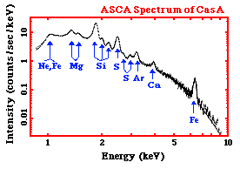

To the right is an X-ray spectrum made using data from the ASCA satellite. It is of a supernova remnant (SNR) - a SNR is a huge cloud of gaseous matter swept up from the explosion of a massive star. The x-axis shows the range of energy of light that is being emitted. The y-axis of the graph shows the intensity of the light recorded by the instrument from the SNR – that is, the number of photons of light the SNR is giving off at each energy, multiplied by the sensitivity of the instrument at that energy. We can tell that the light, or radiation, from this SNR is very high energy - if we look at the units of the x-axis - we can see that the photons of light have energies measured in keV, or kilo-electron Volts. A kilo-electron Volt is 1000 electron Volts (eV). This puts is the X-ray range of the electromagnetic spectrum.

The graph shows a decreasing curve, with lots of bumps in it. The curve itself is called a continuum – it represents X-ray photons emitted at all energies continuously. The X-rays that are producing this continuum can be caused by several mechanisms that are completely different than those producing the X-rays at the various peaks and bumps on the curve. The peaks and bumps are called line emission. Not only are these two different kinds of X-ray emission (continuum and line) produced differently, but they each tell us different things about the source that is emitting them.

The Electromagnetic Spectrum

White light (what we call visible or optical light) can be split up into its colors easily and with a familiar result – the rainbow. All we have to do is use a slit to focus a narrow beam of the light at a prism. This set-up is actually a basic spectrometer.

The resultant rainbow is really a continuous spectrum that shows us the different energies light (from red to blue) present in visible light. But the electromagnetic spectrum encompasses more than just optical light – it covers all energies of light extending from low-energy radio waves, to microwaves, to infrared, to optical light, to ultraviolet, to very high-energy X- and gamma-rays.

Line Emission
Instead of using our spectrometer on a light bulb, what if we were to use it to look a tube of gas – for example, hydrogen? We would first need to heat the hydrogen to very high temperatures, or give the atoms of hydrogen energy by running an electric current through the tube. This would cause the gas to glow – to emit radiation. If we looked at the spectrum of light given off by the hydrogen gas with our spectroscope, instead of seeing a continuum of colors, we would just see a few bright lines. Below we see the spectrum, the unique fingerprint of hydrogen.

These bright lines are called emission lines. Remember how we heated the hydrogen to give the atoms energy? By doing that, we excited the electrons in the atom - when the electrons fell back to their ground state, they gave off photons of light at hydrogen's characteristic energies. If we altered the amount or abundance of hydrogen gas we have, we could change the intensity of the lines, that is, their brightness, because more photons would be produced. But we couldn't change their color - no matter how much or how little hydrogen gas was present, the pattern of lines would be the same. Hydrogen's pattern of emission lines is unique to it. The brightness of the emission lines can give us a great deal of information about the abundance of hydrogen present. This is particularly useful in a star, where there are many elements mixed together.

Each element in the periodic table can appear in gaseous form and will each produce a series of bright emission lines unique to that element. The spectrum of hydrogen will not look like the spectrum of helium, or the spectrum of carbon, or of any other element.

Hydrogen:

Helium:

Carbon:

We know that the continuum of the electromagnetic spectrum extends from low-energy radio waves, to microwaves, to infrared, to optical light, to ultraviolet, to X and gamma rays. In the same way, hydrogen's unique spectrum extends over a range, as do the spectra of the other elements. The above spectra are in the optical range of light. Line emission can actually occur at any energy of light (i.e. visible, UV, etc.) and with any type of atom, however, not all atoms have line emission at all wavelengths. The difference in energy between levels in the atom is not great enough for the emission to be X-rays in atoms of lighter elements, for example.

Different Graphical Representations of Spectra
The sample spectra above represent energy emission as lines, the amount of photons of light represented by the brightness and width of the line. But we can also make a graphical representation of a spectrum. Instead of the emission of a characteristic energy being shown as a line, it can be shown as a peak on a graph. In this case, the height and width of the peak show its intensity. One example of this is the very first spectrum we looked at – the one of the supernova remnant. The peaks and bumps on the graph are simply a graphical representation of the emission lines of different elements.
Below, you will see the spectrum of the Sun at ultraviolet wavelengths. There are distinct lines (in the top graph) and peaks (in the bottom one) and if you look at the X-axis, you can see what energies they correspond to. For example, we know that helium emits light at a wavelength of 304 Ångstroms, so if we see a peak at that wavelength, we know that there is helium present.

Spectra and Astronomy
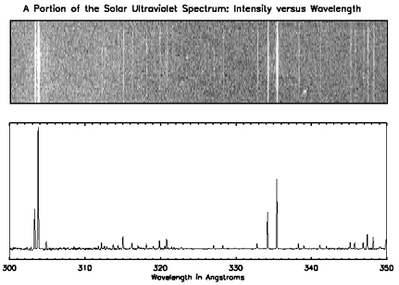

In a star, there are actually many elements present. The way we can tell which ones are there is by looking at the spectra of the star. In fact, the element helium was first discovered in the Sun, before it was ever discovered on Earth. The element is named after the Greek name for the Sun, Helios. The science of spectroscopy is quite sophisticated. From spectral lines astronomers can determine not only the element, but also the temperature and density of that element in the star. Emission lines can also tell us about the magnetic field of the star. The width of the line can tell us how fast the material is moving, giving us information about stellar wind. If the lines shift back and forth, it means that the star may be orbiting another star - the spectrum will give the information necessary to estimating the mass and size of the star system and the companion star. If the lines grow and fade in strength we can learn about the physical changes in the star.
Spectral information, particularly from energies of light other than optical, can tell us about material around stars. This material may have been pulled from a companion star by a black hole or a neutron star, where it will form an orbiting disk. Around a compact object (black hole, neutron star), the material in this accretion disk is heated to the point that it gives off X-rays, and the material eventually falls onto the black hole or neutron star. It is by looking at the spectrum of X-rays being emitted by that object and its surrounding disk that we can learn about the nature of these objects.

Continuum Emission
Just like visible light, with its range of energies from red to blue, X-rays have a continuum, or a range of energies associated with it. X-rays usually range in energy from around 0.5 keV up to around 1000 keV.

Like line emission, continuum X-ray emission involves charged particles. Continuum emission is a result of the acceleration of a population of charged particles. All X-ray sources contain such particles. These particles must be at least partially ionized - their electrons need to be unbound from their nuclei to be free to zip around when they are heated to extreme temperatures. For an electron to radiate X-rays, the gas containing the electron must have extreme conditions, such as temperatures of millions of degrees, super-strong magnetic fields, or the electrons themselves must be moving at nearly the speed of light. Extreme conditions can be found in disks of matter orbiting black holes or in supernova remnants. Strong magnetic fields, like those created in the wake of a supernova explosion, can also accelerate fast moving ions in spirals around the field lines to the point of X-ray emission. Electrons can be accelerated to nearly the speed of light in the shockwave created by a supernova explosion.

There are three mechanisms that will produce a continuum X-ray emission. They are Synchrotron Radiation, Bremsstrahlung, and Compton Scattering. The radiation produced is continuous, and not at the discreet energies of line emission because the populations of electrons have a continuous range of energies, and they can be accelerated through a range of energies.

Synchrotron radiation is emitted when a fast electron interacts with a magnetic field. A magnetic field in an area an electron is traveling in will cause the electron to change direction by exerting a force on it perpendicular to the direction the electron is moving. As a result, the electron will be accelerated, causing it to radiate electromagnetic energy. This is called magnetic bremsstrahlung or synchrotron radiation (after radiation observed from particle accelerators by that name). If the electrons and the magnetic field are energetic enough, the emitted radiation can be in the form of X-rays.
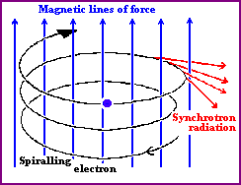
Image courtesy of University of Hertfordshire

Bremsstrahlung occurs when an electron passes close to a positive ion, and the strong electric forces cause its trajectory to change. The acceleration of the electron in this way causes it to radiate electromagnetic energy – this radiation is called bremsstrahlung, (from the German meaning 'braking radiation'). Thermal bremsstrahlung occurs in a hot gas, where many electrons are stripped from their nuclei, leaving electrons and positive ions. If the gas is hot enough (millions of Kelvin), this kind of radiation will primarily take the form of X-rays.
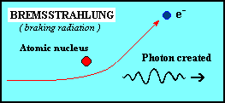

Image courtesy of University of Hertfordshire

Comptonization is when a photon collides with an electron – the photon will either give up energy to or gain energy from the electron, changing the electron's velocity as a result.
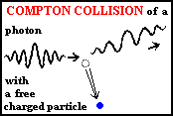
Image courtesy of University of Hertfordshire

What Are Some Examples of Continuum Emission?
Gas that is hotter than 10 million degrees, such as the gas heated by a supernova explosion, produces most of its emission in X-rays from thermal bremsstrahlung. Gas can be heated to these temperatures by the outward moving shock of a supernova explosion, or in an accretion disk around a black hole or neutron star. Synchrotron radiation can produce X-rays around supernova remnants (SNR), where the magnetic fields are strong and ions have been accelerated by the shock wave to high energies. X-rays produced by SNR require electrons with energies of about 10⁴ GeV (Giga electron-Volts) each (you would have to heat an electron to a temperature of about ten trillion degrees for it to have this much energy)! Synchrotron radiation and Compton scattered radiation are major components of the diffuse X-ray background and emission from active galaxies.

For the Student
Using the text, define the following terms: spectroscopy, keV, continuum, continuum emission, line emission, electromagnetic spectrum, synchrotron radiation, bremsstrahlung, comptonization.

Reference URLs:

Spectroscopy
http://imagine.gsfc.nasa.gov/docs/science/how_l1/spectra.html
http://www.colorado.edu/physics/PhysicsInitiative/Physics2000/quantumzone/

Activity: Graphing Spectra
Days Needed: 1
Grade level: 9 - 12

Objective
Students will be introduced to two different representations of spectra - the photographic representation, such as the familiar rainbow, and the graphical representation used more often by astronomers. Students will explore the differences and similarities of both these representations, and will develop a more intuitive feel for a graphical representation, which may not yet be familiar to them.

Science and Math Standards

NCTM
- Content Standard 8:
  - Geometry from an Algebraic Perspective
- Content Standard 10:
  - Statistics

NSES
- Content Standard A:
  - Unifying Concepts and Processes in Science
- Content Standard C:
  - Light, Energy and Magnetism
  - Structure of Atoms and Matter

Prerequisites
- Math Students should understand interpreting and manipulating graphical data.
- Science Students should understand the concept of a spectrum.
- Students should have read the Introduction to Spectroscopy.

Introduction
A rainbow is often given as an everyday example of a spectrum. Most students have seen a rainbow, so this example is used to help make the unfamiliar more familiar. However, the spectra that scientists use, and the spectra that students will see in this lesson plan, appear very different than a rainbow. In this activity, students will explore for themselves two different representations of the same spectrum, and will be introduced to advantages and disadvantages of the different representations.

Engagement
Hand out the “Student Worksheet: Graphing Spectra Part 1.” Have the class get into groups, if they aren't already, and complete it. The class should be discussing the answers, but each writing their own explanation on their own paper. The paper will be collected at the end of class and used as an assessment. The teacher should judge how much time they feel the class will need for this exercise.

After the class is done, discuss their answers to the questions posed in the worksheet.

Elaboration
Hand out “Student Worksheet: Graphing Spectra Part 2.” Have each student complete it on his or her own. Go over their answers in class when they have completed them. The teacher may choose to collect and correct the worksheets before discussing the answers in class.

Evaluation
Formative assessment and observation should be evident throughout the lesson. The worksheet, final questions during closure or a future quiz may serve as summative assessment.

Closure
Have students write for three minutes what they have learned about spectra, how they are represented and the usefulness of the different representations.

Student Worksheet:

Graphing Spectra Part 1
Below are two examples of the same emission spectrum. The first example is without any "quantitative" data, while the second shows light energy as a function of wavelength. The x-axis has the same units (wavelength, in this case, although frequency or energy could also be used) in both cases, and it runs from 300 to 350 Ångstroms. In your group, discuss the following questions, then write individual answers on paper.

- As you move along the wavelength axis from 300 Ångstroms to 350 Ångstroms, what will happen to the amount of energy emitted by the source? Explain why.
- In the second spectrum, explain why the emission lines are at different heights.
- In order for bottom plot to include more "quantitative" data, what variable should go along the y-axis?
- How is this variable illustrated in both graphs?
- Describe how the second spectrum would look if it were a function of energy (instead of wavelength).
- What types of information are gathered from both spectra?

Solar UV Spectra
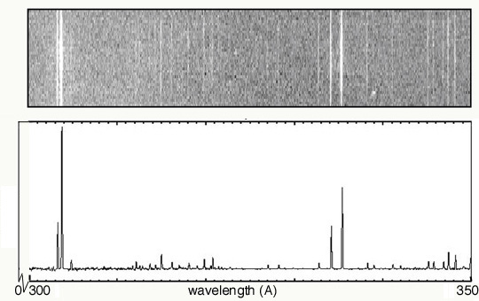

Solution: Student Worksheet:
KEY

Graphing Spectra Part 1

Below are the answers to the "Think About" questions.
- As you move along the wavelength axis from 300 Ångstroms to 350 Ångstroms, what will happen to the amount of energy emitted by the source? Explain why.
The energy decreases. This is because the energy is inversely proportional to the wavelength: E = hc/l

- In the second spectrum, explain why the emission lines are at different heights.
The varying heights represents the different intensities of the lines. The lines in the left-most portion of the spectrum are brighter than any of the others.

- In order for bottom plot to include more "quantitative" data, what variable should go along the y-axis?
The y-axis should be labeled as "Intensity".

- How is this variable illustrated in both graphs?
In the top image, it is represented by the brightness of the line. In the bottom plot, it is represented by the height of the line.

- Describe how the second spectrum would look if it was a function of energy (instead of wavelength).
Keeping the usual sense of values increase from left to right, the order the emission lines would be flipped left-to-right. That is, the brightest lines would be on the right.

- What types of information are gathered from both spectra?
From the spectra, we can identify the emission lines. With knowledge of the characteristic emission lines of various elements, we could then identify the elements giving rise to this spectrum.

Solar UV Spectra

Student Worksheet:

Graphing Spectra Part 2

The following spectrum represents the energy state of the element, carbon. Carbon's emission lines in the visible range are a function of wavelength from 4,000 to 7,000 Ångstroms. You are going to create a graphical representation of carbon's spectrum from the photographic representation. Refer to the example above to help. At the particular wavelengths, illustrate the varying brightness of carbon's emission lines. Notice that in the photographic representation of the spectrum there is an underlying continuum of emission, in addition to the bright spectral lines. This continuum is due to contamination of the spectrum by ambient light, such as small amounts of white light that are picked up by the spectrometer. Your graphical representation should include this low level of emission at all wavelengths as well as carbon's spectral line features.
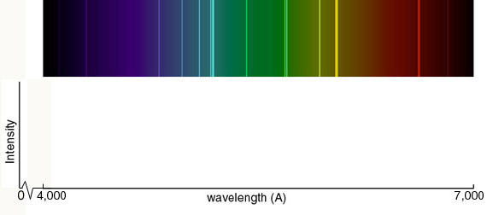

Below you are given spectra for both hydrogen and helium. For each element, select two of the brightest emission lines at the particular wavelengths and measure the wavelengths. The ruler below indicates the scale of the spectrum. Solve for the frequency and energy of these lines, using the relationships between wavelength and frequency and between frequency and energy. (Hint: You will have to manipulate an equation.) After the flame test, you will complete the same calculations for the following elements: sodium and calcium.
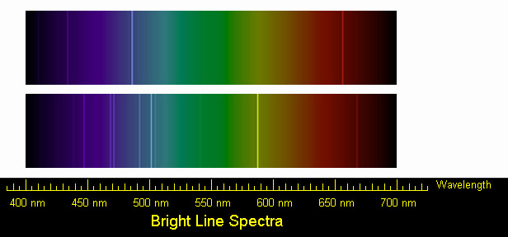

Solution: Student Worksheet:

Graphing Spectra Part 2
KEY
The graphical representation should include all visible lines shown in the color spectrum. The continuum should rise gradually from 4000 Ångstroms, and remain fairly constant through blue, and decrease slightly in green portion of the spectrum. It should increase again, reach a maximum near yellow, and then decline again in the red.

Below are the solutions for the identifying the lines in the spectra of hydrogen and helium.

Hydrogen
We can identify three bright lines for hydrogen in the top spectrum. Measuring from the scale, the wavelengths are 435 nm (purple), 486 nm (blue) and 657 nm (red). Recall (e.g. from the Calculation Investigation) that the frequency is given by ν = c/λ, and the energy is given by E = hν (where h = 6.626 × 10⁻³⁴ J-s, and c = 3 × 10⁸ m/s). In the table below we summarize the frequency and energy results for these lines. (We include the color to aid in identifying the line in the spectrum.)

Wavelength (nm) | Color | Frequency (Hz) | Energy (J)
435 | purple | 6.90 × 10¹⁴ | 4.57 × 10⁻¹⁹
486 | blue | 6.17 × 10¹⁴ | 4.09 × 10⁻¹⁹
657 | red | 4.57 × 10¹⁴ | 3.03 × 10⁻¹⁹

Helium
We can identify a number of lines in the spectrum of Helium. The bright lines are listed in the table below, along with their frequencies and energies. Students may identify any two of these.

Wavelength (nm) | Color | Frequency (Hz) | Energy (J)
447 | purple | 6.71 × 10¹⁴ | 4.45 × 10⁻¹⁹
469 | blue | 6.40 × 10¹⁴ | 4.24 × 10⁻¹⁹
472 | blue | 6.36 × 10¹⁴ | 4.21 × 10⁻¹⁹
493 | blue-green | 6.09 × 10¹⁴ | 4.03 × 10⁻¹⁹
501 | blue-green | 5.99 × 10¹⁴ | 3.97 × 10⁻¹⁹
505 | blue-green | 5.94 × 10¹⁴ | 3.94 × 10⁻¹⁹
587 | yellow | 5.11 × 10¹⁴ | 3.39 × 10⁻¹⁹
669 | red | 4.48 × 10¹⁴ | 2.97 × 10⁻¹⁹

Activity: Flame Test
Days Needed 1.5 Days
Grade level 9 - 12

Objective
Students will discover first hand how different elements emit different specific wavelengths of light energy when burned, and that these can be identified when the light is separated with a prism.

Science and Math Standards

NCTM
- Content Standard 2:
  - Mathematics as Communication
- Content Standard 4:
  - Mathematics as Connections
- Content Standard 8:
  - Geometry from an algebraic perspective

NSES
- Content Standard B:
  - Abilities necessary to do scientific inquiry
  - Understandings about scientific inquiry
- Content Standard C:
  - Structure of Atoms
  - Interactions of energy and matter
- Content Standard G:
  - Nature of Scientific Knowledge
  - Historical Perspectives

Prerequisites
- Math Students should have had some Pre-Algebra, especially in the areas of manipulation of formulas and pattern recognition.
- Science Students should have had an introduction to the electromagnetic spectrum, the concept of a spectrum and how atoms emit light energy.

Introduction
Recalling the characteristics of atoms and light, the flame test is a great way to physically demonstrate some of the more abstract ideas discussed in the background sections on Atoms and Light Energy and Spectroscopy.

Exploration
The students will work in lab groups of three to four students to construct meaning on the causes of various light emissions from the following 0.5M chemical solutions: LiCl, NaCl, CuCl, BaCl, CsCl, and CaCl. To prepare for the Flame Test, each 0.5M solution should be placed in a test tube by itself. Each of the six test tubes should then be placed at the various laboratory stations 1 through 6. The students will rotate to each station to test the solution.

Materials
- 7 test tubes
- test tube rack
- platinum wire or wood splints
- laboratory burner
- goggles
- apron
- 0.5M solutions of LiCl, NaCl, CuCl, BaCl, CsCl and CaCl, and 1M of HCl

Hand out “Student Worksheet: Flame Test” student worksheet. Have the students answer the thought questions at the end of Part I in groups, but on paper. They should be utilized to facilitate a meaningful discussion on light emission. Afterwards, the students should complete the questions in Part II individually. They may be assigned for homework if there is not enough class time.

Evaluation
Formative assessment and observation should be evident throughout the lesson. The worksheet, final questions during closure or a future quiz may serve as summative assessment.

Closure
Have students take three minutes to write in their own words why different elements produce flames of different colors when burned. How is this quality useful in astronomy?

Reference URL

Flame Test
http://www.creative-chemistry.org.uk/activities/flametests.htm

Student Worksheet:

Flame Test

Part I

Procedure
- Put on lab apron and safety goggles.
- Add 15 drops of each 0.5M solution to a different clean test tube.
- To clean the wire, dip it into the test tube of 1M of HCl and heat the wire in the hottest part of the flame until no color shows.
- When the platinum wire is clean, dip the wire in the test tube containing a 0.5M solution and hold it in the hottest part of the flame. Record your observation of the color of the flame on the data table.
- Repeat the process of cleaning the platinum wire. Now get ready to test another solution.
- Test all of the solutions and make sure that you record the color of the flame for each element on the Data Table.
- Check your flame colors to known results.
- Fill one clean test tube with 15 drops of one of the 0.5M solutions. The teacher keeps track of what element solution is in this "mystery tube." Repeat the flame test, without telling the students what solution it is. Students must use the information gained from the first part of the experiment to identify the mystery solution.
- Use the diffraction grating to observe the color of the flame for the following elements: Sodium, Barium, Copper, and Lithium. The students should be able to see the individual lines making up the light from the flame. This can be tricky! In order for it to work, the room will have to be completely dark (in order to block out other light sources) and the students will have to be close to the flame, holding the diffraction grating up to their eyes. It may be necessary to rotate the diffraction grating in order to see the emission lines. Be patient!
- Record the colors of the elements' emission lines in column three of the Data Table.
- Before leaving the laboratory, wash your hands thoroughly with soap and water.

Stations | Observed Flame Color | Color of  Emission Lines | l (m) | n (Hz) | E (J)
Calcium (0.5M CaCl)
Sodium (0.5M NaCl)
Barium (0.5M BaCl)
Lithium (0.5M LiCl)
Copper (0.5M CuCl)
Cesium (0.5MCsCl)

Think About
Discuss the following questions in lab groups. Remember you are trying to determine what is taking place during the Flame Test whereby various colors of light are being emitted. One person in your group will have the responsibility of writing the group answers down. After discussing these questions in the group, another person will be responsible for sharing your thoughts with the whole class. You may refer to background material.
- What particles are found in the chemicals that may be responsible for the production of colored light?
- Why do different chemicals emit different colors of light?
- Why do you think the chemicals have to be heated in the flame first before the colored light is emitted?
- Colorful light emissions are applicable to everyday life. Where else have you observed colorful light emissions. Are these light emission applications related? Explain.
- What is the characteristic flame color for Sodium, Lithium, Barium, Copper, Cesium, and Calcium? Explain why.
- When the diffraction grating was used to view the flame, explain why different colorful emission lines were observed for the elements.

Part II
Use the image below to view the spectra of calcium (top) and sodium (bottom). Solve for frequency and energy of the two brightest emission lines for each element. Use the brightest lines. Show your work and record your answers on the Data Table.

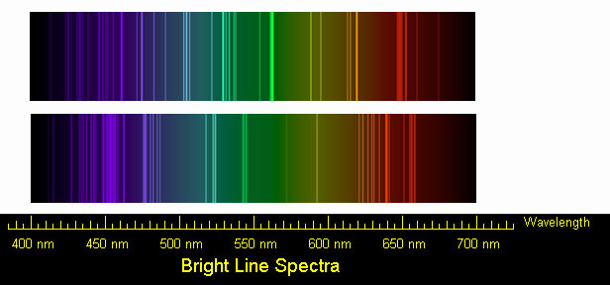

Activity: Design an Element Poster Advertisement
Days needed a week
Grade level 4 - 8, 9 - 12

Objectives
Students will discuss what they have learned about atoms and elements in their own words. Students will design a poster advertisement for their chosen element. Students will use more than just their right brain to think about science!!

Science and Math Standards

NCTM
- Content Standard 2:
  - Mathematics as Communication

NSES
- Content Standard B:
  - Structure of Atoms
  - Interactions of energy and matter
- Content Standard G:
  - Science in personal and social perspectives.

Prerequisites
Science Students should have read the background information on how atoms emit light energy and have a basic understanding of the elements.

Introduction
Each element in the Universe has unique properties due to its atomic configuration (the arrangement and numbers of protons, neutrons and electrons it has). In the previous activities, students have learned about how each element has a unique spectral "fingerprint." In this activity, students will explore in more depth the properties of one particular element, and share their knowledge with the class in the form of a poster advertisement for their element.

Exploration

The students should be given a week to complete this assignment as either a student-individual or group project. If it is assigned as a group project, some class time will be needed. Give each student a copy of the “Student Worksheet: Design an Element Poster Advertisement” which describes the requirements of the project.

Evaluation
Each of the requirements on the Student Worksheet is worth 20 points. The students should present their posters to the class, and for an extra 20 points all students should be encouraged and prepared to conduct some form of a demonstration using the assigned element as either an element or compound.

Closure
When the students have completed their element posters, they should be presented to and shared with the class. It might be useful to have the posters on display for a short amount of time, so that students will be able to see each others posters and become familiar with each others elements.

Adaptations
This project is easily adaptable to almost any grade level. Middle school students might concentrate on the basic properties of the element. At all levels, artistic creativity should be encouraged. In addition, with a one or two classes participating, an entire periodic table could be assembled and displayed. When a semi-permanent display is not possible, some teachers have used their school gymnasium or auditorium to lay the posters out and photograph their students’ “periodic table.”

Middle school students might also enjoy creating super heroes whose powers are based on one of the elements. For example, "Goldi Ox" (a play on Goldilocks) uses the properties of gold.

Reference URLs

Periodic Table of the Elements
http://www.webelements.com/

Student Worksheet:

Design an Atom Poster Advertisement

Assignment
Now that you have determined several ways to identify elements, you will be assigned an element to make an advertisement poster on its everyday use. You want to make this poster as appealing as possible for your immediate classmates and school community, so that people will take the time to read and learn about the everyday use of several elements found on the Periodic Table.

Your poster needs to include the following:
- a Catchy Title and Atomic Model
- the Electronic Configuration
- a Listing of physical and chemical properties of your assigned element (at least two each)
- a picture of where this element is found and how is it used; in other words, its everyday application; (This picture should either be drawn, taken from the internet, a magazine, or copied from a book).
- a one-paragraph typed caption for the above picture telling where the element is found and how it is used. Give the element's atomic symbol. This information must be factual and written in your own words. If you choose to do so, your one-paragraph caption can be written as a poem or jingle.

