Time That Star!
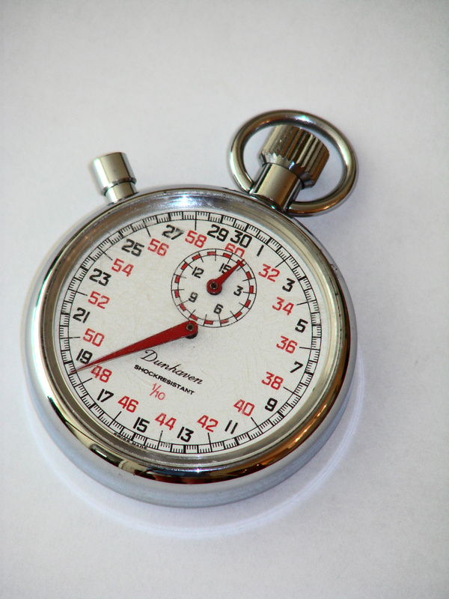

Day 1 Data Tables

Summary
Use the following data tables to keep track of your pendulum swing trials.

Table 1
Pendulum cord length: ________________

Trials | t₁ | t₂ | t₃ | t_{a} | t_{b} | t_{c}
1
2
3
4
5
Mean
Distance of Swing

Table 2
Pendulum cord length: ________________

Trials | t₁ | t₂ | t₃ | t_{a} | t_{b} | t_{c}
1
2
3
4
5
Mean
Distance of Swing

