Time That Star!
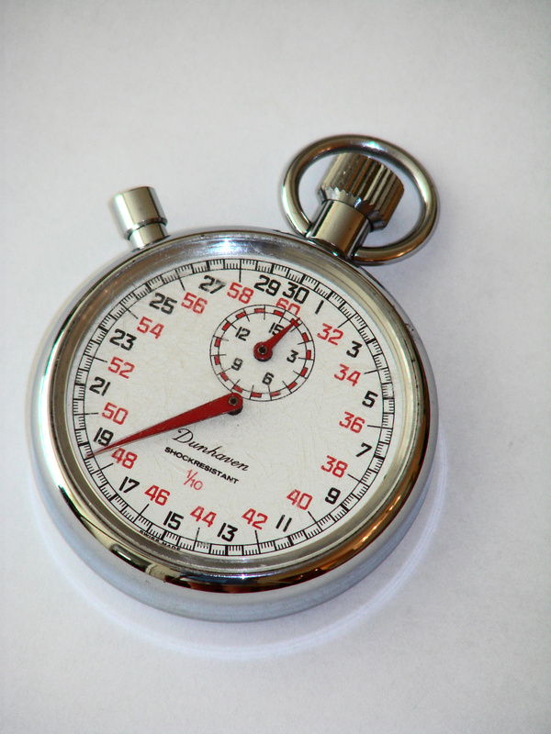

Day 1 Lab Procedure

Summary

Today you are going to set up a simple pendulum and explore its motion for various numbers of swings and for different lengths of pendulum arms.

Procedure

- Decide who will be the Data Keeper, the Materials Manager, and the Time Keeper. Record the roles below.
- Data Keeper / Reader: ______________________________________________

- Materials Manager / Checker: ______________________________________________

- Time Keeper / Facilitator: ______________________________________________

- Materials Manager retrieves all materials listed from teacher. Reader should read all directions.

- Each triad should place two chairs back-to-back separated by about 20 cm.

- Materials Manager turns the hook into the wood/cardboard and tie the 60 cm string to the hook. Next, s/he ties the 60 cm string around the mass to make a simple pendulum. Then, place the wood block on top of the chair backs with the pendulum dangling between the two chairs.
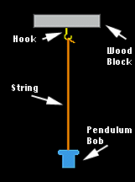
- Next, tape a meter stick to the floor below the pendulum, so that when the pendulum is at rest, it dangles over the 50 cm mark on the meter stick.

- Checker and other group members should help confirm the set-up of the lab as seen below.
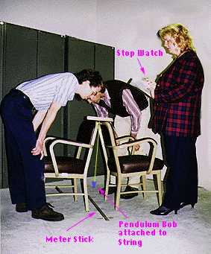
- The mass of the pendulum should be gently pulled out by the Materials Manager to the 75 cm mark, making sure the string is taut. Now when the Time Keeper looks directly over it, he or she sees the 75 cm mark covered by the mass.

The lab begins here (Reader – read this step carefully!).

- Let time = 0 when the pendulum is released from being held over 75 cm. When the Time Keeper says go, the pendulum is released and the watch started. When the pendulum reaches its maximum movement (roughly over 25 cm), someone says “stop:, and the watch is stopped. Repeat this measurement 5 times, making sure the Data Keeper records each trial on the Data Table under t₁.
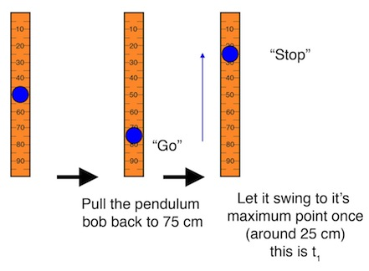

Now repeat the procedure with someone saying “stop” the second time the pendulum reaches its maximum movement near 25 cm. The Data Keeper records each trial on the Data Table under t₂.
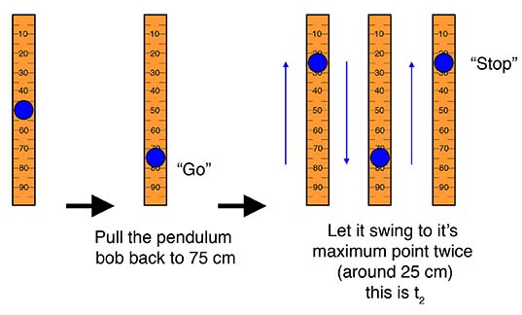
Repeat the procedure again, this time saying “stop” the third time the pendulum reaches its maximum movement near 25 cm. The Data Keeper records each trial on the Data Table under t₃.

You can even do this for the fourth time if the pendulum continues to reach its maximum movement that many times!
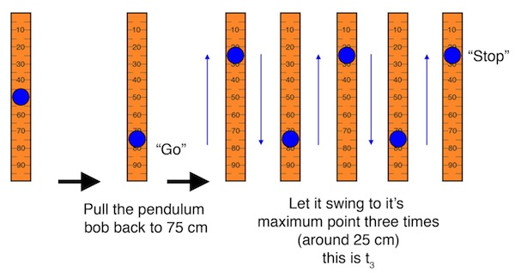

- The Data Keeper will record data for at least 3 complete swings of the pendulum (4 if possible). Each measurement should be made 5 times, and the mean determined from the 5 trials and recorded on the Data Table.

- Again, let time = 0 when the pendulum is released from being held over 75 cm. When Time Keeper says “go” the pendulum is released and the watch started. This time, the pendulum reaches its maximum movement when it swings back over 75 cm, and someone says “stop”. The Data Keeper should record each trial as t_{a} on the Data Table. Repeat this measurement 5 times.
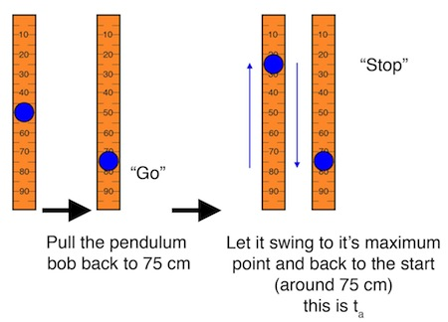

Now, repeat the procedure with someone now saying “stop” the second time the pendulum reaches its maximum movement near 75 cm. The Data Keeper should record this as t_{b} on the Data Table. Take this measurement 5 times.
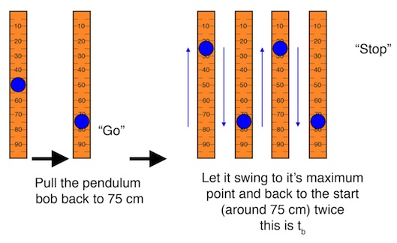

Repeat the procedure again, this time with someone saying “stop” the third time the pendulum reaches its maximum movement near 75 cm. The Data Keeper should record the time for each of 5 trials under t_{c} on the Data Table.

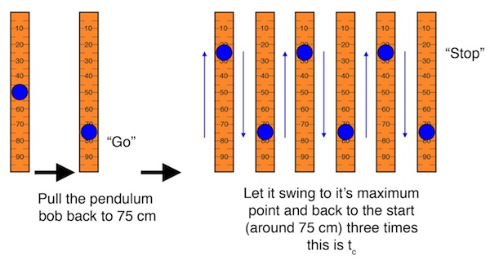

Once more, you can do this for the fourth time if the pendulum continues to reach its maximum movement that many times.

- The Data Keeper will record data for at least 3 complete swings of the pendulum (4 if possible). Each measurement should be made 5 times, and the mean determined from the 5 trials and recorded on the Data Table.

- After the data are collected and appropriately placed on the Data Table, it is time to plot the data. Each team member is responsible for making their own plot of the length of the swing versus the mean time in seconds.

- Repeat steps 4-12, but substitute the 30 cm string for the 60 cm string.

