Time That Star!
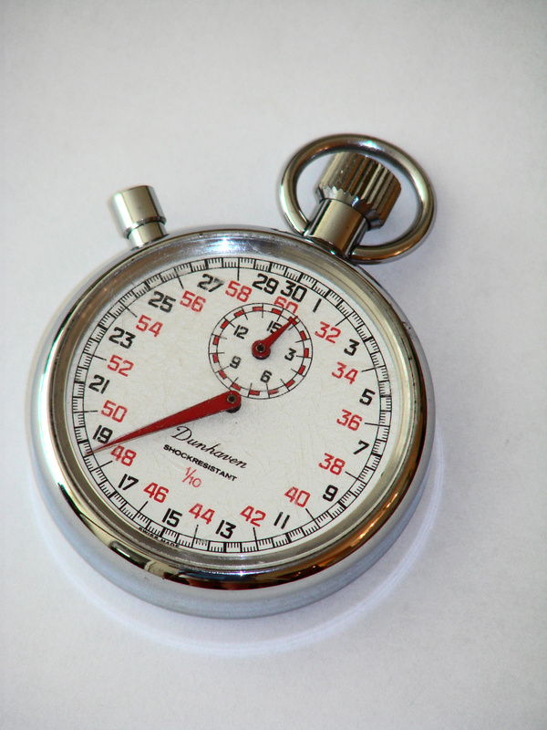

Day 2 Binary Star Data

Summary
Use the following data to perform Epoch Folding to determine the rotation period or the orbital period of the given sources.

Stellar Rotation Data
The following two data sets can tell astronomers how fast a star is rotating.

Cen X-3 Data
These data for Cen X-3 are rom EXOSAT satellite’s Medium Energy experiment. All data are from 19 June 1985. The time is in seconds from the beginning of that day.

Time (Seconds) | Rate (counts/cm²/s)
0 | 14.7062277
0.484 | 14.8695928
0.968 | 15.8992848
1.452 | 15.7533336
1.936 | 16.1208738
2.42 | 15.66
2.904 | 16.5468258
3.388 | 15.211294
3.872 | 15.5961072
4.356 | 15.3717151
4.84 | 14.7062277
5.324 | 14.8695928
5.808 | 15.8992848
6.292 | 15.7533336
6.776 | 16.1208738
7.26 | 16.5247452
7.744 | 16.5468258
8.228 | 15.211294
8.712 | 15.5961072
9.196 | 15.3717151

GX 301-2 Stellar Rotation Data
These data for GX 301-2 are from the A2 experiment aboard the HEAO-1 satellite. All data are from 1 February 1978. The time is in seconds from the beginning of that day.

Time (Seconds) | Rate (counts/cm²/s) | Time (Seconds) | Rate (counts/cm²/s) | Time (Seconds) | Rate (counts/cm²/s)
72362.10 | 0.01388 | 73027.70 | 0.01953 | 73857.14 | 0.03258
72387.70 | 0.01512 | 73053.30 | 0.01688 | 73882.74 | 0.03518
72413.30 | 0.01593 | 73099.38 | 0.02005 | 73908.34 | 0.04642
72438.90 | 0.02347 | 73145.46 | 0.02447 | 73933.95 | 0.04945
72464.50 | 0.03103 | 73171.06 | 0.03435 | 73959.54 | 0.04190
72490.10 | 0.03113 | 73196.66 | 0.03123 | 73985.14 | 0.04512
72515.70 | 0.03387 | 73222.27 | 0.04637 | 74010.74 | 0.04933
72541.30 | 0.03270 | 73247.86 | 0.04983 | 74036.34 | 0.04593
72566.90 | 0.04195 | 73273.46 | 0.04498 | 74061.95 | 0.04435
72592.50 | 0.04873 | 73299.06 | 0.04375 | 74087.54 | 0.03997
72618.10 | 0.03942 | 73324.66 | 0.03735 | 74113.14 | 0.04358
72643.70 | 0.04453 | 73350.27 | 0.03998 | 74138.74 | 0.03462
72669.30 | 0.03557 | 73375.86 | 0.03278 | 74164.34 | 0.02330
72694.90 | 0.03318 | 73401.46 | 0.03377 | 74189.95 | 0.01715
72720.50 | 0.03347 | 73427.06 | 0.02837 | 74215.54 | 0.01945
72746.10 | 0.03520 | 73452.66 | 0.02468 | 74241.14 | 0.02760
72771.70 | 0.02420 | 73478.27 | 0.01903 | 74266.74 | 0.03603
72797.30 | 0.01890 | 73503.86 | 0.01927 | 74292.34 | 0.03190
72822.90 | 0.02057 | 73590.90 | 0.03228 | 74317.95 | 0.03705
72848.50 | 0.02873 | 73677.95 | 0.03677 | 74343.54 | 0.03342
72874.10 | 0.02737 | 73703.54 | 0.02440 | 74369.14 | 0.02537
72899.70 | 0.03315 | 73729.14 | 0.01590 | 74394.74 | 0.02307
72925.30 | 0.03692 | 73754.74 | 0.02042 | 74420.34 | 0.01768
72950.90 | 0.03377 | 73780.34 | 0.01408 | 74445.95 | 0.01930
72976.50 | 0.03375 | 73805.95 | 0.01908 | 74471.54 | 0.01730
73002.10 | 0.02500 | 73831.54 | 0.02345

Orbital Rotation Data
The following two data sets can tell astronomers how fast two stars are orbiting each other.

Cir X-1 Orbital Data
These data for Cir X-1 are from the RXTE Satellite’s All Sky Monitor. The time is the number of days from the beginning of the mission.

Time (Days) | Rate (counts/s) | Time (Days) | Rate (counts/s) | Time (Days) | Rate (counts/s)
186.0 | 93.55 | 205.0 | 71.92 | 224.0 | 76.04
187.0 | 105.36 | 206.0 | 75.87 | 225.0 | 37.82
188.0 | 97.05 | 207.0 | 81.32 | 226.0 | 99.55
189.0 | 85.28 | 208.0 | 70.23 | 227.0 | 171.93
190.0 | 88.64 | 209.0 | 76.63 | 228.0 | 141.79
191.0 | 88.60 | 210.0 | 163.11 | 229.0 | 125.30
192.0 | 60.92 | 211.0 | 195.43 | 230.0 | 101.67
193.0 | 121.83 | 212.0 | 154.57 | 231.0 | 81.85
194.0 | 170.94 | 213.0 | 110.34 | 232.0 | 74.14
195.0 | 177.16 | 214.0 | 105.15 | 233.0 | 87.63
196.0 | 113.90 | 215.0 | 86.03 | 234.0 | 101.00
197.0 | 82.20 | 216.0 | 114.17 | 235.0 | 97.89
198.0 | 97.48 | 217.0 | 125.39 | 236.0 | 83.97
199.0 | 120.72 | 218.0 | 112.97 | 237.0 | 85.34
200.0 | 109.35 | 219.0 | 90.32 | 238.0 | 77.82
201.0 | 75.39 | 220.0 | 75.04 | 239.0 | 76.74
202.0 | 71.62 | 221.0 | 85.32 | 240.0 | 73.02
203.0 | 70.81 | 222.0 | 70.34 | 241.0 | 74.61
204.0 | 63.48 | 223.0 | 77.66

GX 301-2 Orbital Data
These data for GX 301-2 are from the Vela 5B satellite. The time is the number of days from the beginning of the mission.

Time (Days) | Rate (counts/s) | Time (Days) | Rate (counts/s)
41001.46 | 5.194 | 41087.55 | 4.008
41006.13 | 1.274 | 41092.22 | 0.407
41010.73 | 1.971 | 41096.88 | 0.522
41017.69 | 1.313 | 41103.66 | 0.164
41022.35 | 1.441 | 41107.27 | 0.187
41025.93 | 0.501 | 41113.02 | 0.173
41033.92 | 1.784 | 41117.71 | 0.302
41038.59 | 0.119 | 41122.36 | 10.349
41043.27 | 11.225 | 41127.03 | 1.128
41047.95 | 1.199 | 41132.80 | 0.478
41052.64 | 0.386 | 41137.50 | 0.786
41057.30 | 0.256 | 41143.28 | 1.999
41061.98 | 2.442 | 41147.95 | 1.843
41066.65 | 0.126 | 41152.64 | 1.605
41071.32 | 1.712 | 41157.27 | 0.304
41075.98 | 0.305 | 41161.96 | 5.784
41082.73 | 7.988 | 41166.64 | 5.509

