Time That Star!

Day 2 Binary Star Plots

Summary
Use the following plots are based on the data provided in the Time That Star! Day 2 Binary Data tables

Stellar Rotation Data
The following two data sets can tell astronomers how fast a star is rotating.

Cen X-3 Data
These data for Cen X-3 are rom EXOSAT satellite’s Medium Energy experiment. All data are from 19 June 1985. The time is in seconds from the beginning of that day.
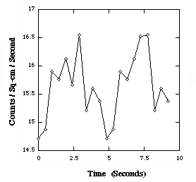

GX 301-2 Stellar Rotation Data
These data for GX 301-2 are from the A2 experiment aboard the HEAO-1 satellite. All data are from 1 February 1978. The time is in seconds from the beginning of that day.
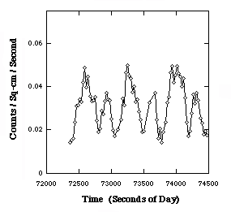

Orbital Rotation Data
The following two data sets can tell astronomers how fast two stars are orbiting each other.

Cir X-1 Orbital Data
These data for Cir X-1 are from the RXTE Satellite’s All Sky Monitor. The time is the number of days from the beginning of the mission.

GX 301-2 Orbital Data
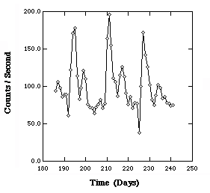
These data for GX 301-2 are from the Vela 5B satellite. The time is the number of days from the beginning of the mission.
