Time That Star!

Day 2 Wrap-up
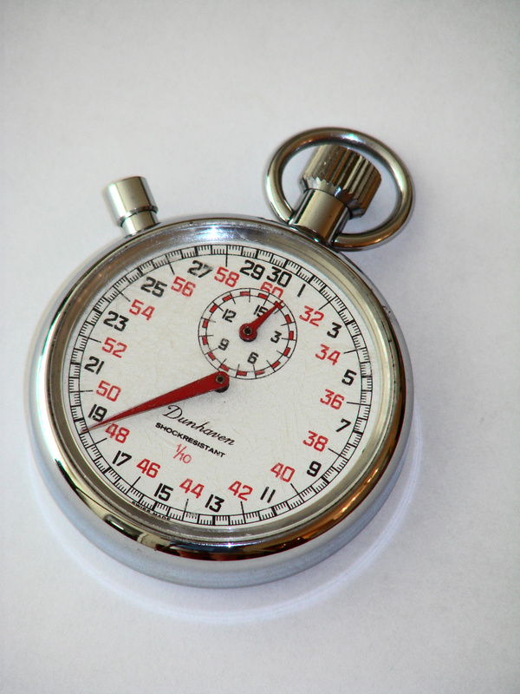
Today you calculated the periods of rotation and the orbital period for several stars. Fill out this worksheet with the results of your experiments. Each student is responsible for completing this worksheet.

- What did your team measure for each of the following?
  - Stellar Rotation Periods

GX 301-2: ___________________

Cen X-3: ___________________

  - Orbital Periods

Cir X-1: ___________________

GX 301-2: ___________________

- The rotational period of our Sun is 25 days. How do the stellar rotation periods you measured for GX 301-2 and Cen X-3 compare to the Sun’s rotation period?

Do these results surprise you? Why or why not?

- How many days does it take the Earth to orbit the Sun?

How does the Earth’s orbital period compare to the orbital periods of the stars in Cir X-1 and GX 301-2?

Do these results surprise you? Why or why not?

- Think of a place in your life where you have seen periodic behavior. Describe that periodic behavior below.

Now, create a rough graph of that periodic behavior through 3-4 periods (either below or on graph paper). Be sure to label the axes of your plot appropriately for your example. The x-axis should be time (seconds, minutes, hours, etc.). The y-axis will depend on your example.

What would the period of your example be?

