“Universe Mash-Up” Hints and How To

by Faith Tucker

You’ve decided to make a Universe Mash-Up, great! Now what? Here are some ideas and helpful hints about how to go about making your mash-up. Take a few minutes to watch the example Universe Mash-Up called From the Inside Out, which we’ll use as a reference as we go.

Pick a Topic
The first thing to do is to read through the various Cosmic Times newspapers and choose a subject for your mash-up. The newspapers cover the development of our understanding of cosmology and are bursting at the seams with exciting scientific discoveries, fascinating characters and historical drama. You can pick either a broad topic that can be traced through all six newspapers or a very specific topic only covered in one or anything in between. For example, when preparing From the Inside Out, I decided to pick a broad theme – specifically, how our understanding of cosmology expanded over time by making more and more distant observations – but you could just as easily do a more narrow theme like Henrietta Leavitt’s groundbreaking work, how Einstein’s theory of relativity was proven or the debate between the Big Bang theory and a Steady State universe.

Next, think about what you want to say about that subject. What do you want your audience to come away with? It might be helpful to figure out what makes your subject exciting to you and then consider how best to communicate that to others. Now would be a good time to look through the Media Archive to see what images, videos and audio clips are available to you. Remember that it’s ok if you need to reassess your mash-up’s topic a bit in light of what media you have at your disposal.

Write a Script
Now that you have a topic and have an idea of what sorts of media you’re working with it’s time to write your script. Keep in mind that From the Inside Out’s script was just over one page of single spaced type, so a 2-minute video of continuous narration would require about half a page of type. However, text on the screen can be just as effective of a communication tool as narration, so feel free to mix it up!

Record the Narration
Once your script is written it’s time to record the narration. Many newer laptops have built-in microphones that can easily be used to record audio using simple recording and editing software. You can also connect an external microphone for enhanced audio quality. Depending on the computer and microphone, you may be able to connect your microphone directly to the computer using a 1/8th inch mini-jack or you might need an interface that will mediate between your microphone’s connector (1/8th mini-jack, XLR, or 1/4th inch jack plug) and your computer’s port (typically USB). When getting ready to record your narration, remember to practice a few times beforehand so you’re comfortable with the material, think about where you’ll want to put any special emphasis, and breathe quietly during pauses. And don’t be afraid to try reading it a couple different ways until you get it the way you like it.

Edit the Narration
Most audio editing software programs will allow you to make a few simple adjustments to your recordings that can make a big difference. In editing my audio after I recorded it, I decreased the volume each time I took a breath to avoid sounding like a fish, cut out a few “ums,” and mixed and matched different takes to get the best of both worlds. To selectively adjust the volume, highlight the portion of the waveform (the up and down squiggles representing the sound) that you want to change and then use the volume adjustment function – typically you can choose whether to decrease/increase the volume gradually or abruptly. Similarly, if there are any filler words or mistakes that you want to edit out without scrapping the whole clip, highlight the relevant portion of the waveform and simply delete or cut it out. Finally, if you love the way you began that sentence in your first take and just nailed the finish in the 15th take, try your hand at cutting and pasting clips together. This may sound daunting, but it’s exactly like cutting, copying and pasting text or video. Just remember to keep the natural rhythm, timing, pauses and volume.

Now that your audio is ready to go, save the audio clips in a readable file format – some good general formats include PCM (.wav for Windows and .aiff for Mas OS), MP3 or MP4. Next import them into your video editing software of choice and arrange them in the clip viewer in the desired order. This gives you the basic skeleton of your video to start adding visuals to.

Choose & Customize Visuals
You have two options as far as visuals go: video or still frames. Peruse the Media Archive and download the visuals you want to use in your mash-up – images will typically come as JPG or PNG files and videos will often be MPEG or QT files. When you import these videos and images into your video editing software, the videos should appear as clips of the appropriate length and the images will often appear as video clips (albeit ones in which you just stare at the unchanging image) of some arbitrary length. You now have an arsenal of clips with which to fill your mash-up!

However, you’ll notice that there were plenty of things in From the Inside Out that were not directly from the Media Archive. An easy way to customize your mash-up is to use a presentation program to create slides with text and/or images on them. Many video editing programs will allow you to insert text and images in a variety of ways, but I’ve found that presentation programs give you much more freedom and control. By using images in a presentation program you can add to the image and even make simple animations.

For example, here is an image found in the Media Archive:
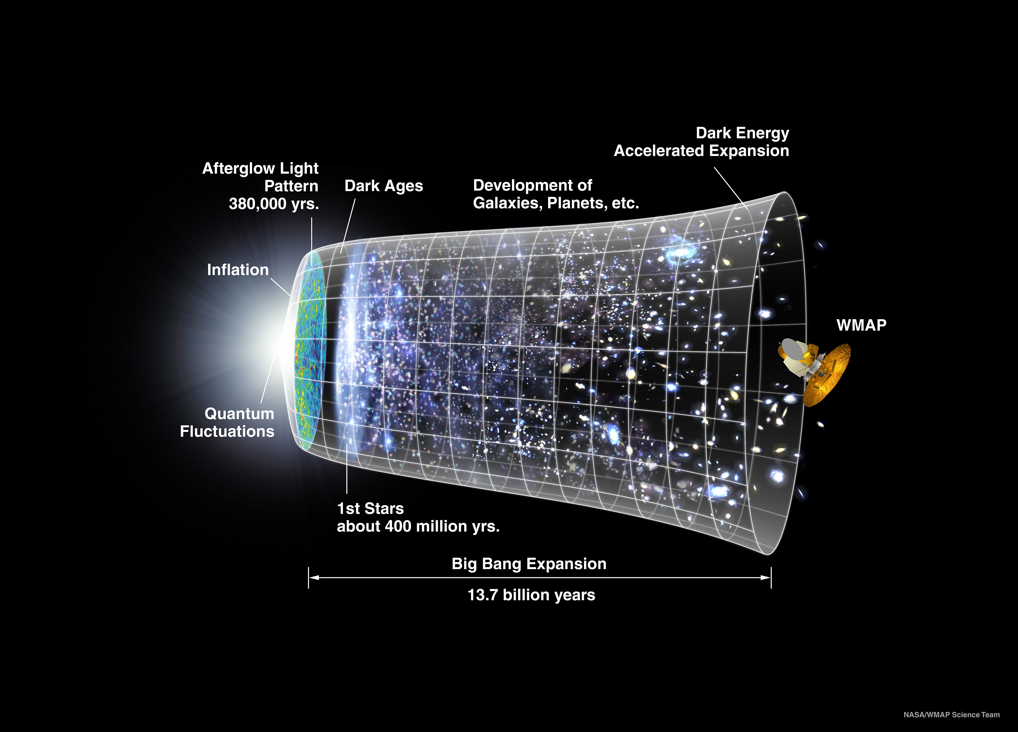

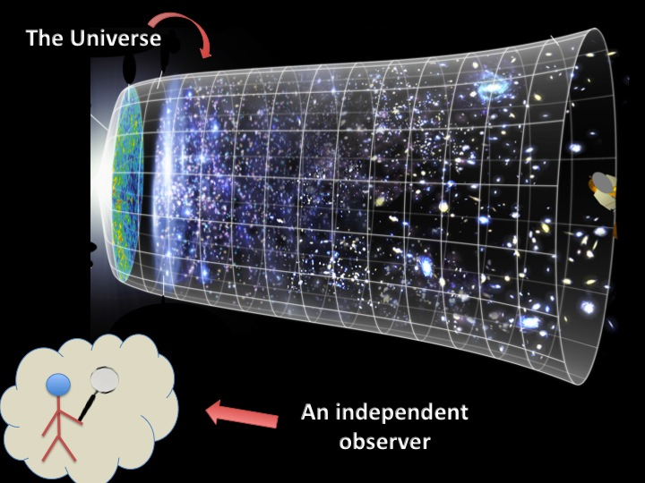
Instead of simply inserting this into the video on its own, I made it the background of the slide. Then I used functions such as “Insert Line/Shape/Clip Art/Text Box” to add a stick figure and some labels:

This customization adds a lot to your mash-up, but there’s even more you can do. To make a simple animation, you’ll want to create a series of slides that when shown rapidly one after another appears animated. To do this, think about creating layers. Start with the basic image on one slide, then “Select all” and “Copy” that slide and “Paste” it onto a new slide. Now make any adjustments/additions you want and repeat the “Select all” – “Copy” – “Paste” – Adjust/add process. Then, if you click through the slides quickly it should appear like a simple animation, like this:

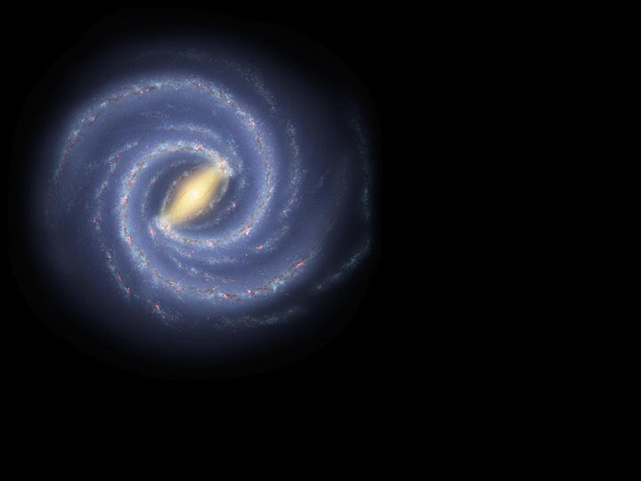

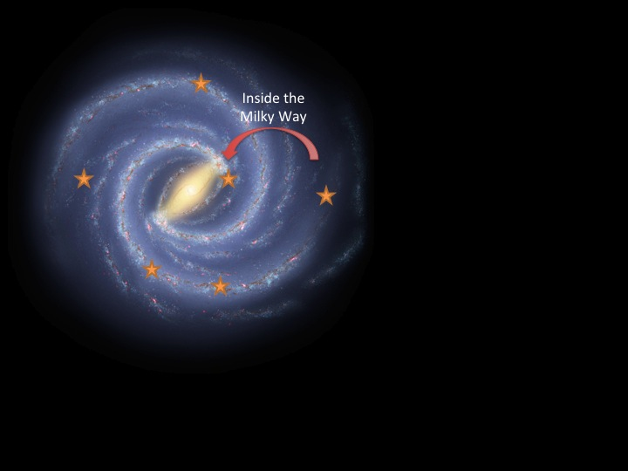

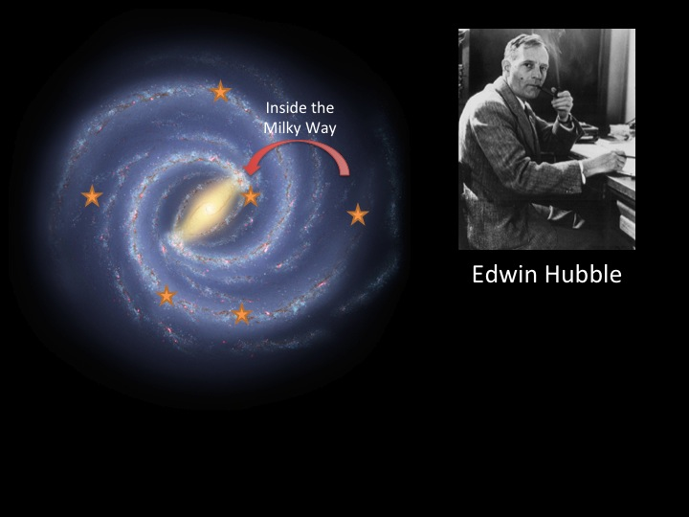

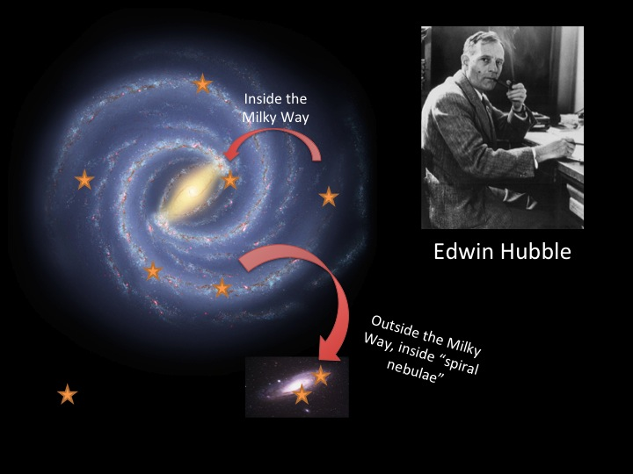

Now I have a visual that shows exactly what I want it to. To use these slides in your mash-up, you will want to adjust the way the file is saved. Instead of saving it as a presentation, you want each slide to be saved as an image (preferably JPG). To do this, go to “File” “Save As” and there should be some option to change the format of the file in question, select “JPG.” Then you can import those images like you did those from the Media Archive.

Edit the Video
By now you should have a complete set of videos, still frames and simple animations that you’re ready to start filling into the mash-up. The process of turning a collection of clips into a smooth, coherent movie can take quite a while and can involve many stages, so start off simple. I would suggest arranging your clips in the order you want to use them and then placing them into your clip viewer without worrying about the timing or transition or nitty-gritty details.

Once you’ve got them all in place, start the beginning and work through the clips, adjusting the length of each clip and it’s placement. The best way to fix a clip that is too long is to place the playhead (the curser showing where you are in the movie) at the point that you want to clip to end at and then select “Split Video Clip at Playhead.” You’ve now cut the clip into the part you want and the excess, so just select and delete the excess chunk. If the clip is a video that you don’t want to abbreviate but takes up too much time, you can try adjusting the speed the clip plays at. By adding a “Fast Forward” effect to the clip you can make it play slightly (or significantly) faster. This can also be done to make a clip longer by adding a “Slow Motion” effect. To make a clip longer, particularly one of your image clips, look for a function that will allow you to adjust the photo settings simply increase the length of the clip.

With your clips all in place and with appropriate lengths you can try experimenting a bit with adding fun transitions and background music or sound effects. Remember to only use copyright-/royalty-free music in your videos, which should be easily found with an online search. If you do use background music, don’t forget that it can be editing and adjusted just like you edited your narration audio.

Share Your Mash-Up!
By now your mash-up should be just about complete! Feel free to play with any other fun features your video editing software has and don’t forget to save often. Once you’re done, show it to your friends, classmates, teacher and family so they can enjoy your masterpiece and learn all about cosmology too!

