NATIONAL AERONAUTICS
AND SPACE ADMINISTRATION

Universe Mash-Ups
Cosmology 101 Through Video Mash-up Projects
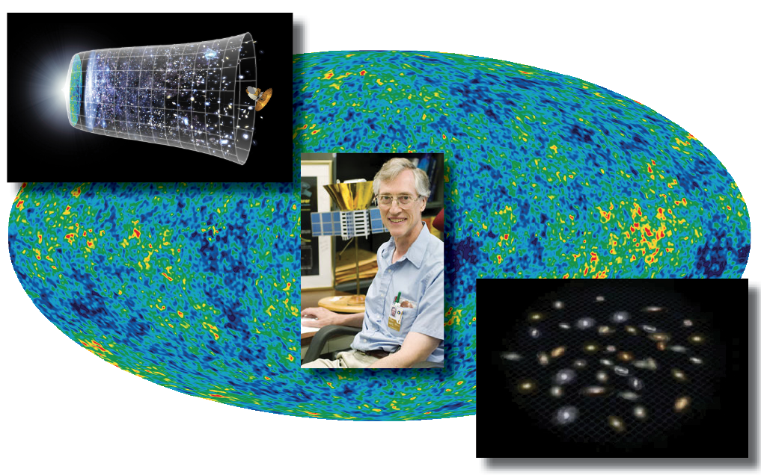

Curriculum support materials by:
Geri Cvetic, NBCT  Chesapeake High School  Pasadena, MD | Dr. Barbara Mattson  NASA/GSFC and USRA/CRESST  Greenbelt, MD
These materials were created under NASA’s Education and Public Outreach program for the High Energy Astrophysics Science Archive Research Center (HEASARC), with added support from the NASA Grant/ Cooperative Agreement NNX09AN22G. Special thanks to Francis Reddy for his input.

Table of Contents
Introduction 3
General Lesson Information 3
Estimated Class Time 3
Objectives 3
National Education Standards 4
Outline 4
Background Information: Video Production 5
Pre-Production 5
Production 6
Post-production 6
Engagement: Introduction 8
Exploration: Pre-production 12
Explanation: Video Production and Post-Production 15
Evaluation 17
Extension: Sharing the Mash-ups 18
Resources 19
Resources for Student Projects 19
Background on Mash-ups in the Classroom 19
Student Handouts
Cosmic Times Keyword Match Pre-test 20
KCLWM Chart 21
Cosmic Times Post-test 22
Universe Mash-up Project Overview and Planning 23
Universe Mash-up Grading Rubric 25
Treatment Script 27
Storyboard 28
Universe Mash-up Production Checklist 29
Universe Mash-up Self Evaluation 31

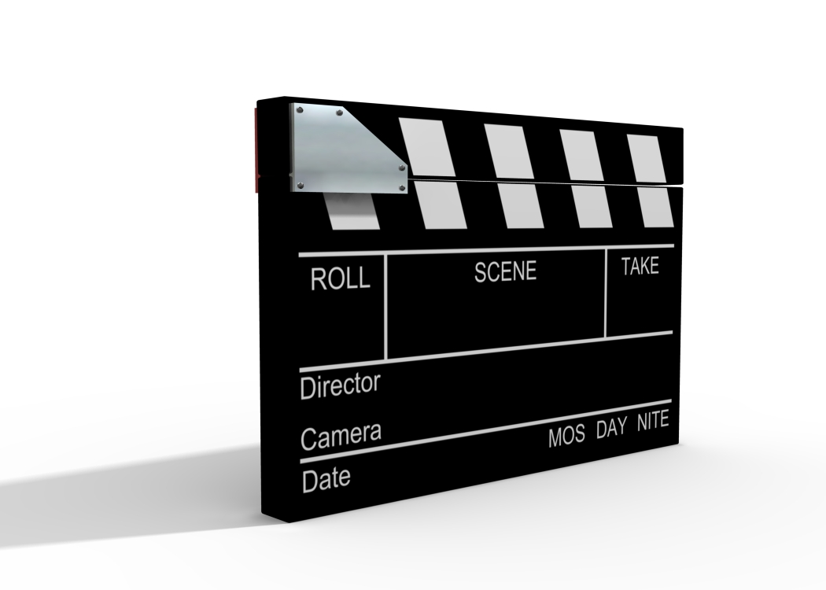

Introduction
Ever see the President and First Lady’s faces inserted into American Gothic, the painting by Grant Wood? Or maybe a video collage of Homer Simpson’s many renditions of the word “d’oh”? These are examples of “mash-ups” – pieces (image, audio or video) created by combining two or more sources of media into a new derivative work.
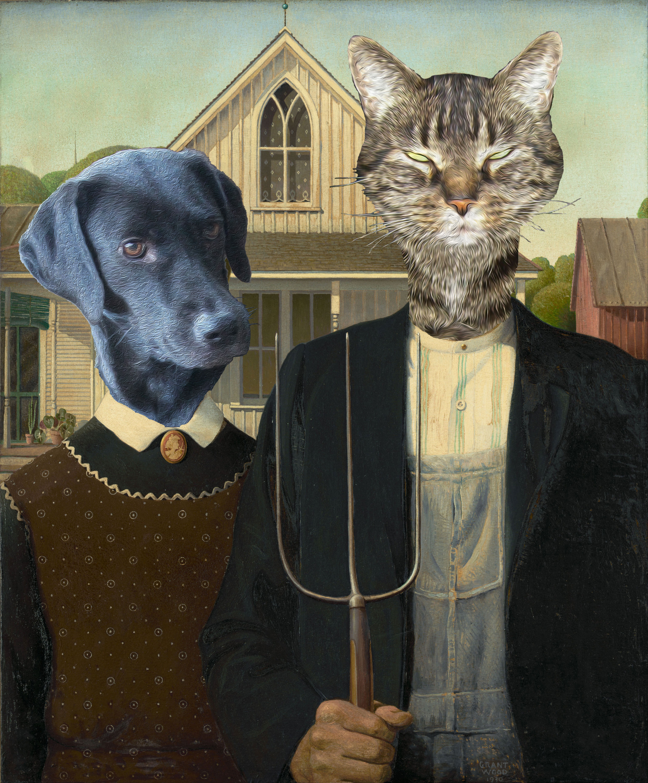
Figure 1: Sample mash-up using Grant Wood’s American Gothic painting and photos of pets.

Using the Cosmic Times Universe Mash-up Project, students will creatively connect with the science, history, and personalities behind our understanding of the expanding Universe. This project weaves together the artistic aspects of creating visual media with rigorous research and script-writing, giving students a better understanding of their topic while having a little fun.

General Lesson Information
The purpose of this lesson is to engage students in the big questions of our Universe through a media mash-up project-based lesson related to the Cosmic Times educational resources. The advantages of the lesson include engaging students, inspiring creativity, using media mash-up technology; acquiring knowledge through differentiated instruction; and presenting their knowledge, ideas and individual perspectives.

Estimated Class Time
3-7 class periods with home assignment component, as needed

Objectives
- Students will gain a general understanding of how our understanding of the Universe has changed over time through new discoveries made possible by the development of knowledge and technologies.
- Students will select a specific topic of interest to them that is related to the Cosmic Times materials and show evidence of their understanding of that topic through their completed projects.
- Students will create a video from various media that reflects their research and ideas.
- Students will share their projects with classmates.

National Education Standards
Science Standards  NS.9-12.1 Science as Inquiry  NS.9-12.4 Earth and Space Science  NS.9-12.5 Science and Technology  NS.9-12.7 History and Nature of Science | Social Studies (History)  NSS-WH.5-12 ERA 8: A Half-Century of Crisis and Achievement, 1900-145  NSS-WH.5-12 ERA 9: The 20th Century Since 1945: Promises and Paradoxes
Technology Standards  NT.K-12.1 Basic Operations and Concepts  NT.K-12.2 Social, Ethical and Human Issues  NT.K-12.3 Technology Productivity Tools  NT.K-12.4 Technology Communication Tools  NT.K-12.5 Technology Research Tools | Language Arts Standards  NL-ENG.K-12.1 Reading for Perspective  NL-ENG.K-12.3 Evaluation Strategies  NL-ENG.K-12.4 Communication Skills  NL-ENG.K-12.5 Communication Strategies  NL-ENG.K-12.7 Evaluating Data  NL-ENG.K-12.8 Developing Research Skills
Also meets the International Society for Technology in Education’s National Educational Technology Standards for Students 1a, 1b, 2a, 2b, 2d, 3a, 3b, 3c, 3d, 4a, 4b, 4c, 4d, 5b.

Outline
- Engagement
Students interact with the main concepts of the Cosmic Times materials in order to select a research topic.
- Exploration
Students do the pre-production work for their video projects. They use the Cosmic Times resources and the NASA library of videos, images, and sound clips to research their topics and select media. They may also use online databases and selected web sites. Students use their research to write a treatment script, create a storyboard, and a final script.
- Explanation
Students do the production and post-production of their video projects. Production may entail taking photos, creating voice-overs, and producing short clips of their own to use in their mash-up; though the main focus of this project is to use the provided existing media content. Finally, students stitch together their media to create their final video.
- Evaluation
Students fill out a self-evaluation of their project and receive teacher feedback.
- Extension
Students share their mash-ups with the class and provide feedback to classmates on their projects.

Background Information: Video Production
Video production has a well-established process, used by producers of the smallest and largest projects. This lesson plan offers resources to walk you and your students through this production process. Even though students will primarily be using existing video clips and media for their Universe Mash-up projects, they will need to follow the production process to create a project that is coherent with a clear message.

In this section you will find an outline of the overall process, so that you can keep an eye on the big picture as your students work on their Universe Mash-up projects.

Pre-Production
The pre-production steps represent the planning phases of video production. They are the steps that happen before the video camera is turned on, before voice-overs are recorded, and before video-editing software is opened up. Students will have a tendency to want to jump right in to production of the video projects, but the pre-production process is critical to creating a strong foundation for the final project. Be sure to give students plenty of time for pre-production and stress the importance of these steps.
- Project definition and research
The project needs to be defined before any production can begin. During this step, students chose a topic for their project, research that topic, and determine what resources (images, video clips and audio clips) are available to them related to that topic.
- Treatment script
A treatment script is essentially a detailed outline of what will go into the final video. Students should write a treatment script that describes the most important elements of the mash-up, including the supporting audio or video that will be used for each segment. The treatment script can be written as an outline or as a narrative, whatever is more comfortable for the student.
- Storyboard
A storyboard is a series of annotated illustrations created to visualize the sequence of images in a movie prior to production. A storyboard allows the student to refine and examine the overall video before putting a lot of time and effort into the production process.
- Final script
The final script takes the storyboard as a guide and then incorporates camera directions, existing clips to be used, voice-overs, and on-screen captions to give the final blueprint for the video project.
When the students are done with pre-production, they’ll be ready to start producing their video project. They should know what voice-overs to record, what videos clips to use, and what additional media they’ll need to create to finish their projects.

Production
The production stage is when audio and video pieces are created and graphics are designed. Students will know exactly what media they will need to create from their final script – anything they want that is not an existing clip or graphic will need to be created.
- Videography
Additional video footage may be required by the final script. The focus of the Universe Mash-up project is on using existing media, so encourage students to use as many available clips as possible. However, if they want additional video, a small point-and-shoot camera or even cellphone camera should do the trick. If your class has access to video equipment, use your own discretion to determine how you allow the students to use it.
- Graphics creation
Additional images or graphics may be created for the video mash-up. These can be created using presentation software and saving the slides as image files that can be read by video editing software. If students take photos to include in their projects, they will need to get the permission of any people in the photo and make a note to add a credit for those people at the end of their video.
- Voice-over recording
Voice-overs or on-screen captions will be key to pulling the video project together. Many computers have a microphone, which can be used, though it won’t produce the best-quality recording. Microphones can be purchased relatively cheaply for somewhat better audio recordings. The students should already have the script for their voice-overs, from their final script written during pre-production.
- Music
Video is often enhanced by music. Students may produce their own music or can find music tracks to use either as part of the video editing software or online. However, students will need to ensure that any music they use is not copyrighted.
At the end of the production phase, students will have all of the pieces to start assembling their video project.

Post-production
The post-production phase is when the video comes together as a final product. Students can finally open the video-editing software and put together all of the elements of their project into one video.

Many computers come with video editing software. However, if your school’s computers do not, ask your local system administrator for assistance in choosing software to use. A quick Internet search for “free video editing software” will turn up several options. As always, use caution when choosing software to download from the Internet – download from reputable sources and read user reviews to be sure you do not inadvertently install malware.
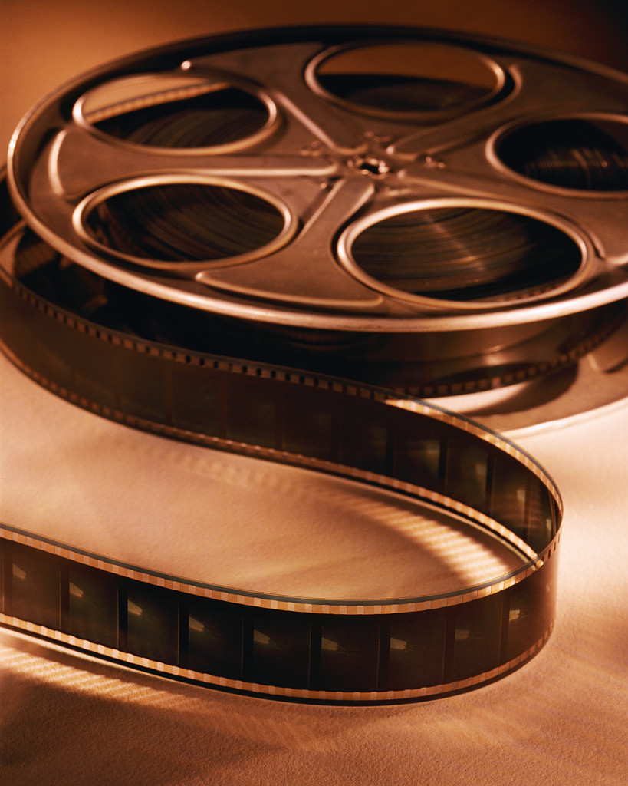
- Editing
Students may need to edit video clips and footage to remove unwanted portions. Then students should put the clips and images in the correct order.
- Add audio
The recorded voice-overs need to be placed into the final product, lined up appropriately to the video and graphics that they were meant to support.
- Transitions, titles, and music
Transitions help to bring the viewers attention from one video clip to the next. Titles are added to give the production a title, to identify speakers, to give further context to the images on the screen, and to provide credits at the end of the video. If students are using music, this should be added to enhance parts of the final video.
- Encoding
Once students are happy with their final product, the editing software will need to encode the movie, outputting a video that can be played on generic video players.
- Sharing
What good is a movie that no one can see? The movie should be shared with other members of the class, on a class website or wiki, or even with NASA for possible inclusion in a Universe Mash-up Student Gallery.

Engagement: Introduction

During the engagement, students will be given an overview of the project assignment and will be introduced to key Cosmic Times concepts. The ultimate goals of the engagement activities are for students to understand the mash-up project requirements, chose a topic for their projects, and form a project group.

Handouts used in the Engagement
- Cosmic Times Keyword Match Pre-test (page 20)
- KCLWM Chart (page 21)
- Cosmic Times Post Test (page 22)

Classroom Instruction

Pre-test
If your students do not have previous experience with the Cosmic Times materials, have them take the Keyword Match Pre-test. The results will help guide the amount of introduction and review you will need to do to prepare your students to work on their video mash-ups. (Pre-test answers: 1-H, 2-J, 3-F, 4-G, 5-B, 6-I, 7-D, 8-A, 9-C, 10-E)

KCLWM graphic organizer
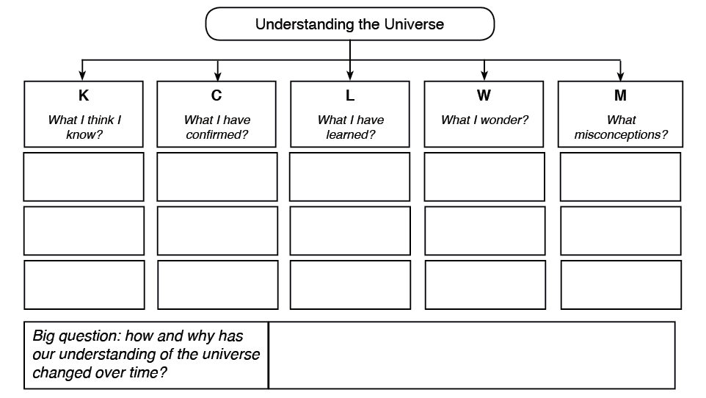
Figure 2: Sample KCLWM chart for Universe Mash-ups
A KCLWM chart is a graphical organizer that can be used to drive instruction and guide student learning. In this lesson plan, the KCLWM chart is used to help students choose a topic for their Universe Mash-up project. Students fill out different columns of the KCLWM chart as the Engagement progresses.

K is for what they KNOW about our understanding of the Universe. This should be used initially as a pre-assessment, though students can continue to fill out new items in this column as the lesson progresses.
C is for what a student has CONFIRMED about our understanding of the Universe. This will be filled out as the student watches/listens to the introductory presentation and as they proceed with their research.
L is for what a student has LEARNED about our understanding of the Universe. This will be filled out as the student watches/listens to the introductory presentation and as they proceed with their research.
W is for what a student WONDERS about our understanding of the Universe. Students fill this out at the end of the Engagement activities to help them come up with topics for their mash-up project.
M is for MISCONCEPTIONS students had about our understanding of the Universe. Students fill this out throughout the lesson if they discover something they thought was a misconception.

Hand out the KCLWM Chart to your students. Have them complete the “K” column, or “What I Know” column, of the chart, indicating what they already know about cosmology. Have students pair-share their answers.

Introductory presentation
Use the provided presentation to introduce Universe Mash-ups to your class and to guide them through a few of the basic ideas that have led us to our current understanding of the nature of the Universe.

Pause periodically to check for understanding by asking probing questions and to give students time to fill in the “C” and “L” columns of their KCLWM charts.

Video is available here:
- YouTube: http://youtu.be/28D3soOQb9c
- TeacherTube: http://www.teachertube.com/viewVideo.php?video_id=291282
- Download: http://go.nasa.gov/1a6vsnM

A sample Universe Mash-up video, From the Inside Out, is also available to view. It is formally included in the Exploration (where you can find viewing and downloading options), but you may want to show it to students now, if they aren’t clear about what they’ll be doing.

Additional introductory activities as required
The following activities can be used if your students need further introduction to the Cosmic Times materials and topics. The goal is for your students to choose a question or topic to research for their mash-up.
- Jigsaw Activity - Students work in teams to learn about how scientists have come to know what they do about the Universe using articles from the Cosmic Times posters. Activity instructions can be found on the Cosmic Times website: http://go.nasa.gov/1cYCCqo
- Gallery Walk - Students work in small groups, visiting each Cosmic Times poster to answer an open-ended question about the information on that poster. Activity instructions can be found on the Cosmic Times website: http://go.nasa.gov/1cYCtmP
- Four Corners – Students split into four groups to discuss possible topics for their Universe Mash-up projects. (Activity instructions follow.)

Assessment and Closure
Have students fill out the “W” column of their K-C-L-W-M chart to help them come up with big questions to research.

Optionally, have students take the Cosmic Times Post Test to assess if they have taken in the main ideas of the Cosmic Times posters. (Post-test answers: 1-D, 2-B, 3-D, 4-A, 5-C, 6-B, 7-D, 8-A, 9-B, 10-C)

At this time, students should choose a project group and research topic. The group size is largely up to the teacher, based on how well the students work in groups and the number of available computers. Ideally a group would be 2-3 students, since it can be difficult for larger groups to work together at a computer station. See “Additional Tips” below for topic suggestions for students who may be having trouble choosing.

Additional Information – Four Corners Activity
Four Corners is a cooperative teaching strategy used here to help students focus in on a topic for their Universe Mash-up project. This activity assumes the students already have some familiarity with the Cosmic Times materials and topics.

Preparation
Label the four corners of the room: Corner 1, Corner 2, Corner 3, and Corner 4

Procedure
- Pre-assessment
  - Write on the board:
When it comes to what I know about the Universe, I am an/a ____
EXPERT - Corner 1
AMATEUR - Corner 2
NOVICE - Corner 3
BEGINNER - Corner 4
  - Have students go to the corner they feel best describes them.
  - Students in each corner pair up and share what they know about the Universe. Students paraphrase what their partners said with their partner. Then each student shares with the corner group.
  - One spokesperson from each corner shares with the class.
- Narrow Topic for Universe Mash-up project
  - Write the following on the board:
I am most interested in doing a mash-up project about _________
SCIENTIFIC PROCESS - Corner 1
TECHNOLOGIES - Corner 2
BIOGRAPHIES - Corner 3
FUTURE ENDEAVORS - Corner 4
  - Have students go to the corner that matches their interest.
  - The students in each corner group pair up and share with their partner why they picked that particular corner. Students paraphrase what their partners said with their partner. Then each shares with the corner group.
  - One spokesperson from each corner group shares with the class.
  - Students then go back to their desk and write down one or two particular topics they want to focus on for their Universe Mash-up project.

Additional tips for the Engagement
- If you will be publishing the students’ work, make sure to obtain signed permission release forms. This may be a difficult task, so think of creative ways to get students to turn them in early. For example, you can make it a requirement that students turn this in before working on their projects, or you may give extra points to those who turn in their slips early.
- Discover where your students’ interests lie. Have students ask big questions and research those questions.
- Here are a few suggested topics for your students
  - Biographical reports on scientists
  - History of Nobel Prizes for astronomy work
  - Exploration of various telescopes, observatories and satellites
  - Stars
  - Galaxies
  - Big Bang
  - Supernovae
  - Measuring distances in astronomy
  - Black holes
  - Dark energy
  - Dark matter
  - Relativity
  - Expanding Universe

Exploration: Pre-production
During the exploration, students will complete the pre-production of their Universe Mash-up projects. They will research a topic, select media (still images, video and audio clips), write a treatment script, create a storyboard, and develop a final script.

Handouts used in the Engagement
- Universe Mash-up Project Overview and Planning (page 23-24)
- Universe Mash-up Grading Rubric (page 25-26)
- Treatment Script worksheet (page 27)
- Storyboard worksheet (page 28)

Classroom Instruction
Once your students have chosen a topic for their mash-up project, they will enter the pre-production phase of their project. The following instructional steps will walk your students through the pre-production phase of their Universe Mash-up projects.

Although students will want to rush into producing their projects, make sure they spend ample time on research, answering their big questions, taking notes and recording their citations.

Review
Begin by having students review their topics and their essential questions generated from the “W” (What I Wonder?) section of their charts. From this, they should have already picked a topic for their Universe Mash-up project.

Project background and grading
Hand out the Universe Mash-up Project Overview and Planning and the Universe Mash-up Grading Rubric to students. Use this opportunity to give students the big picture overview of the Universe Mash-up project. The Overview worksheet includes a checklist with due-dates, so you may want to use this time to also layout your expectations for these.

Sample Mash-up
Tell students that they will now begin pre-production of their projects. Hand out the Treatment Script worksheet. Then have them watch the sample video mash-up, From the Inside Out, using the worksheet to guide students’ understanding of the video. As students view the sample mash-up video, stop periodically to give students the opportunity to fill out the worksheet.

The video is available from the following links:
- YouTube: http://youtu.be/niowTgn-viQ
- TeacherTube: http://www.teachertube.com/viewVideo.php?video_id=291281
- Download: http://go.nasa.gov/14SaClv

After viewing the film, discuss the sample video and relate the discussion back to production process using their worksheets.

Treatment script
Using their worksheets as a starting point, students should begin research on their topic, filling in the second part of the Treatment Script worksheet to help formulate a plan for their projects.

Introduce students to the resources in the Universe Mash-up media archive and lists of related links.
- Cosmic Times Media Archive: http://go.nasa.gov/1hK15Cy
- Cosmology Research Resources: http://go.nasa.gov/1hK195a
- Technology Resources: http://go.nasa.gov/1hK19SN
- Cosmic Times-Related Press: http://go.nasa.gov/1hK1aGd

Emphasize the importance of recording their sources for each part of their research. They need to know where the images and videos they plan to use are located so they can download them when the time comes for video production. They will also need to keep track of credits for the media that they use, so they give proper citations for the works they use. Make it clear to students that if media has a copyright, they will need to ask permission from the copyright owner to use it. Most of NASA’s media is copyright free, but it will still require a credit.

Storyboard
Once students have their treatment scripts written, they should start to plan out the visual flow of their videos. Hand out the Storyboard worksheet, and have students fill it out, showing the main segments of their final project in the flow of the storyboard. Students may continue research during this phase to ensure they have the visuals they need to tell the story they want to tell.

Final script
Students next take their storyboard and turn it into a final script. This should include the text for any voice-overs they’d like to include (or text they will put on the screen in place of voice-overs).

Additional tips for the Exploration (Pre-production)
- Finding resources
  - Students should use mainly the Cosmic Times and NASA resources.
  - The Hotlists will help students to navigate the Cosmic Times resources.
  - The Keyword Cloud (http://go.nasa.gov/1a6xuUN) is especially helpful to students in locating information on their topics. Clicking on a word in the Keyword Cloud takes you to all of the related resources on that topic. Students will find images, videos and audio clips in the Cosmic Times Media Archive.
- Instruction
  - Using the rubric, begin with the end in mind. Set up expectations for the student’s projects early on, so they know exactly how they will be graded.
  - Encourage students to clearly understand their topic so they are able to find their voice and tell their piece of the Universe story creatively.
  - Work with students using the planning sheets so they follow each step.
  - Encourage students to start off with a strong beginning by opening with an interesting title and to personalize credits.
  - It may be nice to help students understand a few media production techniques, for example: a wide or long shot (establishment shot) medium shot (interactions) and a close up (shows emotions).
  - Students may use transitions, sound effects etc. to help tell the story.
  - If you are using the Extension of this lesson and sharing the videos, students should return their permission slips for publishing their projects before moving on to the Explanation and production.
  - If your students need additional help, they might find the Universe Mash-up Hints and How-to handout helpful; it was written by Faith Tucker who made the From the Inside Out example Universe Mash-up. Available here: http://go.nasa.gov/14SbuGx (PDF download)

Explanation: Video Production and Post-Production
During the explanation, students are involved in producing their video projects. They will use their final script as a guide to determine what media they already have on hand (from the Universe Mash-up Media Archive, for example), and what pieces they’ll need to create (such as voice-overs and transition titles) – this is the production phase of the project. Once all of the pieces have been gathered, post-production begins and students assemble their final video mash-up projects.

Handout used in the Explanation
- Universe Mash-up Production Checklist (pages 29-30)

Classroom Instruction
With a final script and storyboard in hand, students are ready to produce their media mash-ups.

Production Checklist
Hand out the Universe Mash-up Production Checklist worksheets to students and have them fill out the descriptions for all the video clips, audio clips, voice-overs, and images that they will need to assemble their final video.

Production
Students should download the media they want to use for their projects. They should also begin production of additional media, checking items off their checklists as they go.

Describe the technologies and/or online tools that you and your students will be using and the guidelines that will be established for managing their use.

Post-Production
With all of their media in hand, students can now assemble their final projects.

As noted in the lesson introduction, most computers now come with video editing software (for example, iMovie is pre-installed on Macs and Movie Maker is available as a free download for Windows). However, if your school’s computers do not have such software readily available, contact your local system administrator for assistance in choosing software to use.

Final project
When students feel their project is finished, they should output the video into a file format that can be shared with others (such as .mov or .mp4). If you are planning to share student projects via a class blog or wiki or through an online video-sharing site, make sure you know what file formats can be used by the publishing platform.

Additional tips for the Explanation (Production and post-production)
- Presentation software can often be used to output videos of the slide shows, so this might be a good option if your class does not have access to video-editing software.
- Again, if your students need additional help, they might find the Universe Mash-up Hints and How-to handout helpful; it was written by Faith Tucker who made the From the Inside Out example Universe Mash-up. Available here: http://go.nasa.gov/14SbuGx (PDF download)

Evaluation
During the Evaluation, students evaluate their own projects based on the grading rubric distributed during the Engagement. Students also receive final scores.

Handout used in the Evaluation
- Universe Mash-up Self-Evaluation (page 31)

Classroom Instruction
With the projects finalized, students are ready to evaluate their work and receive evaluations from their teacher.

Self Evaluation
Hand out the Self-Evaluation worksheet to students and have them fill out the score they believe they deserve, based on the Universe Mash-up Grading Rubric.

Final grades
Grade the student projects using the Grading Rubric. Respond to the student’s self evaluation to show where you agree with their assessment and where they may have missed the mark. Make your comments constructive so students see how they could have improved their project if they were given a chance to revise it.

Extension: Sharing the Mash-ups
During the Extension, students share their Universe Mash-up projects. After all, what good is a video project if others don’t get to see it?

Classroom Instruction
How students share their videos is largely up to you. However, if you are sharing them on a publicly accessible site, you will need to obtain parental permission to post student works.

A class blog or wiki would be a natural place to post the student projects. If you don’t already have a place to share work online with your students, check with your school to see what tools it has access to such tools. Alternatively, you could simply play the videos for the whole class or make the videos available on an in-class computer.

Optionally, you can ask students to give feedback on their classmate’s projects. You may want to guide the feedback, asking students to leave one comment that describes something they really liked about each project and a second comment that describes something that confused them about each project. If you have time, or as extra credit, you can invite students to revise their projects (or simply submit a final script reflecting how they would revise their projects) based on the class feedback.

Resources

Resources for Student Projects
- Cosmic Times: http://cosmictimes.gsfc.nasa.gov
- Cosmic Times Media Archive: http://go.nasa.gov/1hK15Cy
- Cosmology Research Resources: http://go.nasa.gov/1hK195a
- Technology Resources: http://go.nasa.gov/1hK19SN
- Cosmic Times-Related Press: http://go.nasa.gov/1hK1aGd

Background on Mash-ups in the Classroom
The Art, Skill, Craft, and Magic of Digital Storytelling: A How-Come, How-To Guide, 2008 Edition
http://dsi.kqed.org/images/uploads/KQED_DStoryManual_Ch3_08.pdf (PDF download)

Berry, P. (2009, spring). Improving student projects with photo story. TechEdge, 28(3), 10-11.

Lamb, B. (2007). Dr. Mashup or, Why Educators Should Learn to Stop Worrying and Love the Remix. Educause Review, 42(4), 12-24. Retrieved from EBSCOhost.
http://www.educause.edu/ero/article/dr-mashup-or-why-educators-should-learn-stop-worrying-and-love-remix

Media Mash Up: Public Libraries, Youth and 21st Century Literacy
http://www.hclib.org/extranet/MediaMashup/mediamashup_narrative.pdf (PDF download)

Place-Based Digital Storytelling Modules
http://www.pbs.org/nationalparks/for-educators/digital-storytelling/

Science 360 - The knowledge network
http://science360.gov

Cosmic Times Keyword Match Pre-test
Match the keywords and phrases in the left column with their definitions in the right column.

1. ___ Einstein’s General Theory of Relativity | A. A shift in the observed spectrum of an object due to its motion
2. ___ Dark energy | B. Stars that light up suddenly to great brightness and then fade away
3. ___ Cosmic microwave background | C. Rapid expansion of the Universe after the Big Bang
4. ___ John Mather | D. Galaxies which are farther away are moving away faster
5. ___ Supernovae | E. Matter whose existence is known only through its gravitational pull on other matter
6. ___ Big bang | F. The light from the early Universe
7. ___ Hubble’s Law | G. COBE satellite
8. ___ Red shift | H. Explains how gravity works
9. ___ Inflation | I. Leading theory of the origin of the Universe
10. ___ Dark matter | J. Hypothesized form of energy that causes the expansion of the Universe to speed up

KCLWM Chart
Fill out this chart as your teacher instructs. Use additional sheets as necessary.
K
What I think I know
C
What I confirmed
L
What I have learned
W
What I wonder
M
What misconceptions
Big Question
How and why has our understanding of the Universe changed over time?
Understanding the Universe

Cosmic Times Post-test
Circle the correct answer.

- What immediately followed the Big Bang?
  - Microwave Radiation
  - Dark Energy
  - Dark Matter
  - Inflation
- What phenomenon is used to measure the expansion of the Universe?
  - Gravity
  - Redshift
  - Inflation
  - Blueshift
- The theory of relativity explains:
  - Space & Time
  - Gravity
  - Energy & Mass
  - All of the above
- Which of the following defines “cosmic microwave background”?
  - radiation left over by the Big Bang
  - rapid expansion of the Universe
  - a form of matter
  - none of the above
- Who first mapped the cosmic microwave background?
  - Penzias & Wilson
  - Albert Einstein
  - John Mather
  - Alan Guth
- Who originated the inflationary Universe theory?
  - Vera Rubens
  - Alan Guth
  - Penzias & Wilson
  - John Mather
- Who was Albert Einstein?
  - Chemist
  - Anthropologist
  - Astronomer
  - Theoretical Physicist
- What is the difference between dark energy and dark matter?
  - One is a hypothesized form of energy, the other is matter detected by its effect on other matter.
  - One is a theory of gravity, the other a theory of energy
  - One is a light source, the other radiation.
  - There is no difference
- What do we call stars that get very bright suddenly, then fade away?
  - Red Dwarfs
  - Blue Giants
  - Neutron Stars
  - Supernovae
- In what year of the 6 Cosmic Times Posters was the Big Bang first mentioned?
  - 1919
  - 1929
  - 1955
  - 1965
  - 1993
  - 2006

Universe Mash-up Project Overview and Planning
You will be creating a media mash-up project about how we understand our Universe using NASA’s Cosmic Times for inspiration. You’ll be using existing video clips, audio clips, and images from the Universe Mash-up media archive to explore an aspect of the Cosmic Times materials.

This worksheet gives an overview of the video production process and includes a checklist for your project to help you keep on track. Your teacher will give you additional resources as you work your way through the production process.

Video production process
There are three main phases to making a video: pre-production, production and post-production.
Phase 1: Pre-Production
Pre-production is the planning phase of the project. These steps happen before the camera is turned on or the video-editing software is fired up. The steps should be followed in order.
Choose a topic

Research the topic

Write a treatment script – outline the main points and flow

Sketch out a storyboard – a visual flow of the scenes

Write the final script

Phase 2: Production
Production is the process of creating all pieces of the final video. These steps can happen in any order.
Produce video footage

Create graphics such as images, photos, or slides

Record voice-overs as required by the final script

Choose music for the background as appropriate

Project checklist and due dates
Phase 3: Post-Production
In post-production, the final video comes together.

Edit video clips and footage and place the clips in order

Encode video and output in a format that others can view

Add audio tracks to the video

Insert transitions, titles and music to the final video

Share your video with your class, friends, family, and the world!

Due date Done?
_______ _____ Pick topic and develop essential question
_______ _____ Research (take notes, record citations, find media)
_______ _____ Write treatment script
_______ _____ Make storyboard
_______ _____ Write final script
_______ _____ Download media to use
_______ _____ Produce additional footage and graphics, if needed
_______ _____ Record narration
_______ _____ Create title, credits graphics
_______ _____ Insert all pieces into presentation software and edit
_______ _____ Score project using rubric and score sheet
_______ _____ Turn in to instructor

Guidelines for video
- Your final video should be 3-5 minutes long and should be accurate and engaging, using the part of the Cosmic Times story that most interests you.
- You will be graded using the Universe Mash-up Project Grading Rubric.
- Make sure the images, videos, and audio you select help tell your story, and make sure to give proper credit for all of the media you use.
- Use only copyright-free materials; if you want to use media that has a copyright, you will need to get permission to use it from the person who holds the copyright.
- Stay with visuals as long as it is interesting – too short a time will make your video seem choppy, while too long will make it drag.
- Make sure your story flows with transitions between different visuals and narration connecting different ideas.
- Speak with a strong, clear voice when narrating.

Universe Mash-up Grading Rubric

Category | 4 points | 3 points | 2 points | 1 point | Score
Content | - Covers topic in-depth with a strong central idea  - Subject knowledge is excellent  - Uses at least 5 facts and 5 details or examples  - Uses MLA bibliography and credits | - Covers topic with a central idea  - Subject knowledge is good  - Uses at least 4 facts and 4 details or examples  - Uses MLA bibliography and credits | - Covers essential information about topic  - Contains 1-2 factual errors  - Uses at least 3 facts and 3 details or examples  - Uses MLA bibliography and credits | - Content is minimal  - Contains several factual errors  - Uses at least 2 facts and 2 details or examples  - Missing MLA bibliography or credits
Creativity | - Product shows a large amount of original thought  - Ideas are creative and inventive  - Uses 3 or more original ideas based on research that helps others under- stand the topic | - Product shows some original thought  - Uses at least 2 ideas that are expressed uniquely that can benefit others | - Product uses other people’s ideas (giving credit), but little evidence of original thought  - Uses at least 1 idea that is expressed uniquely that can benefit others | - Uses other people’s ideas, but does not give them credit  - Does express any ideas uniquely in a way that can benefit others
Pre-production | - Treatment script shows strong evidence of high-level research and detailed planning  - Storyboard has at least 10 detailed thumbnail sketches  - Final script shows a logical sequence, good pacing, interesting dialogue and effects | - Treatment script shows evidence of research and planning  - Storyboard contains at least 8 thumbnail sketches  - Final script shows flow of ideas, pacing, dialogue and effects | - Treatment script shows some evidence of research and planning  - Storyboard contains at least 5 thumbnail sketches  - Final script does not flow well between ideas, dialogue and effects | - Treatment script shows little evidence of research and planning  - Storyboard contains fewer than 5 thumbnail sketches  - Final script is incomplete
Production | - Production techniques demonstrate outstanding technical skills  - Clarity of video and audio throughout the video  - Uses at least: 10 images, 8 digital effects, one video clip and/or audio clip, and 5 voice-overs  - If using text: no more than 8 words per scene, allows time to read, and text is easy to read.  - Includes credits and does not use copyrighted resources | - Production techniques demonstrate technical skills  - Clarity of video and audio is achieved  - Uses at least: 8 images, 6 digital effects, and 3 voice-overs  - If using text: no more than 12 words per scene, allows time to read, and text easy to read  - Includes credits and does not use copyrighted resources | - Production techniques demonstrate beginner level skills  - Clarity of video and audio is evident  - Uses at least: 5 images and 1 voice-over  - If using text: uses too many words per scene, does not allow time to read, or text is hard to read  - Includes credits and does not use copyrighted resources | - Production skills are not evident  - Ideas do not flow  - Clarity of video and audio is not achieved  - Uses fewer than 5 images and no voice-over  - If using text: uses too many words per scene, does not allow time to read, and text is hard to read  - Does not include credits and/or uses copyrighted resources
Organization | - Content is well organized by grouping related ideas and using correct sequence  - An overall unity and coherence producing a connected flow of content is established | - Content is organized by grouping related ideas and using sequence  - There is unity and coherence | - Content is logically organized for the most part | - There was no clear or logical organizational structure, just lots of facts
Overall effectiveness | - Strong message is conveyed  - Video covers topic accurately, clearly, and in depth  - Highly engages and impacts the audience | - A central message is conveyed  - Video covers topic accurately and clearly  - Video engages and impacts the audience | - A central theme is present  - Video covers topic with some engagement and impact | - Video is scattered and confusing with no central message evident  - Video is not engaging

Treatment Script

A treatment script is an outline of the main elements of a video or how you treat the video. You may think of the treatment script as the guide of what you will create.
- Watch the Universe Mash-up example, From the Inside Out. Put yourself in the place of the creator of the video and answer the following questions to better understand the video’s main elements. These main elements would be the treatment script.
    - What’s the theme or central message?
    - Who is the audience?
    - What’s the purpose of the video?
    - What’s the desired outcome – what do you want the viewer to do, think or feel?
    - What style has been successful with this particular audience in the past?
    - What’s new or different about this subject?
    - What’s the budget for the production?
    - How long will the finished video be?
- Think about the project you want to create and then answer those same questions. Use your answers as guidelines as you write your treatment script for your Universe Mash-up.

Storyboard
A storyboard is a visual outline of a video. Essentially it is a blueprint for your video so that you know each clip that you’ll use and any additional media you’ll need to produce to make your final project.

Fill in the following template for your storyboard – use additional pages as necessary. For all clips and images, record where to find them and how the credit for using the image should appear under “Source.” If you need to create the video or image, put “original” under the Source.
Shot 1:

Audio:

Source:
Shot 2:

Audio:

Source:

Shot 3:

Audio:

Source:

Shot 4:

Audio:

Source:
Shot 5:

Audio:

Source:

Shot 6:

Audio:

Source:

Universe Mash-up Production Checklist
You will need to take an inventory of the media you will need for your mash-up. Look through your final script and identify all the elements – video clips, audio clips and images. Fill out the lists below. Only when you have all the pieces assembled can you move on to the post-production phase of your project.

Video Clips
Pre-made clips |  |  | Original clips (need to be filmed)
Downloaded? | Title or description |  | Produced? | Title or description

Audio Clips or Voice-Overs
Pre-made clips |  |  | Original clips (need to be recorded)
Downloaded? | Title or description |  | Produced? | Title or description

Universe Mash-up Production Checklist (page 2)

Images
Pre-made images |  |  | Original images (need to be made)
Downloaded? | Title or description |  | Produced? | Title or description

Universe Mash-up Self Evaluation
Use the Universe Mash-up Grading rubric to determine the score you believe your project has earned. List the evidence to justify your score.

My Cosmic Times Media Mash-up deserves a score of: ________________

Justification
My project’s Content deserves ______ points, because:
My project’s Creativity deserves ______ points, because:
My project’s Pre-production deserves ______ points, because:
My project’s Production deserves ______ points, because:
My project’s Organization deserves ______ points, because:
My project’s Overall effectiveness deserves ______ points, because:

Teacher’s comments

