X-ray Spectroscopy and
the Chemistry of Supernova Remnants
A Series of Lesson Plans by
Allie Hajian and Maggie Masetti (NASA/GSFC, Greenbelt, MD)
Rick Fowler (Crossland High School, Temple Hills, Maryland)
Angela Page (Hyattsville Elementary School, Hyattsville, Maryland)

Objectives
Students will read and write about the chemistry and spectroscopy of stars and supernova remnants, as well as understand their relevance and impact on human life. Students will also learn about cutting edge technology that will help us to build better instruments with which to study the Universe.

Each section has several pages of background material relevant to the associated activities and the lesson plan as a whole. The background sections include short exercises or thought questions developed to help the student reach a better understanding of the material presented. Each section also has activities developed by real teachers - designed to bring important concepts in astronomy right into the classroom. Each activity is correlated to national science and math standards for grades 9 - 12. These activities show how interrelated chemistry, physics, and astronomy really are.

Outline of Unit

Part I: How and Where are Elements Created?
- Background: The Life Cycles of Stars: How Supernovae Are Formed – Describes the life of a high-mass star - as well as its death in a giant supernova explosion.
- Background: The Dispersion of Elements – Describes how supernova explosions not only disperse the elements created inside a star, they create new elements.
- Activity: Fusion Reactions – In this activity, each student is given a card with an element produced inside stars on it - the students then form fusion reactions that occur within stars.

Part II: What is Electromagnetic (EM) Radiation? How is it created in atoms? What units are used to characterize EM radiation?
- Background: How Do the Properties of Light Help Us to Study Supernovae and Their Remnants? – Students learn about the electromagnetic spectrum.
- Activity: Calculation Investigation – Students learn about unit analysis by converting energies to wavelengths to frequencies.
- Background: Atoms and Light Energy – Describes how atoms emit light, and how we can use this to learn about astronomical objects.
- Activity: Calculate the Energy! – Students will calculate the energy differences in different energy states of the Bohr atom of Hydrogen.

Part III: What tools are used to identify elements? What importance do X-rays have to astronomy?
- Background: Introduction to Spectroscopy – Everything you ever wanted to know about spectroscopy but were afraid to ask!
- Activity: Graphing Spectra – Practice drawing graphs of spectra, and understanding the different ways spectra can be represented, as well as what each representation can tell us.
- Activity: Flame Test – A chemistry experiment that shows how heated elements emit different colors of light.
- Activity: Design an Element Poster Advertisement – Students will discuss what they have learned about atoms and elements in their own words, designing a poster advertisement for their chosen element. Students will use more than just their right brain to think about science!

Part IV: How does the newest technology help us to understand the Universe?
- Background: All About The Microcalorimeter – All about microcalorimeter technology, the next generation X-ray spectrometer.
- Activity: Identifying Light Energy by Temperature Changes – Learn first hand how a microcalorimeter really works
- Activity: Identifying Elements in Supernova Remnants using Spectra – Now the students get to take all they have learned and really apply it. Students will identify the elements present in a supernova remnant by analyzing its spectrum.
- Background: A Plethora of X-ray Telescopes – Learn about existing and future X-ray telescopes and what they hope to accomplish.
- Activity: Satellite Venn Diagram – Students will organize the information about X-ray observatories into a Venn diagram.
- Activity: Writing Assignment – As a closing activity, students will demonstrate the ability to use text information and data to persuade a reading audience of the benefits of using calorimeter detectors to do X-ray astronomy.

Part I: How and Where are Elements Created?

The Life Cycles of Stars: How Supernovae Are Formed
It is very poetic to say that we are made from the dust of the stars. Amazingly, it's also true! Much of our bodies, and our planet, are made of elements that were created in the explosions of massive stars. Let's examine exactly how this can be.

Life Cycles of Stars
A star's life cycle is determined by its mass. The larger its mass, the shorter its life cycle. A star's mass is determined by the amount of matter that is available in its nebula, the giant cloud of gas and dust from which it was born. Over time, the hydrogen gas in the nebula is pulled together by gravity and it begins to spin. As the gas spins faster, it heats up and becomes as a protostar. Eventually the temperature reaches 15,000,000 degrees and nuclear fusion occurs in the cloud's core. The cloud begins to glow brightly, contracts a little, and becomes stable. It is now a main sequence star and will remain in this stage, shining for millions to billions of years to come. This is the stage our Sun is at right now.

As the main sequence star glows, hydrogen in its core is converted into helium by nuclear fusion. When the hydrogen supply in the core begins to run out, and the star is no longer generating heat by nuclear fusion, the core becomes unstable and contracts. The outer shell of the star, which is still mostly hydrogen, starts to expand. As it expands, it cools and glows red. The star has now reached the red giant phase. It is red because it is cooler than it was in the main sequence star stage and it is a giant because the outer shell has expanded outward. In the core of the red giant, helium fuses into carbon. All stars evolve the same way up to the red giant phase. The amount of mass a star has determines which of the following life cycle paths it will take from there.
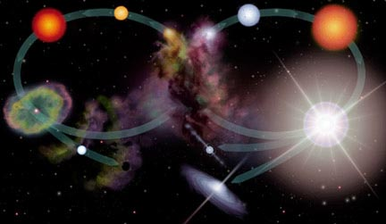
The life cycle of a low mass star (left oval) and a high mass star (right oval).

The illustration above compares the different evolutionary paths low-mass stars (like our Sun) and high-mass stars take after the red giant phase. For low-mass stars (left hand side), after the helium has fused into carbon, the core collapses again. As the core collapses, the outer layers of the star are expelled. The outer layers form a planetary nebula. The core remains as a white dwarf and eventually cools to become a black dwarf.

On the right of the illustration is the life cycle of a massive star (10 times or more the size of our Sun). Like low-mass stars, high-mass stars are born in nebulae and evolve and live in the Main Sequence. However, their life cycles start to differ after the red giant phase. A massive star will undergo a supernova explosion. If the remnant of the explosion is 1.4 to about 3 times as massive as our Sun, it will become a neutron star. The core of a massive star that has more than roughly 3 times the mass of our Sun after the explosion will do something quite different. The force of gravity overcomes the nuclear forces that keep protons and neutrons from combining. The core is thus swallowed by its own gravity. It has now become a black hole that readily attracts any matter and energy that comes near it. What happens between the red giant phase and the supernova explosion is described below.

From Red Giant to Supernova: The Evolutionary Path of High Mass Stars
Once stars that are 5 times or more massive than our Sun reach the red giant phase, their core temperature increases as carbon atoms are formed from the fusion of helium atoms. Gravity continues to pull carbon atoms together as the temperature increases and additional fusion processes proceed, forming oxygen, nitrogen, and eventually iron.
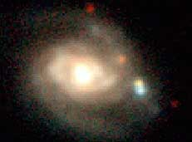
The two supernovae, one reddish yellow and one blue, form a close pair just below the image center (to the right of the galaxy nucleus)
Image Credit: C. Hergenrother, Whipple Observatory, P. Garnavich, P.Berlind, R.Kirshner (CFA).

When the core contains essentially just iron, fusion in the core ceases. This is because iron is the most compact and stable of all the elements. It takes more energy to break up the iron nucleus than that of any other element. Creating heavier elements through fusing of iron thus requires an input of energy rather than the release of energy. Since energy is no longer being radiated from the core, in less than a second, the star begins the final phase of gravitational collapse. The core temperature rises to over 100 billion degrees as the iron atoms are crushed together. The repulsive force between the nuclei overcomes the force of gravity, and the core recoils out from the heart of the star in a shock wave, which we see as a supernova explosion.

As the shock encounters material in the star's outer layers, the material is heated, fusing to form new elements and radioactive isotopes. While many of the more common elements are made through nuclear fusion in the cores of stars, it takes the unstable conditions of the supernova explosion to form many of the heavier elements. The shock wave propels this material out into space. The material that is exploded away from the star is now known as a supernova remnant.

The hot material, the radioactive isotopes, as well as the leftover core of the exploded star, produce X-rays and gamma rays.

For the Student
Using the above background information, (and additional sources of information from the library or the web), make your own diagram of the life cycle of a high-mass star.

For the Student
Using the text, and any external printed references, define the following terms: protostar, life cycle, main sequence star, red giant, white dwarf, black dwarf, supernova, neutron star, pulsar, black hole, fusion, element, isotope, X-ray, gamma-ray.

Reference URLs:

Supernovae
http://imagine.gsfc.nasa.gov/docs/science/know_l1/supernovae.html
http://imagine.gsfc.nasa.gov/docs/science/know_l2/supernovae.html

Life Cycles of Stars
http://imagine.gsfc.nasa.gov/docs/teachers/lifecycles/stars.html

The Dispersion of Elements
In addition to making elements, supernovae scatter them. The elements that are made both inside the star as well as the ones created in the intense heat of the supernova explosion are spread out in to the interstellar medium. These are the elements that make up stars, planets and everything on Earth – including us. Except for hydrogen and some helium created in the Big Bang, all of the stuff we, and the Earth around us, are made of, was generated in stars, through sustained fusion or in supernova explosions.

Enrichment of the Space Between the Stars
The most common elements, like carbon and nitrogen, are created in the cores of most stars, fused from lighter elements like hydrogen and helium. The heaviest elements, like iron, however, are only formed in the massive stars that end their lives in supernova explosions. Still other elements are born in the extreme conditions of the explosion itself. Without supernovae, life would not be possible. Our blood has iron in the hemoglobin, which is vital to our ability to breath. We need oxygen in our atmosphere to breathe. Nitrogen enriches our planet's soil. Earth itself would be a very different place without the elements created in stars and supernova explosions.

How do the elements that are released in the wake of a supernova explosion end up in the make-up of a planet like Earth? Though we normally think of space of being empty, it actually isn't. It might seem empty since the average particle density of interstellar space is around 1 atom per cubic centimeter, but there are some 1037 tons of this thin matter in our Galaxy alone! We call the matter that fills the space between the stars the "interstellar medium" or ISM.
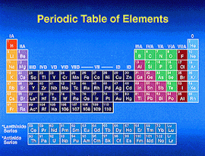
The Periodic Table of the Elements

Supernovae change the chemical composition of the ISM, by adding elements that were not present before, or were only present in trace amounts. Though these explosions only occur a few times a century in our Galaxy, they are responsible for the synthesis of all the elements heavier than iron, including many we come across in daily life, like copper, mercury, gold, iodine and lead. Most of the elements that are produced in supernovae have small cosmic abundances and very few have been directly detected in the interstellar medium. The ISM is also enriched in other ways, by stars losing mass due to the solar wind for example, but supernovae are the main means in which it becomes enriched with heavier elements.

The gradual enrichment of the interstellar medium with heavier elements has made subtle changes to how stars burn: the fusion process in our own Sun is moderated by the presence of carbon. The first stars in the Universe had much less carbon and their lives were somewhat different from modern stars. Stars that will be formed in the future will have even more of these heavier elements and will have somewhat different life cycles. Supernovae play a very important part in this chemical evolution of the Universe.

Chaos and Structure
The chaos caused by supernovae, like the one that created the Crab Nebula (shown at left), is also responsible for the complex structure of the ISM. A supernova creates shock waves through the interstellar medium, compressing the material there, heating it up to millions of degrees. Astronomers believe that these shock waves are vital to the process of star formation, causing large clouds of gas to collapse and form new stars. No supernovae, no new stars.
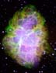
The Crab Nebula

What is the time scale? In tens of thousands of years after the initial explosion, a supernova remnant may grow to 100 light years in diameter. A few hundreds of thousands of years after the explosion, the ejecta will eventually mix in with the general interstellar medium. The supernova has thus enriched the interstellar medium with heavy elements across a sphere a thousand light years across or so. This means that millions or even billions of years may elapse between the supernova explosion that creates an atom of gold, for example, and the formation of the solar system where the atom eventually ends up. That's a long time! In this amount of time, a star can circle the Galaxy several times - and two stars that started off being next to each other may have ended up on the opposite side of the Galaxy!
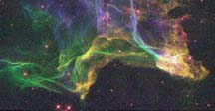
The Cygnus Loop
Credit: J. Hester (ASU), NASA
It is impossible to speculate which specific supernovae created the heavy elements that ended up in a specific solar system; the heavy elements that are in your body and in objects around you, are the products of many different supernovae over many millions of years all over the Galaxy. Over many millions of years, the interstellar medium is continuously enriched by thousands of supernovae. That makes it all the more amazing when one tiny corner of the interstellar medium becomes dense enough, and a solar system is formed.

Reference URLs:

Supernovae
http://imagine.gsfc.nasa.gov/docs/science/know_l1/supernovae.html

For the Student
Using the text, and any external printed references, define the following terms: supernova remnant, interstellar medium, light year.

http://imagine.gsfc.nasa.gov/docs/science/know_l2/supernovae.html

Life Cycles of Stars
http://imagine.gsfc.nasa.gov/docs/teachers/lifecycles/stars.htm

Element Production in the Universe
http://zebu.uoregon.edu/disted/ph123/l10.html
http://aether.lbl.gov/www/tour/elements/stellar/stellar_a.html

Activity – Fusion Reactions

Days Needed: 1-2
Grade Level : 11 - 12

Objective
Students will learn about the elements created in the cores of high-mass stars in this activity.

Science and Math Standards
NSES
- Content Standard B:
  - Structure of Atoms
  - Interactions of energy and matter
- Content Standard G:
  - Nature of Scientific Knowledge

Pre-requisites
- Students should be familiar with basic chemistry.
- Students should also have read the background sections on the Life Cycles of the Stars and the Dispersion of Elements.

Introduction
Elements are produced in the cores of high-mass stars by fusion reactions. All stars start by burning hydrogen and end up creating many heavier elements inside their cores. It is this kind of star that will eventually spread the elements it created in its core when it dies in a supernova explosion.

Engagement
Using colored clay, either home-made or store-bought, make a model of the core of a star. If time allows, the class can do this themselves, otherwise, the teacher can demonstrate it for the class.

Materials:
- 8 colors of clay, either home-made or store-bought (see recipe for home-made clay here: http://amazingmoms.com/htm/artclayrecipes.htm)
- ball-bearing or other small metallic ball (large silver beads would work)
- plastic knife

Procedure:
Cover the ball-bearing or bead with one color of clay - make the layer of clay at least half an inch thick. Use another color of clay to make a layer over the first. Do this until you have 8 layers of clay, each a different color, each at least half an inch thick. Now, cut the ball in half to make a cross section (you'll have to cut around the ball-bearing). The inside shows the different layers present in the core of a high-mass star. Each of those layers of clay belongs to a different element. The ball-bearing is the iron core of the star. At the end of the day's activity, the class will come back to the model and learn what the different layers are.

Exploration

Materials:
Index cards with elements written on them. You'll need
- 4 hydrogen-1 (¹H)
- 13 helium-4 (⁴He)
- 4 carbon-12 (¹²C)
- 1 magnesium-24 (²⁴Mg)
- 4 oxygen-16 (¹⁶O)
- 1 sulphur-32 (³²S)
- 1 neon-20 (²⁰Ne)
- 1 silicon-28 (²⁸Si)
- 2 nickel-56 (⁵⁶Ni)
- 2 cobalt-56 (⁵⁶Co)
- 2 iron-56 (⁵⁶Fe)
- 2 iron-57 (⁵⁷Fe)
- 2 iron-58 (⁵⁸Fe)
- 1 iron-59 (⁵⁹Fe)
- 3 neutrons (n)
- 4 positrons (e+)
- 2 neutrinos
- at least 7 energy

Procedure:
Give each student an index card with an element written on it. Have the students move about the classroom and construct fusion reactions. Their goal is to form the reactions that create helium, carbon, magnesium, oxygen, sulphur, neon, nickel, cobalt, and 4 different isotopes of iron. The teacher should assist or give hints as necessary.

The students should end up with the following fusion relationships:

4 (¹H)  ⁴He + 2 e⁺ + 2 neutrinos + energy
3 (⁴He)  ¹²C + energy
¹²C + ¹²C  ²⁴Mg + energy
¹²C + ⁴He  ¹⁶O + energy
¹⁶O + ¹⁶O  ³²S + energy
¹⁶O + ⁴He  ²⁰Ne +energy
²⁸Si + 7(⁴He)  ⁵⁶Ni + energy
⁵⁶Ni  ⁵⁶Co + e⁺ (positive Beta Decay)
⁵⁶Co  ⁵⁶Fe + e⁺ (positive Beta Decay)
⁵⁶Fe + n  ⁵⁷Fe
⁵⁷Fe + n  ⁵⁸Fe
⁵⁸Fe + n  ⁵⁹Fe

When the students create a correct reaction, write it on the board – keep the reactions in the order they are in the table above. The order is important.

Adapting for class size: The number of cards handed out will vary depending on class size. If your class size is small, only do 2 or 3 reactions at a time, handing out only the cards with elements that are in those reactions. Just be sure every student has a card. If your class size is large, do about half the reactions at a time, giving the students only the cards used in those reactions. If there are not enough cards to go around, give out extra energy cards. It is all right to have more than one student representing energy in a reaction. When the students are done, collect those cards and hand out the cards used in the rest of the fusion reactions and have the class form them.

When the class is done forming reactions, have them examine the reactions and their order. They should see, that like high-mass stars, they have created heavy elements, even though they started with just hydrogen. A high-mass star converts its hydrogen to helium, helium to carbon, carbon to magnesium, carbon and helium to oxygen, oxygen to sulfur, oxygen and helium to neon, and silicon and helium to nickel. The unstable isotope of nickel created undergoes positive beta decay and forms an isotope of cobalt that in turn decays into iron. Positive beta decay is when a proton becomes a neutron, and a positron is emitted. A high-mass star creates many unstable isotopes of iron and actually goes through a series of reactions that cause the star to make heavier and heavier nuclei of elements, all the way up to bismuth-209 - the heaviest known nonradioactive nucleus.

This process is the origin of the copper and silver in the coins in our pockets, the lead in our car batteries, and the gold in the rings on our fingers!

Now that the class is aware of the order in which the elements are created in a star, bring them back to the model of the core of the star from the beginning of class. The ball bearing is the iron core of the star. The layers outside it are where various nuclei fuse. Have the students associate a layer of clay with an element that is being produced by the high-mass star. This will illustrate that as the temperature of the star increases with depth, the ash of each burning stage becomes the fuel for the next stage. Surrounding the core of iron nuclei is a layer of silicon fusion, then magnesium, then neon, then oxygen, then carbon, then helium, and lastly, in the relatively cool periphery of the core, hydrogen fuses into helium. A layer of non-burning hydrogen envelops the core.

Have the class draw their version of the onion-like nature of the core of a star based on the model and explain the process that occurs at each layer for homework. Here is an example:

Evaluation
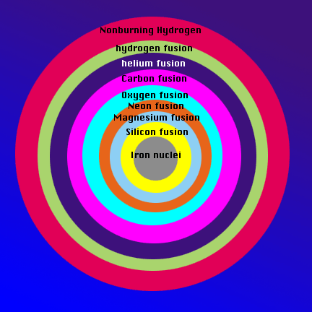
An example of a drawing depicting the layers of elements in the core of a high-mass star

Have each group of students explain the reaction they have made and why they think it is correct. Their individual diagrams and explanations of the core of a high-mass star may also be evaluated.

Reference URLs

Element Production
http://zebu.uoregon.edu/disted/ph123/l10.html
http://aether.lbl.gov/www/tour/elements/stellar/stellar_a.html
http://library.thinkquest.org/17940/texts/ppcno_cycles/ppcno_cycles.html
http://csep10.phys.utk.edu/guidry/violence/supernovae.html
http://zebu.uoregon.edu/~soper/Sun/fusion.html
http://zebu.uoregon.edu/~soper/Sun/fusionsteps.html

Reference Book:
Astronomy Today, by Eric Chaisson and Steve McMillan.

Part II: What is Electromagnetic (EM) Radiation? How is it created in atoms? What units are used to characterize EM radiation?

How Do the Properties of Light Help Us to Study Supernovae and Their Remnants?

What is Electromagnetic (EM) Radiation?
There are special properties of light that we can take advantage of to understand even objects that are millions and billions of light years away. In this section we explore some of these properties and how we can use them to understand our Universe. In the previous section of this unit, you were told that superheated material created by the supernova explosion gives off X-rays and gamma-rays. X-rays and gamma-rays are really just light (electromagnetic radiation) that has very high energy.

Although it would seem that the human eye gives us a pretty accurate view of the world, we are literally blind to much of what surrounds us. A whole Universe of color exists, only a thin band of which our eyes are able to detect; an example of this visible range of color is the familiar rainbow (an example of a "spectrum"). The optical spectrum ranges in color from reds and oranges up through blues and purples. Each of these colors actually corresponds to a different energy of light. The colors or energies of light that our eyes cannot see also have names that are familiar to us. We listen to radios, we eat food heated in microwaves, we have X-rays taken of our broken bones. Yet many times we do not realize that radio, X-ray, and microwave are really just different energies of light!

The entire range of energies of light, including both light we can see and light we cannot see, is called the electromagnetic spectrum. It includes, from highest energy to lowest: gamma-rays, X-rays, ultraviolet, optical, infrared, microwaves, and radio waves.
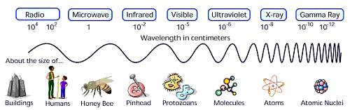

Because light is something that is given off, or radiated from an object, we can call it radiation. That's why we often talk about X-ray radiation - it's the same thing as saying X-ray light. When we refer to the whole spectrum of light, we can call it electromagnetic radiation.

Because we can see only visible light, we are put at a disadvantage because the Universe is actively emitting light at all different energies.

Light has different colors because it has different energies. This is true whether we are talking about red and blue visible light, or infrared (IR) and X-ray light. Of all the colors in the visible spectrum, red light is the least energetic and blue is the most. Beyond the red end of the visible part of the spectrum lie infrared and radio light, both of which have lower energy than visible light. Above the blue end of the visible spectrum lies the higher energies of ultraviolet light, X-rays, and finally, gamma-rays.

What Units are Used to Characterize EM Radiation?
Light can be described not only in terms of its energy, but also its wavelength, or its frequency. There is a one-to-one correspondence between each of these representations. X-rays and gamma rays are usually described in terms of energy, optical and infrared light in terms of wavelength, and radio in terms of frequency. This is a scientific convention that allows the use of the units that are the most convenient for describing whatever energy of light you are looking at. For example, it would be inconvenient to describe both low energy radio waves and high-energy gamma rays with the same units because the difference in their energies is so great. A radio wave can have an energy on the order of 4 × 10⁻¹⁰ eV as compared to 4 × 10⁹ eV for gamma rays. That's an energy difference of 10¹⁹, or ten million trillion eV!

Wavelength is the distance between two peaks of a wave, and it can be measured with a base unit of meters (m) (such as centimeters, or Ångstroms). Frequency is the number of cycles of a wave to pass some point in a second. The basic unit of frequency is cycles per second, or Hertz (Hz). Energy in astronomy is often measured in electron volts, or eV or its multiples (such as kilo electron volts, or 1,000 eV) .

Wavelength and frequency are related by the speed of light (c=3.00 × 10⁸ m/s), a fundamental constant. Energy is also directly proportional to frequency (the constant of proportionality is Planck's constant, h=6.626 × 10⁻³⁴ m² kg/s) and inversely proportional to wavelength. It was Max Planck who demonstrated that light sometimes behaves as a particle by showing that its energy (E) divided by its frequency (usually denoted using the Greek letter ν) is a constant. Since we know that frequency is equal to the speed of light (c) divided by wavelength (the Greek letter λ), we also know the relationship between energy and wavelength. The energy (or wavelength or frequency) of light can give important clues into how the light was produced, and it is this characterization of light emission that allows us to understand objects in the distant universe.

Since light can act like both a particle and a wave, we say that light has a particle-wave duality. We call particles of light photons. Low-energy photons (i.e. radio) tend to behave more like waves, while higher energy photons (i.e. X-rays) behave more like particles. This is an important difference because it affects the way we build instruments to measure light (telescopes!).

You are familiar with light in many forms, like sunlight, which you see every day. But how is this light created? Further, how can we use the properties of light to understand objects in the Universe?

Observing Supernovae and Their Remnants at Different Energies
It pays to make multiple observations of astronomical objects because they emit light of different energies. Supernovae remnants can give off visible light, ultraviolet light, radio waves and X-rays. Each observation of a supernovae remnant can give us different information about it.

Let's examine the Crab Nebula; it is unique in that it contains one of only a few pulsars that are observable at so many different energies.

The Crab Nebula's creation was witnessed in July of 1054 A.D. when Chinese astronomers and members of the Native American Anasazi tribe separately recorded the appearance of a new star. Although it was visible for only a few months, it was bright enough to be seen even during the day! In the 19th century, French comet hunter Charles Messier recorded a fuzzy ball of light near the constellation Taurus. This fuzzy ball turned out not to be a comet after all, but the remains of a massive star whose explosive death had been witnessed centuries before by the Chinese and the Anasazi.
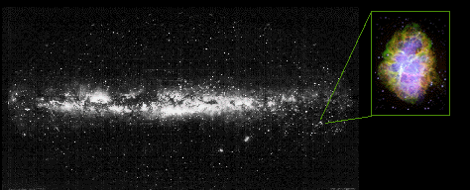
The location of the Crab Nebula (inset) in the Milky Way Galaxy.

Scientists now believe the Crab Nebula is the remains of a star that suffered a supernova explosion. The core of the star collapsed and formed a rapidly rotating, magnetic neutron star, releasing energy sufficient to blast the surface layers of the star into space with the strength of a 10²⁸-megaton bomb or a hundred million nuclear warheads. Nestled in the nebulous cloud of expelled gases, the rotating neutron star, or pulsar, continues to generate strobe-like pulses that can be observed at radio, optical, and X-ray energies. The Crab Nebula was one of the first sources of X-rays identified in the early 1960s when the first X-ray astronomy observations were made.
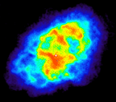
Crab Nebula in Radio
At radio wavelengths, the Crab Nebula, seen to the left, displays two distinctive physical features. The nebulous regions hide radio emission coming from unbound electrons spiraling around inside the nebula. The pulsar at the heart of the Crab Nebula generates pulses at radio frequencies roughly 60 times a second. In this image, the pulsar's flashes are blurred together (since the image was "exposed" for much longer than 1/60 s) and it appears as the bright white spot near the middle of the nebula.
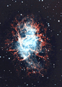
Crab in optical

In the optical, both a web of filaments at the outer edges of the nebula and a bluish core become apparent. The blue core is from electrons within the nebula being deflected and accelerated by the magnetic field of the central neutron star. The red filaments surrounding the edges of the nebula are the remnants of the original outer layers of the star.
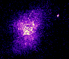
Crab in UV
In the ultraviolet (or UV) the nebula is slightly larger than when seen in X-rays. Cooler electrons (responsible for the UV emission) extend out beyond the hot electrons near the central pulsar. This supports the theory that the central pulsar is responsible for energizing the electrons.

X-ray observations reveal a condensed core near the central pulsar, which is the bright dot visible slightly left and below center in the image to the right. The Crab Nebula appears smaller and more condensed in X-rays because the electrons, which are primarily responsible for the X-ray emission, exist only near the central pulsar. Scientists believe that the strong magnetic field near the surface of the neutron star "heats up" the electrons in it and that these "hot" electrons are responsible for the X-ray emission.
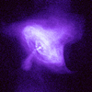
Crab in X-ray

Reference URLs:

For the Student
Using the text and any external references, define the following terms: radio waves, microwaves, infrared, visible, ultraviolet, X-rays, gamma rays, light energy, photon, electromagnetic spectrum, electromagnetic radiation, Hertz, wave peak, frequency, and wavelength.

The EM Spectrum
http://imagine.gsfc.nasa.gov/docs/introduction/emspectrum.html

Activity: Calculation Investigation
Days needed: 1
Grade Level: 11 - 12

Objective
In this activity, students will learn how white light, such as that from an overhead projector, is broken up into its component colors by a diffraction grating. They will learn the relationships between wavelength, frequency, and energy and how to convert between any of these characterizations of a particular color of light. Background information includes general information on the electromagnetic spectrum and the nature of light.

Science and Math Standards

NCTM
- Content Standard 1:
  - Mathematics as problem Solving
  - Structure of Atoms
- Content Standard 2:
  - Mathematics as Communication
- Content Standard 4:
  - Mathematical Connections
- Content Standard 6:
  - Functions

NSES
- Content Standard B:
  - Light, heat, energy and magnetism

Pre-requisites
- Science Students should read the background material on the Electromagnetic Spectrum
- Math Students should have a basic understanding of algebra and should have read the background material on the Electromagnetic Spectrum

Introduction
Light can be described in many ways, by its energy, its wavelength, or its frequency. All three terms are equally important, and all are interrelated. Each color in the spectrum, for example red, has a distinct energy, but also has a specific wavelength and frequency. The convention is that infrared light and visible light (the rainbow of colors our eyes can see) are usually described by wavelength, radio waves in terms of frequency, and high-energy X-rays and gamma-rays in terms of energy. This scientific convention allows the use of the units that are the most convenient for that energy of light. For example, it would be inconvenient to describe both low-energy radio waves and high-energy gamma rays with the same units because the difference between their energies is so great. A radio wave can have an energy on the order of 4 × 10⁻¹⁰ eV, as opposed to 4 × 10⁹ eV for gamma rays. That's an energy difference of 10¹⁹, or ten million trillion, eV!

Engagement
Using the overhead projector, prism, diffraction grating, and two sheets of cardboard, the students will set up the apparatus as illustrated below to project the spectrum of white light on a screen. Students will then pose questions about what they are observing, and what they are going to do to answer these questions.

Using an Overhead Projector to Project a Spectrum
We (and two of our teacher interns) have tried this recently. We had very good success with the overhead projector method of generating a good, large spectrum. This idea was originally published by Dr. Philip M. Sadler in the article "Projecting Spectra for Classroom Investigations," The Physics Teacher, 29(7), 1991, pp. 423-427.

You will need:
- an overhead projector and a source of power
- two or three books or pieces of 8×10 dark construction paper
- diffraction grating - (a film with thousands of microscopic grooves per inch that break up white light) - this is available from Edmund Scientific. Use one about the size of a 35mm slide.
- white wall or screen

- To make a visible light spectrum, plug in the projector, and turn on the lamp. Set up the projector so it is projecting at a white screen or wall.
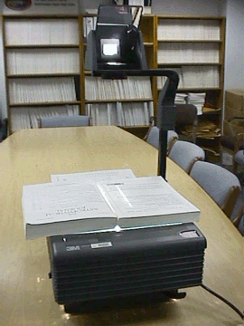
Set-up for the experiment, including the overhead, books to create a slit of light, and the diffraction grating (at top of overhead)

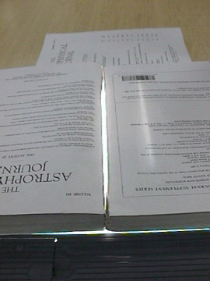
Close-up of creating the slit of light from the overhead.
- Use books on the base plate of the projector to completely block all but a single slit of light no larger than an 1" wide from being projected on the screen. Focus the projector.
- Place a diffraction grating over the lens at the top of the "projection stack". Rotate the grating (if necessary) until the spectrum appears on both sides of the projected slit on the wall or screen.
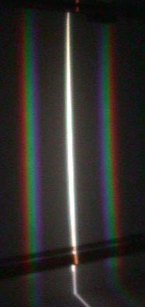

The image on the screen shows the central white band of light coming from the projector, plus a spectrum on both sides.
- Turn off the lights, lower blinds, whatever you can do to make the room dark. You should now have a nice spectrum projected onto the screen/wall.

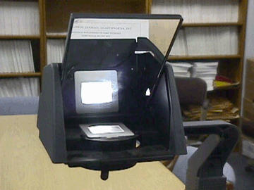

Close-up showing the placement of the diffraction grating on the overhead lens.

Exploration
Print out the “Student Worksheet: Calculation Investigation” for the class. Have the students complete it.

Evaluation
Formative assessment and observation should be evident throughout the lesson. The worksheet, final questions during closure or a future quiz may serve as summative assessment.

Closure
If students have been keeping a lab journal, direct students to write for ten minutes in their journals summarizing the lab and all procedures in this lesson. Encourage students to then share their findings and what they might have written in their journals. Otherwise, have students create a lab report for this lesson, summarizing their findings. The format of the lab report would then be up to the teacher.

Extension
Using a supply of diffraction gratings, students can make their own spectroscope (either making "spectroscope glasses" using two gratings or a "spectroscope telescope" using one grating and a hollow tube). Students can then look at different light sources. (Caution students that they should not look a the Sun!)

Student Worksheet:

Calculation Investigation
You are given the following two equations that express the relationships between the speed, the wavelength, the energy and the frequency of light:
c = λν
speed = wavelength × frequency
E = hν
energy = Planck's constant × frequency

Where h=6.626 × 10⁻³⁴ m² kg/s.

Answer This!
- Check the equations above and show that the units match on each side of the equations.
- Manipulate both equations to solve for energy (E) as a function of wavelength (l) and fundamental constants. Show each step. Show that the units match on each side of the resulting equations.
- Given a photon's wavelength, frequency or energy in the chart below, use the above equations to solve for the other two (in the units indicated). Use the useful constants below if you need to. Use the chart of the electromagnetic spectrum (below the table) to fill in the part of the electromagnetic radiation range for each row.

Wavelength (m) | Frequency (Hz) | Energy (J) | Electromagnetic Radiation Range
0.001
 | 7.0 × 10¹³
5.0 × 10⁻⁷
 |  | 2.0 × 10⁻¹⁵
 | 1.2 × 10²²

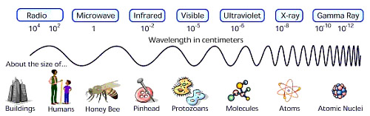

Thought Questions
In three minutes, summarize what you have learned about light and the relationship between its energy, frequency and wavelength. Write an unanswered question you still have.

Solution: Student Worksheet
KEY

EM Spectrum - A Calculation Investigation
You are given the following two equations that express the relationships between the speed, the wavelength, the energy and the frequency of light:
c = λν
speed = wavelength × frequency
E = hν
energy = Planck's constant × frequency

Where h=6.626 × 10⁻³⁴ m² kg/s.

Answer This!
- Check the equations above and show that the units match on each side of the equations.
- Manipulate both equations to solve for energy (E) as a function of wavelength (l) and fundamental constants. Show each step. Show that the units match on each side of the resulting equations.
- Given a photon's wavelength, frequency or energy in the chart below, use the above equations to solve for the other two (in the units indicated). Use the useful constants below if you need to. Use the chart of the electromagnetic spectrum (below the table) to fill in the part of the electromagnetic radiation range for each row.

Wavelength (m) | Frequency (Hz) | Energy (J) | Electromagnetic Radiation Range
0.001 | 3.0 × 10¹¹ | 2.0 × 10⁻²² | microwave
4.3 × 10⁻⁶ | 7.0 × 10¹³ | 4.6 × 10⁻²⁰ | infrared
5.0 × 10⁻⁷ | 6.0 × 10¹⁴ | 4.0 × 10⁻¹⁹ | visible
1.0 × 10⁻¹⁰ | 3.0 × 10¹⁸ | 2.0 × 10⁻¹⁵ | X-ray
2.5 × 10⁻¹⁴ | 1.2 × 10²² | 8.0 × 10⁻¹² | gamma ray

Thought Questions

Students should note the inverse relationship between wavelength and frequency: as wavelength increases, frequency decreases or as wavelength decreases, frequency increases. They should note a similar inverse relationship between wavelength and energy. Students should also note the linear, correlated relationship between frequency and energy: as frequency increases, energy increases.

Students might also compare the size of the wavelength of various waves to the sizes of common objects, as illustrated in the above figure. They might also note how small the energies are.

Atoms and Light Energy
The study of atoms and their characteristics overlap several different sciences. Chemists, Physicists, and Astronomers all must understand the microscopic scale at which much of the Universe functions in order to see the "bigger picture."

Inside the Atom
Just like bricks are the building blocks of a home, atoms are the building blocks of matter. Matter is anything that has mass and takes up space (volume). All matter is made up of atoms. The atom has a nucleus, which contains particles of positive charge (protons) and particles of neutral charge (neutrons). Surrounding the nucleus of an atom are shells of electrons - small negatively charged particles. These shells are actually different energy levels and within the energy levels, the electrons orbit the nucleus of the atom.
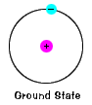

The ground state of an electron, the energy level it normally occupies, is the state of lowest energy for that electron.
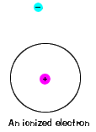

There is also a maximum energy that each electron can have and still be part of its atom. Beyond that energy, the electron is no longer bound to the nucleus of the atom and it is ionized.

When an electron temporarily occupies an energy state greater than its ground state, it is in an excited state. An electron can become excited if it is given extra energy, such as if it absorbs a photon, or packet of light, or collides with a nearby atom or particle.
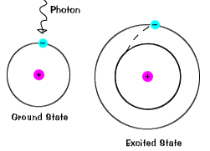

Light Energy
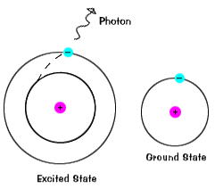

Each orbital has a specific energy associated with it. For an electron to be boosted to an orbital with a higher energy, it must overcome the difference in energy between the orbital it is in, and the orbital to which is is going. This means that it must absorb a photon that contains precisely that amount of energy, or take exactly that amount of energy from another particle in a collision.

The illustrations on this page are simplified versions of real atoms, of course. Real atoms, even relatively simple ones like hydrogen, have many different orbitals, and so there are many possible energies with different initial and final states. When an atom is in an excited state, the electron can drop all the way to the ground state in one go, or stop on the way in an intermediate level.

Electrons do not stay in excited states for very long – they soon return to their ground states, emitting a photon with the same energy as the one that was absorbed.

Identifying Individual Types of Atoms
Transitions among the various orbitals are unique for each element because the protons and neutrons in the nucleus uniquely determine the energy levels. We know that different elements have different numbers of protons and neutrons in their nuclei. When the electrons of a certain atom return to lower orbitals from excited states, the photons they emit have energies that are characteristic of that kind of atom. This gives each element a unique fingerprint, making it possible to identify the elements present in a container of gas, or even a star.

We can use tools like the periodic table of elements to figure out exactly how many protons, and thus electrons, an atom has. First of all, we know that for an atom to have a neutral charge, it must have the same number of protons and electrons. If an atom loses or gains electrons, it becomes ionized, or charged. The periodic table will give us the atomic number of an element. The atomic number tells us how many protons an atom has. For example, hydrogen has an atomic number of one - which means it has one proton, and thus one electron - and actually has no neutrons.

For the Student
Based on the previous description of the atom, draw a model of the hydrogen atom. The "standard" model of an atom is known as the Bohr model.

Different forms of the same chemical element that differ only by the number of neutrons in their nucleus are called isotopes. Most elements have more than one naturally occurring isotope. Many more isotopes have been produced in nuclear reactors and scientific laboratories. Isotopes usually aren't very stable, and they tend to undergo radioactive decay until something that is more stable is formed. You may be familiar with the element uranium - it has several unstable isotopes, U-235 being one of the most commonly known. The “235” means that this form of uranium has 235 neutrons and protons combined. If we looked up uranium's atomic number, and subtracted that from 235, we could calculate the number of neutrons that isotope has.

Here's another example - carbon usually occurs in the form of C-12 (carbon-12), that is, 6 protons and 6 neutrons, though one isotope is C-13, with 6 protons and 7 neutrons.

For the Student
Use the periodic table and the names of the elements given below to figure out how many protons, neutrons and electrons they have. Draw a model of an atom of the following element: silicon-28, magnesium-24, sulphur-32, oxygen-16, and helium-4.

A Optional Note on the Quantum Mechanical Nature of Atoms

While the Bohr atom described above is a nice way to learn about the structure of atoms, it is not the most accurate way to model them.

Although each orbital does have a precise energy, the electron is now envisioned as being smeared out in an "electron cloud" surrounding the nucleus. It is common to speak of the mean distance to the cloud as the radius of the electron's orbit. So just remember, we'll keep the words "orbit" and "orbital", though we are now using them to describe not a flat orbital plane, but a region where an electron has a probability of being.

For the Student
Using the text, define the following terms: energy levels, absorption, emission, excited state, ground state, ionization, atom, element, atomic mass, atomic number, isotope.

Electrons are kept near the nucleus by the electric attraction between the nucleus and the electrons. Kept there in the same way that the nine planets stay near the Sun instead of roaming the galaxy. Unlike the solar system, where all the planets' orbits are on the same plane, electrons orbits are more three-dimensional. Each energy level on an atom has a different shape. There are mathematical equations, which will tell you the probability of the electron's location within that orbit.

Let's consider the hydrogen atom, which we already drew a Bohr model of.

Probable locations of the electron in the ground state of the Hydrogen atom.

What you're looking at in these pictures are graphs of the probability of the electron's location. The nucleus is at the center of each of these graphs, and where the graph is lightest is where the electron is most likely to lie. What you see here is sort of a cross section. That is, you have to imagine the picture rotated around the vertical axis. So the region inhabited by this electron looks like a disk, but it should actually be a sphere. This graph is for an electron in its lowest possible energy state, or "ground state."

To the right is an excited state of hydrogen. Notice that at the center, where the nucleus is, the picture is dark, indicating that the electron is unlikely to be there. The two light regions, where the electron is most likely to be found, are really just one region. Remember, you have to mentally rotate this around a vertical axis, so that in three dimensions the light region is really doughnut shaped.


Probable locations of the electron in an excited state of hydrogen.

The text and images in this section were adapted from Dave Slaven's page on The Atom (see References below).

Reference URLs:

The Atom
http://webs.morningside.edu/slaven/Physics/atom/

Spectra
http://www.colorado.edu/physics/PhysicsInitiative/Physics2000/quantumzone/

The Periodic Table
http://www.webelements.com/

Activity: Calculate the Energy!
Days Needed: less than 1
Grade level: 9 – 12

Objective
Students will review what has been learned so far about the basic structure of an atom. Students will then calculate the energy differences in different energy states of the Bohr atom of Hydrogen. They will then compare these energy levels with observed Hydrogen lines in a laboratory spectrum.

Science and Math Standards

NCTM
- Content Standard 2
  - Mathematics as Communications
- Content Standard 4
  - Mathematics as Connections

NSES
- Content Standard A
  - Evidence, models, and explanation
- Content Standard C
  - Structure of atoms

Prerequisites
- Math Students should be familiar with basic algebra.
- Science Students should understand the structure of atoms and the relationship between energy and light, and how atoms emit light.
- Students should have read the background sections on the Properties of Light and Atoms and Light Energy.

Introduction
We can use tools like the periodic table of elements to figure out exactly how many protons, neutrons, and electrons at atom has. Understanding the structure and function of an atom is very important in understanding spectroscopy. Spectroscopy is one of the most useful tools for unlocking the mysteries of supernovae and their remnants.

Engagement

Edible Subatomic Particles
Materials needed:
- large plastic easter eggs, enough for one per student, or one per group
- gumballs or m&ms of two different colors
- tic tacs
- ping pong balls (same amount as easter eggs)

A large plastic egg (atom) is given, one per person – each egg contains a split ping-pong ball (nucleus) with a set number of either gumballs or M&M-type candies (neutrons and protons) inside. Be sure to use different colors for protons and neutrons. Put smaller hard candy (like tic tacs, for instance) in the egg, but so they can move freely around the ping-pong ball. They will be the electrons. Make sure there are the same number of protons and electrons (unless you want an ionized atom). You may want to give each student an “atom” of a different “element” by varying the number of sub-atomic particles in each students egg.

Without opening the egg, and using the scientific method, have the students determine the components within: number, size, movement, weight/mass, sound.

Have the students open the eggs – now report on the contents specifically as to number and size only. Can the student deduce what element they have an atom of? Make sure to point out that the electrons are not in perfect orbits around the nucleus. Like real electrons, they form a sort of electron cloud. Now is a good time to bring in information about the quantum mechanical nature of the atom. For example, originally, each electron orbital was pictured as having a specific radius, much like a planetary orbit in the solar system. However, the modern view is not so simple. Though each orbital does have a precise energy, the electron is now envisioned as being smeared out in an “electron cloud” surrounding the nucleus.

Adapted from a lesson plan by Miriam Meade, http://www.iit.edu/~smile/ch9211.html

Exploration
In the background section on “Atoms and Light Energy”, the students should have learned that there are many energy states within an atom. The class is now going to calculate the energies differences between some of the different levels the atom. This will tie directly in to the concept of a spectrum.

Print out the “Student Worksheet: Calculate the Energy!” for the class. Have students eat remains of atom while completing on the worksheet.

Evaluation
Students should show calculations of energy levels. These calculations and answers to the questions on the Student Handout, as well as the closure exercise, provide material for assessing the students’ understanding of the concept that energy transitions lead to emission of observed light at particular wavelengths.

Closure
Students should write a three-minute paper describing how this exercise explains line emission from atoms such as hydrogen.

Adaptations
Any number of materials could be substituted to create the “atoms”: corn kernels for protons, navy beans for neutrons, alfalfa seeds poppy seeds or cake decorating sprinkles or small beads for electrons, etc. If plastic eggs are out of season, a clear plastic ball that come in two halves (available at craft or fabric stores) can be used.

Students can also weigh the individual constituents before the atom is assembled. They should see that most of the mass of the atom is made up of the protons and neutrons.

Student Worksheet:

Calculate the Energy!

Neils Bohr numbered the energy levels (n) of hydrogen, with level 1 (n=1) being the ground state, level 2 being the first excited state, and so on. Remember that there is a maximum energy that each electron can have and still be part of its atom. Beyond that energy, the electron is no longer bound to the nucleus of the atom and it is ionized. In that case n approaches infinity.

The equation for determining the energy of any state (the nth) is as follows:
E = -13.6/n² eV

Because the energy is so small, the energy is measured in electron-volts, designated as “eV”.
1 eV = 1.6 × 10⁻¹⁹ J.

Answer the following questions:
- Using the above expression, calculate the energy of the first excited state. Your answer will be negative. This signifies that the electron is bound to the atom (as opposed to being a free electron).
- Use the above expression to find the energy of the photon released when an electron around a hydrogen atom moves from the 4th to the 2nd level.
- Now use the above expression to find the energy of the photon released when a free electron is captured to the 2nd level.
- Use the relationship between a photon’s energy and its wavelength to calculate the wavelength of the photon emitted in question 2.
- Compare the wavelength for this transition with the lab spectrum of hydrogen below.
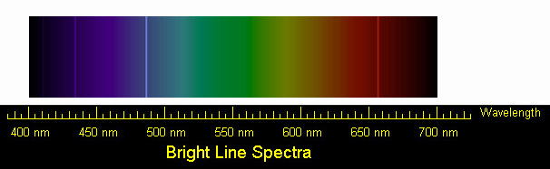

Solution: Student Worksheet:

Calculate the Energy!
KEY

Neils Bohr numbered the energy levels (n) of hydrogen, with level 1 (n=1) being the ground state, level 2 being the first excited state, and so on. Remember that there is a maximum energy that each electron can have and still be part of its atom. Beyond that energy, the electron is no longer bound to the nucleus of the atom and it is ionized. In that case n approaches infinity.

The equation for determining the energy of any state (the nth) is as follows:
E = -13.6/n² eV

Because the energy is so small, the energy is measured in electron-volts, designated as “eV”.
1 eV = 1.6 × 10⁻¹⁹ J.

Answer the following questions:
- Using the above expression, calculate the energy of the first excited state. Your answer will be negative. This signifies that the electron is bound to the atom (as opposed to being a free electron).

For the first excited state, n=2. Using this in the above equation gives E = -3.40 eV

- Use the above expression to find the energy of the photon released when an electron around a hydrogen atom moves from the 4th to the 2nd level.

The energy of the photon is found by computing the difference
in the energies of the fourth (n=4) and second (n=2) levels
E = -13.6/4² – (-13.6/2²)
E = -0.85 + 3.40
E = 2.55 eV

- Now use the above expression to find the energy of the photon released when a free electron is captured to the 2nd level.

We represent a free electron by assigning it an infinite n. Hence, its energy is zero.

The energy of the photon emitted by a free electron captured to the n=2 level is thus
E = 0 – (-13.6/22) = 3.4 eV

- Use the relationship between a photon’s energy and its wavelength to calculate the wavelength of the photon emitted in question 2.

From the Calculation Investigation, we learned that energy and wavelength are related through E = h c / l.

We can solve this for the wavelength, l = h c / E. where h = 6.626 × 10⁻³⁴J-s, and c = 3 × 10⁸ m/s

We convert our energy E= 2.55 eV into Joules using 1 eV = 1.6×10⁻¹⁹ J. This gives an energy of E = 4.08 × 10⁻¹⁹ J

We then find a wavelength of
l = ((6.626 × 10⁻³⁴) x (3 × 10⁸)) / (4.08 × 10⁻¹⁹)
l = 4.87 × 10⁻⁷ m

Or, using 1 nm = 1 × 10⁻⁹ m,
l = 487 nm.

- Compare the wavelength for this transition with the lab spectrum of hydrogen below.

The transition is the bright blue line, just to the left of the center.

Part III: What tools are used to identify elements? What importance do X-rays have to astronomy?

Introduction to Spectroscopy

Spectroscopy is a complex art - but it can be very useful in helping scientists understand how an object like a black hole, neutron star, or active galaxy is producing light, how fast it is moving, and even what elements it is made of. A spectrum is simply a chart or a graph that shows the intensity of light being emitted over a range of energies. Spectra can be produced for any energy of light - from low-energy radio waves to very high-energy gamma rays.

Spectra are complex because each spectrum holds a wide variety of information. For instance, there are many different mechanisms by which an object, like a star, can produce light - or using the technical term for light, electromagnetic radiation. Each of these mechanisms has a characteristic spectrum.

Let's look at a spectrum and examine each part of it.
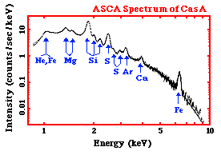

To the right is an X-ray spectrum made using data from the ASCA satellite. It is of a supernova remnant (SNR) - a SNR is a huge cloud of gaseous matter swept up from the explosion of a massive star. The x-axis shows the range of energy of light that is being emitted. The y-axis of the graph shows the intensity of the light recorded by the instrument from the SNR – that is, the number of photons of light the SNR is giving off at each energy, multiplied by the sensitivity of the instrument at that energy. We can tell that the light, or radiation, from this SNR is very high energy - if we look at the units of the x-axis - we can see that the photons of light have energies measured in keV, or kilo-electron Volts. A kilo-electron Volt is 1000 electron Volts (eV). This puts is the X-ray range of the electromagnetic spectrum.

The graph shows a decreasing curve, with lots of bumps in it. The curve itself is called a continuum – it represents X-ray photons emitted at all energies continuously. The X-rays that are producing this continuum can be caused by several mechanisms that are completely different than those producing the X-rays at the various peaks and bumps on the curve. The peaks and bumps are called line emission. Not only are these two different kinds of X-ray emission (continuum and line) produced differently, but they each tell us different things about the source that is emitting them.

The Electromagnetic Spectrum

White light (what we call visible or optical light) can be split up into its colors easily and with a familiar result – the rainbow. All we have to do is use a slit to focus a narrow beam of the light at a prism. This set-up is actually a basic spectrometer.

The resultant rainbow is really a continuous spectrum that shows us the different energies light (from red to blue) present in visible light. But the electromagnetic spectrum encompasses more than just optical light – it covers all energies of light extending from low-energy radio waves, to microwaves, to infrared, to optical light, to ultraviolet, to very high-energy X- and gamma-rays.

Line Emission
Instead of using our spectrometer on a light bulb, what if we were to use it to look a tube of gas – for example, hydrogen? We would first need to heat the hydrogen to very high temperatures, or give the atoms of hydrogen energy by running an electric current through the tube. This would cause the gas to glow – to emit radiation. If we looked at the spectrum of light given off by the hydrogen gas with our spectroscope, instead of seeing a continuum of colors, we would just see a few bright lines. Below we see the spectrum, the unique fingerprint of hydrogen.

These bright lines are called emission lines. Remember how we heated the hydrogen to give the atoms energy? By doing that, we excited the electrons in the atom - when the electrons fell back to their ground state, they gave off photons of light at hydrogen's characteristic energies. If we altered the amount or abundance of hydrogen gas we have, we could change the intensity of the lines, that is, their brightness, because more photons would be produced. But we couldn't change their color - no matter how much or how little hydrogen gas was present, the pattern of lines would be the same. Hydrogen's pattern of emission lines is unique to it. The brightness of the emission lines can give us a great deal of information about the abundance of hydrogen present. This is particularly useful in a star, where there are many elements mixed together.

Each element in the periodic table can appear in gaseous form and will each produce a series of bright emission lines unique to that element. The spectrum of hydrogen will not look like the spectrum of helium, or the spectrum of carbon, or of any other element.

Hydrogen:

Helium:

Carbon:

We know that the continuum of the electromagnetic spectrum extends from low-energy radio waves, to microwaves, to infrared, to optical light, to ultraviolet, to X and gamma rays. In the same way, hydrogen's unique spectrum extends over a range, as do the spectra of the other elements. The above spectra are in the optical range of light. Line emission can actually occur at any energy of light (i.e. visible, UV, etc.) and with any type of atom, however, not all atoms have line emission at all wavelengths. The difference in energy between levels in the atom is not great enough for the emission to be X-rays in atoms of lighter elements, for example.

Different Graphical Representations of Spectra
The sample spectra above represent energy emission as lines, the amount of photons of light represented by the brightness and width of the line. But we can also make a graphical representation of a spectrum. Instead of the emission of a characteristic energy being shown as a line, it can be shown as a peak on a graph. In this case, the height and width of the peak show its intensity. One example of this is the very first spectrum we looked at – the one of the supernova remnant. The peaks and bumps on the graph are simply a graphical representation of the emission lines of different elements.
Below, you will see the spectrum of the Sun at ultraviolet wavelengths. There are distinct lines (in the top graph) and peaks (in the bottom one) and if you look at the X-axis, you can see what energies they correspond to. For example, we know that helium emits light at a wavelength of 304 Ångstroms, so if we see a peak at that wavelength, we know that there is helium present.

Spectra and Astronomy
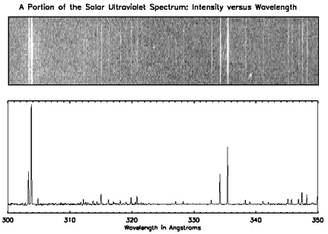

In a star, there are actually many elements present. The way we can tell which ones are there is by looking at the spectra of the star. In fact, the element helium was first discovered in the Sun, before it was ever discovered on Earth. The element is named after the Greek name for the Sun, Helios. The science of spectroscopy is quite sophisticated. From spectral lines astronomers can determine not only the element, but also the temperature and density of that element in the star. Emission lines can also tell us about the magnetic field of the star. The width of the line can tell us how fast the material is moving, giving us information about stellar wind. If the lines shift back and forth, it means that the star may be orbiting another star - the spectrum will give the information necessary to estimating the mass and size of the star system and the companion star. If the lines grow and fade in strength we can learn about the physical changes in the star.
Spectral information, particularly from energies of light other than optical, can tell us about material around stars. This material may have been pulled from a companion star by a black hole or a neutron star, where it will form an orbiting disk. Around a compact object (black hole, neutron star), the material in this accretion disk is heated to the point that it gives off X-rays, and the material eventually falls onto the black hole or neutron star. It is by looking at the spectrum of X-rays being emitted by that object and its surrounding disk that we can learn about the nature of these objects.

Continuum Emission
Just like visible light, with its range of energies from red to blue, X-rays have a continuum, or a range of energies associated with it. X-rays usually range in energy from around 0.5 keV up to around 1000 keV.

Like line emission, continuum X-ray emission involves charged particles. Continuum emission is a result of the acceleration of a population of charged particles. All X-ray sources contain such particles. These particles must be at least partially ionized - their electrons need to be unbound from their nuclei to be free to zip around when they are heated to extreme temperatures. For an electron to radiate X-rays, the gas containing the electron must have extreme conditions, such as temperatures of millions of degrees, super-strong magnetic fields, or the electrons themselves must be moving at nearly the speed of light. Extreme conditions can be found in disks of matter orbiting black holes or in supernova remnants. Strong magnetic fields, like those created in the wake of a supernova explosion, can also accelerate fast moving ions in spirals around the field lines to the point of X-ray emission. Electrons can be accelerated to nearly the speed of light in the shockwave created by a supernova explosion.

There are three mechanisms that will produce a continuum X-ray emission. They are Synchrotron Radiation, Bremsstrahlung, and Compton Scattering. The radiation produced is continuous, and not at the discreet energies of line emission because the populations of electrons have a continuous range of energies, and they can be accelerated through a range of energies.

Synchrotron radiation is emitted when a fast electron interacts with a magnetic field. A magnetic field in an area an electron is traveling in will cause the electron to change direction by exerting a force on it perpendicular to the direction the electron is moving. As a result, the electron will be accelerated, causing it to radiate electromagnetic energy. This is called magnetic bremsstrahlung or synchrotron radiation (after radiation observed from particle accelerators by that name). If the electrons and the magnetic field are energetic enough, the emitted radiation can be in the form of X-rays.
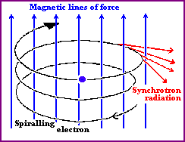
Image courtesy of University of Hertfordshire

Bremsstrahlung occurs when an electron passes close to a positive ion, and the strong electric forces cause its trajectory to change. The acceleration of the electron in this way causes it to radiate electromagnetic energy – this radiation is called bremsstrahlung, (from the German meaning 'braking radiation'). Thermal bremsstrahlung occurs in a hot gas, where many electrons are stripped from their nuclei, leaving electrons and positive ions. If the gas is hot enough (millions of Kelvin), this kind of radiation will primarily take the form of X-rays.
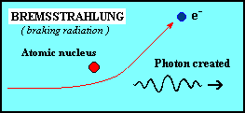

Image courtesy of University of Hertfordshire

Comptonization is when a photon collides with an electron – the photon will either give up energy to or gain energy from the electron, changing the electron's velocity as a result.
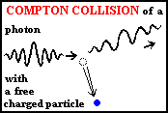
Image courtesy of University of Hertfordshire

What Are Some Examples of Continuum Emission?
Gas that is hotter than 10 million degrees, such as the gas heated by a supernova explosion, produces most of its emission in X-rays from thermal bremsstrahlung. Gas can be heated to these temperatures by the outward moving shock of a supernova explosion, or in an accretion disk around a black hole or neutron star. Synchrotron radiation can produce X-rays around supernova remnants (SNR), where the magnetic fields are strong and ions have been accelerated by the shock wave to high energies. X-rays produced by SNR require electrons with energies of about 10⁴ GeV (Giga electron-Volts) each (you would have to heat an electron to a temperature of about ten trillion degrees for it to have this much energy)! Synchrotron radiation and Compton scattered radiation are major components of the diffuse X-ray background and emission from active galaxies.

For the Student
Using the text, define the following terms: spectroscopy, keV, continuum, continuum emission, line emission, electromagnetic spectrum, synchrotron radiation, bremsstrahlung, comptonization.

Reference URLs:

Spectroscopy
http://imagine.gsfc.nasa.gov/docs/science/how_l1/spectra.html
http://www.colorado.edu/physics/PhysicsInitiative/Physics2000/quantumzone/

Activity: Graphing Spectra
Days Needed: 1
Grade level: 9 - 12

Objective
Students will be introduced to two different representations of spectra - the photographic representation, such as the familiar rainbow, and the graphical representation used more often by astronomers. Students will explore the differences and similarities of both these representations, and will develop a more intuitive feel for a graphical representation, which may not yet be familiar to them.

Science and Math Standards

NCTM
- Content Standard 8:
  - Geometry from an Algebraic Perspective
- Content Standard 10:
  - Statistics

NSES
- Content Standard A:
  - Unifying Concepts and Processes in Science
- Content Standard C:
  - Light, Energy and Magnetism
  - Structure of Atoms and Matter

Prerequisites
- Math Students should understand interpreting and manipulating graphical data.
- Science Students should understand the concept of a spectrum.
- Students should have read the Introduction to Spectroscopy.

Introduction
A rainbow is often given as an everyday example of a spectrum. Most students have seen a rainbow, so this example is used to help make the unfamiliar more familiar. However, the spectra that scientists use, and the spectra that students will see in this lesson plan, appear very different than a rainbow. In this activity, students will explore for themselves two different representations of the same spectrum, and will be introduced to advantages and disadvantages of the different representations.

Engagement
Hand out the “Student Worksheet: Graphing Spectra Part 1.” Have the class get into groups, if they aren't already, and complete it. The class should be discussing the answers, but each writing their own explanation on their own paper. The paper will be collected at the end of class and used as an assessment. The teacher should judge how much time they feel the class will need for this exercise.

After the class is done, discuss their answers to the questions posed in the worksheet.

Elaboration
Hand out “Student Worksheet: Graphing Spectra Part 2.” Have each student complete it on his or her own. Go over their answers in class when they have completed them. The teacher may choose to collect and correct the worksheets before discussing the answers in class.

Evaluation
Formative assessment and observation should be evident throughout the lesson. The worksheet, final questions during closure or a future quiz may serve as summative assessment.

Closure
Have students write for three minutes what they have learned about spectra, how they are represented and the usefulness of the different representations.

Student Worksheet:

Graphing Spectra Part 1
Below are two examples of the same emission spectrum. The first example is without any "quantitative" data, while the second shows light energy as a function of wavelength. The x-axis has the same units (wavelength, in this case, although frequency or energy could also be used) in both cases, and it runs from 300 to 350 Ångstroms. In your group, discuss the following questions, then write individual answers on paper.

- As you move along the wavelength axis from 300 Ångstroms to 350 Ångstroms, what will happen to the amount of energy emitted by the source? Explain why.
- In the second spectrum, explain why the emission lines are at different heights.
- In order for bottom plot to include more "quantitative" data, what variable should go along the y-axis?
- How is this variable illustrated in both graphs?
- Describe how the second spectrum would look if it were a function of energy (instead of wavelength).
- What types of information are gathered from both spectra?

Solar UV Spectra
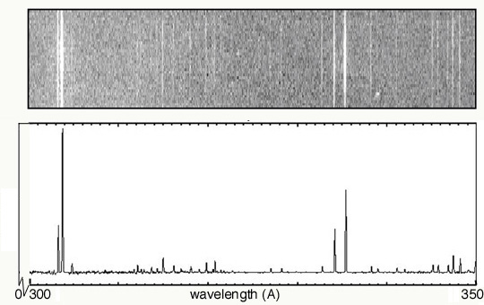

Solution: Student Worksheet:
KEY

Graphing Spectra Part 1

Below are the answers to the "Think About" questions.
- As you move along the wavelength axis from 300 Ångstroms to 350 Ångstroms, what will happen to the amount of energy emitted by the source? Explain why.
The energy decreases. This is because the energy is inversely proportional to the wavelength: E = hc/l

- In the second spectrum, explain why the emission lines are at different heights.
The varying heights represents the different intensities of the lines. The lines in the left-most portion of the spectrum are brighter than any of the others.

- In order for bottom plot to include more "quantitative" data, what variable should go along the y-axis?
The y-axis should be labeled as "Intensity".

- How is this variable illustrated in both graphs?
In the top image, it is represented by the brightness of the line. In the bottom plot, it is represented by the height of the line.

- Describe how the second spectrum would look if it was a function of energy (instead of wavelength).
Keeping the usual sense of values increase from left to right, the order the emission lines would be flipped left-to-right. That is, the brightest lines would be on the right.

- What types of information are gathered from both spectra?
From the spectra, we can identify the emission lines. With knowledge of the characteristic emission lines of various elements, we could then identify the elements giving rise to this spectrum.

Solar UV Spectra

Student Worksheet:

Graphing Spectra Part 2

The following spectrum represents the energy state of the element, carbon. Carbon's emission lines in the visible range are a function of wavelength from 4,000 to 7,000 Ångstroms. You are going to create a graphical representation of carbon's spectrum from the photographic representation. Refer to the example above to help. At the particular wavelengths, illustrate the varying brightness of carbon's emission lines. Notice that in the photographic representation of the spectrum there is an underlying continuum of emission, in addition to the bright spectral lines. This continuum is due to contamination of the spectrum by ambient light, such as small amounts of white light that are picked up by the spectrometer. Your graphical representation should include this low level of emission at all wavelengths as well as carbon's spectral line features.
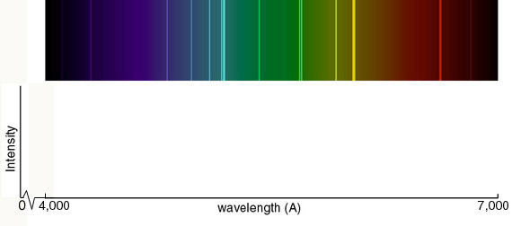

Below you are given spectra for both hydrogen and helium. For each element, select two of the brightest emission lines at the particular wavelengths and measure the wavelengths. The ruler below indicates the scale of the spectrum. Solve for the frequency and energy of these lines, using the relationships between wavelength and frequency and between frequency and energy. (Hint: You will have to manipulate an equation.) After the flame test, you will complete the same calculations for the following elements: sodium and calcium.
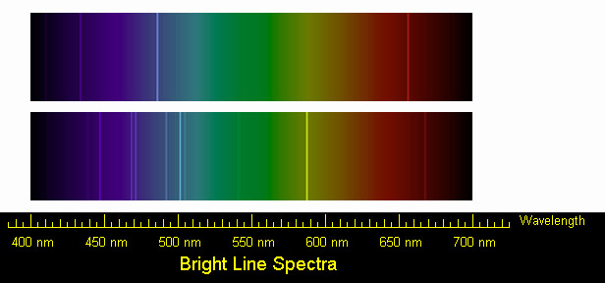

Solution: Student Worksheet:

Graphing Spectra Part 2
KEY
The graphical representation should include all visible lines shown in the color spectrum. The continuum should rise gradually from 4000 Ångstroms, and remain fairly constant through blue, and decrease slightly in green portion of the spectrum. It should increase again, reach a maximum near yellow, and then decline again in the red.

Below are the solutions for the identifying the lines in the spectra of hydrogen and helium.

Hydrogen
We can identify three bright lines for hydrogen in the top spectrum. Measuring from the scale, the wavelengths are 435 nm (purple), 486 nm (blue) and 657 nm (red). Recall (e.g. from the Calculation Investigation) that the frequency is given by ν = c/λ, and the energy is given by E = hν (where h = 6.626 × 10⁻³⁴ J-s, and c = 3 × 10⁸ m/s). In the table below we summarize the frequency and energy results for these lines. (We include the color to aid in identifying the line in the spectrum.)

Wavelength (nm) | Color | Frequency (Hz) | Energy (J)
435 | purple | 6.90 × 10¹⁴ | 4.57 × 10⁻¹⁹
486 | blue | 6.17 × 10¹⁴ | 4.09 × 10⁻¹⁹
657 | red | 4.57 × 10¹⁴ | 3.03 × 10⁻¹⁹

Helium
We can identify a number of lines in the spectrum of Helium. The bright lines are listed in the table below, along with their frequencies and energies. Students may identify any two of these.

Wavelength (nm) | Color | Frequency (Hz) | Energy (J)
447 | purple | 6.71 × 10¹⁴ | 4.45 × 10⁻¹⁹
469 | blue | 6.40 × 10¹⁴ | 4.24 × 10⁻¹⁹
472 | blue | 6.36 × 10¹⁴ | 4.21 × 10⁻¹⁹
493 | blue-green | 6.09 × 10¹⁴ | 4.03 × 10⁻¹⁹
501 | blue-green | 5.99 × 10¹⁴ | 3.97 × 10⁻¹⁹
505 | blue-green | 5.94 × 10¹⁴ | 3.94 × 10⁻¹⁹
587 | yellow | 5.11 × 10¹⁴ | 3.39 × 10⁻¹⁹
669 | red | 4.48 × 10¹⁴ | 2.97 × 10⁻¹⁹

Activity: Flame Test
Days Needed 1.5 Days
Grade level 9 - 12

Objective
Students will discover first hand how different elements emit different specific wavelengths of light energy when burned, and that these can be identified when the light is separated with a prism.

Science and Math Standards

NCTM
- Content Standard 2:
  - Mathematics as Communication
- Content Standard 4:
  - Mathematics as Connections
- Content Standard 8:
  - Geometry from an algebraic perspective

NSES
- Content Standard B:
  - Abilities necessary to do scientific inquiry
  - Understandings about scientific inquiry
- Content Standard C:
  - Structure of Atoms
  - Interactions of energy and matter
- Content Standard G:
  - Nature of Scientific Knowledge
  - Historical Perspectives

Prerequisites
- Math Students should have had some Pre-Algebra, especially in the areas of manipulation of formulas and pattern recognition.
- Science Students should have had an introduction to the electromagnetic spectrum, the concept of a spectrum and how atoms emit light energy.

Introduction
Recalling the characteristics of atoms and light, the flame test is a great way to physically demonstrate some of the more abstract ideas discussed in the background sections on Atoms and Light Energy and Spectroscopy.

Exploration
The students will work in lab groups of three to four students to construct meaning on the causes of various light emissions from the following 0.5M chemical solutions: LiCl, NaCl, CuCl, BaCl, CsCl, and CaCl. To prepare for the Flame Test, each 0.5M solution should be placed in a test tube by itself. Each of the six test tubes should then be placed at the various laboratory stations 1 through 6. The students will rotate to each station to test the solution.

Materials
- 7 test tubes
- test tube rack
- platinum wire or wood splints
- laboratory burner
- goggles
- apron
- 0.5M solutions of LiCl, NaCl, CuCl, BaCl, CsCl and CaCl, and 1M of HCl

Hand out “Student Worksheet: Flame Test” student worksheet. Have the students answer the thought questions at the end of Part I in groups, but on paper. They should be utilized to facilitate a meaningful discussion on light emission. Afterwards, the students should complete the questions in Part II individually. They may be assigned for homework if there is not enough class time.

Evaluation
Formative assessment and observation should be evident throughout the lesson. The worksheet, final questions during closure or a future quiz may serve as summative assessment.

Closure
Have students take three minutes to write in their own words why different elements produce flames of different colors when burned. How is this quality useful in astronomy?

Reference URL

Flame Test
http://www.creative-chemistry.org.uk/activities/flametests.htm

Student Worksheet:

Flame Test

Part I

Procedure
- Put on lab apron and safety goggles.
- Add 15 drops of each 0.5M solution to a different clean test tube.
- To clean the wire, dip it into the test tube of 1M of HCl and heat the wire in the hottest part of the flame until no color shows.
- When the platinum wire is clean, dip the wire in the test tube containing a 0.5M solution and hold it in the hottest part of the flame. Record your observation of the color of the flame on the data table.
- Repeat the process of cleaning the platinum wire. Now get ready to test another solution.
- Test all of the solutions and make sure that you record the color of the flame for each element on the Data Table.
- Check your flame colors to known results.
- Fill one clean test tube with 15 drops of one of the 0.5M solutions. The teacher keeps track of what element solution is in this "mystery tube." Repeat the flame test, without telling the students what solution it is. Students must use the information gained from the first part of the experiment to identify the mystery solution.
- Use the diffraction grating to observe the color of the flame for the following elements: Sodium, Barium, Copper, and Lithium. The students should be able to see the individual lines making up the light from the flame. This can be tricky! In order for it to work, the room will have to be completely dark (in order to block out other light sources) and the students will have to be close to the flame, holding the diffraction grating up to their eyes. It may be necessary to rotate the diffraction grating in order to see the emission lines. Be patient!
- Record the colors of the elements' emission lines in column three of the Data Table.
- Before leaving the laboratory, wash your hands thoroughly with soap and water.

Stations | Observed Flame Color | Color of  Emission Lines | l (m) | n (Hz) | E (J)
Calcium (0.5M CaCl)
Sodium (0.5M NaCl)
Barium (0.5M BaCl)
Lithium (0.5M LiCl)
Copper (0.5M CuCl)
Cesium (0.5MCsCl)

Think About
Discuss the following questions in lab groups. Remember you are trying to determine what is taking place during the Flame Test whereby various colors of light are being emitted. One person in your group will have the responsibility of writing the group answers down. After discussing these questions in the group, another person will be responsible for sharing your thoughts with the whole class. You may refer to background material.
- What particles are found in the chemicals that may be responsible for the production of colored light?
- Why do different chemicals emit different colors of light?
- Why do you think the chemicals have to be heated in the flame first before the colored light is emitted?
- Colorful light emissions are applicable to everyday life. Where else have you observed colorful light emissions. Are these light emission applications related? Explain.
- What is the characteristic flame color for Sodium, Lithium, Barium, Copper, Cesium, and Calcium? Explain why.
- When the diffraction grating was used to view the flame, explain why different colorful emission lines were observed for the elements.

Part II
Use the image below to view the spectra of calcium (top) and sodium (bottom). Solve for frequency and energy of the two brightest emission lines for each element. Use the brightest lines. Show your work and record your answers on the Data Table.

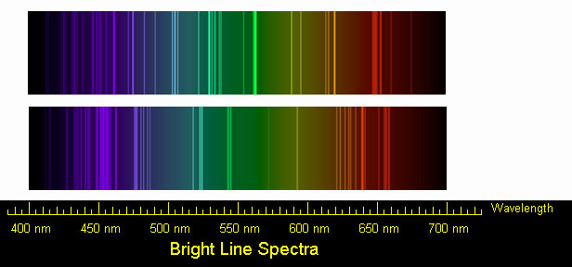

Activity: Design an Element Poster Advertisement
Days needed a week
Grade level 4 - 8, 9 - 12

Objectives
Students will discuss what they have learned about atoms and elements in their own words. Students will design a poster advertisement for their chosen element. Students will use more than just their right brain to think about science!!

Science and Math Standards

NCTM
- Content Standard 2:
  - Mathematics as Communication

NSES
- Content Standard B:
  - Structure of Atoms
  - Interactions of energy and matter
- Content Standard G:
  - Science in personal and social perspectives.

Prerequisites
Science Students should have read the background information on how atoms emit light energy and have a basic understanding of the elements.

Introduction
Each element in the Universe has unique properties due to its atomic configuration (the arrangement and numbers of protons, neutrons and electrons it has). In the previous activities, students have learned about how each element has a unique spectral "fingerprint." In this activity, students will explore in more depth the properties of one particular element, and share their knowledge with the class in the form of a poster advertisement for their element.

Exploration

The students should be given a week to complete this assignment as either a student-individual or group project. If it is assigned as a group project, some class time will be needed. Give each student a copy of the “Student Worksheet: Design an Element Poster Advertisement” which describes the requirements of the project.

Evaluation
Each of the requirements on the Student Worksheet is worth 20 points. The students should present their posters to the class, and for an extra 20 points all students should be encouraged and prepared to conduct some form of a demonstration using the assigned element as either an element or compound.

Closure
When the students have completed their element posters, they should be presented to and shared with the class. It might be useful to have the posters on display for a short amount of time, so that students will be able to see each others posters and become familiar with each others elements.

Adaptations
This project is easily adaptable to almost any grade level. Middle school students might concentrate on the basic properties of the element. At all levels, artistic creativity should be encouraged. In addition, with a one or two classes participating, an entire periodic table could be assembled and displayed. When a semi-permanent display is not possible, some teachers have used their school gymnasium or auditorium to lay the posters out and photograph their students’ “periodic table.”

Middle school students might also enjoy creating super heroes whose powers are based on one of the elements. For example, "Goldi Ox" (a play on Goldilocks) uses the properties of gold.

Reference URLs

Periodic Table of the Elements
http://www.webelements.com/

Student Worksheet:

Design an Atom Poster Advertisement

Assignment
Now that you have determined several ways to identify elements, you will be assigned an element to make an advertisement poster on its everyday use. You want to make this poster as appealing as possible for your immediate classmates and school community, so that people will take the time to read and learn about the everyday use of several elements found on the Periodic Table.

Your poster needs to include the following:
- a Catchy Title and Atomic Model
- the Electronic Configuration
- a Listing of physical and chemical properties of your assigned element (at least two each)
- a picture of where this element is found and how is it used; in other words, its everyday application; (This picture should either be drawn, taken from the internet, a magazine, or copied from a book).
- a one-paragraph typed caption for the above picture telling where the element is found and how it is used. Give the element's atomic symbol. This information must be factual and written in your own words. If you choose to do so, your one-paragraph caption can be written as a poem or jingle.

Part IV: How does the newest technology help us to understand the Universe?

All About the Microcalorimeter
Perhaps the most intriguing advance in X-ray astronomy instrumentation in the 1990s has been the development of the microcalorimeter, spearheaded by work at NASA's Goddard Space Flight Center. The microcalorimeter instrument designed at Goddard was called XRS, short for the X-ray Spectrometer.

What is a Microcalorimeter?
A microcalorimeter is basically a thermal device made of an absorber, a thermistor, and a heat sink.
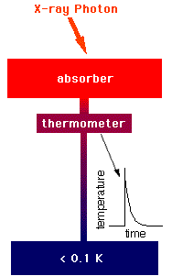
The components of the calorimeter

The absorber must do 3 things: absorb X-rays from space efficiently, quickly, completely convert the absorbed energy into heat (thermalize the energy), and have a low heat capacity. There is no material known, which excels at all 3 of these properties, so choosing the absorber material involves deciding on the best combination of them.

A thermistor is a device that changes its electrical resistance dramatically with a small change in temperature. Since a thermometer is any device that measures temperature, a thermistor is a kind of thermometer.

The combination of the absorber and the thermistor is what we call the "X-ray detector". The images in this section show a diagram of a detector, a photo of a detector array (they are the gray-green rectangles in the middle), and a close-up of the array. The array consists of 32 individual calorimeter detectors. You can (barely) see two black legs from each detector at the top of the image, and one leg from each detector squeezing between a pair of detectors at the bottom. These legs of the detector are what is called the "weak link" to the heat sink.
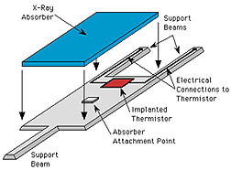
Schematic of the Calorimeter

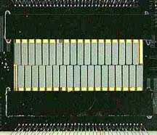
Array of Calorimeter Detectors



Close-up of Calorimeter Array

The heat sink is what absorbs heat from the detector, keeping it cool. In the case of a recently designed XRS, the heat sink used to keep the detector cool enough to work was a refrigeration unit called the Adiabatic Demagnetization Refrigerator (ADR). An ADR uses the magnetic properties of molecules in the "salt pill" to cool the detector to 60 milliKelvin (or 0.06 degrees above absolute zero).
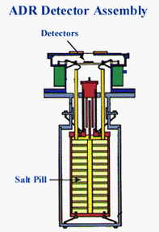

How Does a Microcalorimeter Work?
An X-ray photon hits the absorber and knocks an electron loose from an atom of the absorber material. This photoelectron (so-called because a photon of light knocked it loose) rattles around in the absorber, ultimately raising the temperature of the absorber by a few milliKelvin (that is, a few thousandths of one degree Kelvin). The temperature-sensitive thermistor is partially isolated from the absorber, to give the absorber time to come into equilibrium before the thermistor begins to see the temperature rise. After a few milliseconds, the thermistor comes to the same temperature as the absorber, a few milliKelvin warmer than the heat sink, which is at 65 milliKelvin. We know it's a little strange to be talking about 'heat' when something is near absolute zero! Next, the thermistor begins to cool as the heat flows out the weak link (the "legs" of the detector) to the heat sink. After a few tens of milliseconds, the thermistor has returned to its normal operating temperature.
The temperature rise (ΔT, where Δ is the Greek letter pronounced “Delta”) measured by the thermistor is approximately proportional to the energy of the X-ray photon:
ΔT ~ E/C
where ΔT is the change in temperature, E is the energy of the X-ray and C is the heat capacity of the absorber. So by measuring how much the temperature changes, we can determine the energy of the X-ray.

The Science
When an X-ray stops in a detector, it gives all of its energy to one electron. That electron can rattle around in the detector and give energy to other electrons. All these excited electrons would rather go back to their original energy. They want to return to what is called the ground state. Through scattering with other electrons or with vibrations in the solid itself, they can lose that extra energy. But that energy has to go somewhere. What it does is heat the solid and increase its temperature. If you measure the change in temperature, you can measure how much energy the X-ray originally had.
How are heat and energy and temperature all related? Heat is a manifestation of energy. Heat and energy are measured in the same units (Joules). If we are thinking of a large group of objects that can exchange energy with each other, we usually think of this energy as heat. An example would be the energy of a gas: we think of its energy as heat and measure it as a temperature. When an X-ray photon heats a solid, it gives its energy to the whole solid. On average, each atom is vibrating a little bit more than before the X-ray hit. Temperature is also the way we relate the total energy of a system to its state of disorder (entropy). A physical property called "heat capacity" tells us how much the temperature rises in a material if we put in a certain amount of energy.

Suppose we wanted to measure the temperature increase due to an X-ray photon being absorbed. We would want a very sensitive thermometer, something that had some physical property that changed a lot for a small change in temperature. We would also want the detector to have a small heat capacity, so its temperature would change a lot for a small change in energy. Finally, we would want to do the whole thing at very low temperatures, because at room temperature there would already be too much thermal energy in your detector to see the very small change in energy from the X-ray. That is what an X-ray calorimeter does. It uses a silicon thermistor, which has an electrical resistance, which changes dramatically with small changes in temperature. This thermistor has a low heat capacity, and operates at less than 0.1 K. That's Kelvin. Zero on the Kelvin scale is an absolute zero and represents the cessation of all thermal vibrations. Water freezes at 273 K. Nitrogen liquefies at 77 K. Helium liquefies at 4 K. and we operate calorimeters at less than 0.1 K! Calorimeters are able to get the best spectral resolution of any non-dispersive spectrometer.

Why Is the Microcalorimeter a Better Way to Detect X-ray Photons?
In proportional counters and CCDs, the energy of the X-ray photon is shared among many electrons. Each of these electrons ends up carrying a typical amount of energy, 3.65 eV in the case of the silicon-based CCDs. These electrons are then collected and counted by the electronics, and it's the number of the detected electrons that indicates the energy of the X-ray photon in a CCD detector system. An 3.65 keV X-ray photon, for example, will produce 1,000 electrons – give or take. There is an uncertainty in the number, because the details of the X-ray – matter interaction is different each time, giving a slightly different amount of energy to each electron. The uncertainty can be estimated by taking the square root of the number of electrons – 30 or so in this case, so the X-ray energy can be determined to an accuracy of 30/1000 ~ 3%. This is a fundamental limit of X-ray detectors that use conversion to electric charges. If you want a higher spectral resolution – and astrophysicists always do – you have to choose a detector that relies on a completely different principle, such as a microcalorimeter. As a result of its different approach, the microcalorimeter provides 10x better spectral resolution for detecting emission lines of iron.

For the Student
Using the text, and any external printed references, define the following terms: Kelvin, thermistor, and heat capacity.

Reference URLs:

Microcalorimeters
http://imagine.gsfc.nasa.gov/docs/science/how_l2/calorimeters.html
http://astrophysics.gsfc.nasa.gov/xrays/programs/astroe/eng/calorimeters.html

Thermodynamics
http://www.unidata.ucar.edu/staff/blynds/tmp.html

Activity: Identifying Light Energy by Temperature Changes
Days Needed 1
Grade level 9 - 12

Objectives
Students will determine the amount of heat energy (infrared light) released from a burning peanut. The students will relate this experiment to a microcalorimeter.

Science and Math Standards

NCTM
- Content Standard 2:
  - Mathematics as Communication
- Content Standard 4:
  - Mathematical Connections

NSES
- Content Standard A:
  - Abilities necessary to do scientific inquiry
  - Understandings about scientific inquiry
- Content Standard B:
  - Structure of Atoms
  - Interactions of energy and matter
- Content Standard F:
  - Science and Technology

Prerequisites
- Science Students should understand that light is a form of energy, and the basics of the electromagnetic spectrum. Students should understand what a spectrum is.
- Math Students should be able to take measurements and use equations to calculate values.

Introduction
Students will explore hands-on how light energy can cause a change in temperature (in this case, in a flask of water). Students will relate what they find in this activity to how a microcalorimeter works to produce a spectrum of light from an incoming source. The microcalorimeter functions as energy dispersive x-ray detectors. This device picks up the energies of individual x-ray photons. The microcalorimeter is a sensitive thermometer that precisely measures the temperature variations due to the absorption of individual photons. Because it can measure very tiny temperature changes, this device will allow for the collection of spectra with extremely high-energy resolution, which will allow the measurement of chemical shifts due to different chemical bonding states, and the precise identification of incident photons.

Exploration

Materials
- paper clip
- peanut
- small aluminum pan
- flask
- ring stand and clamp,
- aluminum can with both ends open
- thermometer

Print out “Student Worksheet: Identifying Light Energy by Temperature Changes” for the class. Have them do the activity – the teacher should have a class discussion to go over the answers to the "Answer This" question.

Evaluation
Formative assessment and observation should be evident throughout the lesson. The worksheet, final questions during closure or a future quiz may serve as summative assessment.

Closure
Ask students to take three minutes to write what they have found in this experiment, and to relate this knowledge to how a microcalorimeter works. What would limit the microcalorimeter's ability to produce a superior spectrum? What characteristics of a microcalorimeter make it an advance in spectrometer technology?

Student Worksheet

Identifying Light Energy by Temperature Changes

Procedure
- As illustrated in the diagram set up your apparatus. Straighten out the paper clip and carefully thread the peanut onto the paper clip. You want to avoid as much as possible cracking the peanut.
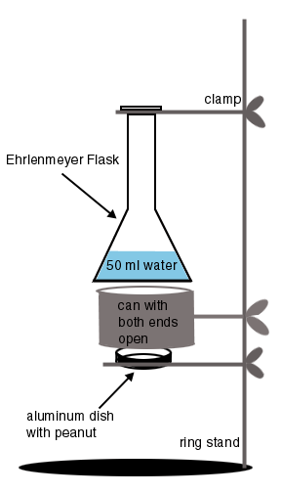

- Measure out 50 ml of water and pour the water into the flask. Determine the mass of 50 ml of water. Record the initial temperature of the water.
- Place the small aluminum pan with peanut underneath the flask with the water in it. Using a match, light the peanut and allow it to burn. Make sure the apparatus is closely set up so that a large amount of heat is not lost into the air.
- Record the final temperature of water after the peanut has stopped burning.
- Answer the Think About questions on paper.

Think About
- Describe what happened to the final temperature of water and explain why.
- The energy emitted from the peanut is mostly infrared light (heat). Review the electromagnetic spectrum diagram. What would happen to the temperature of the water if the peanut were to emit the same number of photons but as ultraviolet light? Hint: Compare the energy of infrared and ultraviolet light.
- Explain how you could use the temperature change of the water to create a spectrum of the light energy released by the burning peanut.
- Relate this experiment to how a microcalorimeter works.

Activity: Identifying Elements in Supernova Remnants
Days Needed: 1 Class period
Grade level: 9 - 12

Objectives
Using X-ray line data, the students will identify elements contained in supernova remnants. Students will compare and contrast Supernova Remnant Spectral Data from different X-ray observatories.

Science and Math Standards

NCTM
- Content Standard 1:
  - Mathematics as Problem Solving
- Content Standard 4:
  - Mathematical Connections
- Content Standard 8
  - Geometry from an Algebraic Perspective

NSES
- Content Standard A:
  - Abilities necessary to do scientific inquiry
  - Understandings about scientific inquiry
- Content Standard B:
  - Structure of Atoms
  - Interactions of energy and matter
- Content Standard G:
  - Nature of Scientific Knowledge

Prerequisites
- Math Students should have some pre-algebra, and be able to identify patterns and interpret graphs
- Science Students should have an understanding of spectra and how they are represented, an understanding of how atoms produce spectral lines. Students should understand how elements are produced and heated in supernova remnants.

Introduction
In groups of 2 or more, the students will be given several X-ray spectra from the ASCA X-ray satellite and will be asked to determine what elements are present using a chart listing elements and the energies of their emission lines. Following a class discussion of their results, they will then be given ASTRO-E spectra of the same sources and asked to determine which elements are present. (There will be much more accuracy with ASTRO-E.) Finally, they will be given spectra from Constellation-X and asked to determine what elements are present. (There will be even better resolution with Constellation-X).
Compare and contrast their findings as a class.

Exploration

Materials
- Simulated ASCA, Astro-E and Constellation-X spectra of Tycho supernova remnant
- Chart of X-ray lines corresponding to elements (print out student handout)

Simulated Supernova Remnant Spectra
- Simulated ASCA Spectrum
- Simulated Astro-E Spectrum
- Simulated Constellation-X Spectrum

Hand out the “Student Worksheet: Identifying Elements in Supernova Remnants” to the class.

Have the class do the activity and answer the questions on the worksheet. The teacher may collect and grade them.

Extension - Using Student Hera to Examine a Supernova Spectrum
Student Hera gives students the opportunity to analyze the same data sets that scientists use, using the same tools scientists use. The Student Hera web pages walk students through examining a spectrum a supernova remnant to identify elements present in the hot gas.

Student Hera Website: http://imagine.gsfc.nasa.gov/docs/teachers/hera/

Evaluation
Formative assessment and observation should be evident throughout the lesson. The worksheet, final questions during closure or a future quiz may serve as summative assessment.

Closure
Direct students to write for ten minutes in their journals summarizing the lab and all procedures in this lesson. Encourage students to then share their findings and what they might have written in their journals.

ASCA Simulated Spectrum
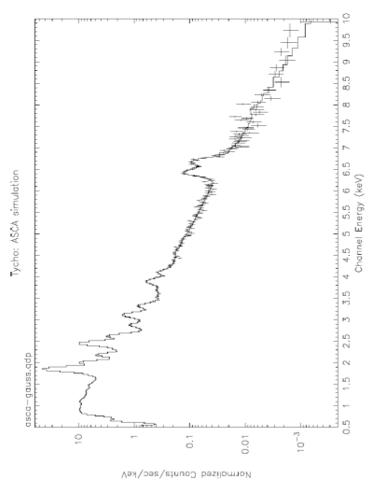

Astro-E Simulated Spectrum
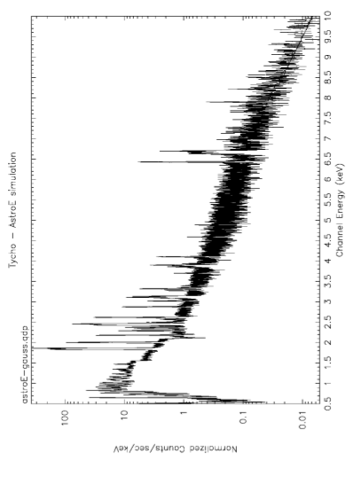

Constellation-X Simulated Spectrum
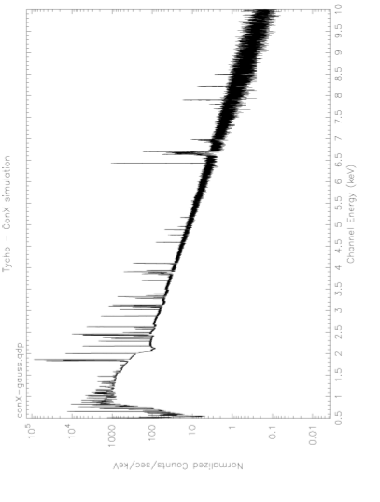

Student Worksheet

Identifying Elements in Supernova Remnants

Procedure
- Take out the three simulated spectra of the Tycho supernova remnant:
  - Simulated ASCA Spectrum
  - Simulated Astro-E Spectrum
  - Simulated Constellation-X Spectrum
- Use the X-ray line chart below to identify the elements that correspond to the various peaks of emission seen in the spectra. (You can write directly on the printed spectra).
- Answer the Think About questions.

Energies of Elemental Spectral Line Features
Element | Energy (keV)
O  O  Ne  Ne  Mg  Mg  Si  Si  S  S  Ar  Ar  Ca  Ca  Fe  Fe | 0.547  0.654  0.922  1.022  1.352  1.471  1.865  2.006  2.461  2.632  3.140  3.323  3.903  4.108  6.701  6.973

Think About
- Using spectra, how does an astronomer determine the composition of a star or supernova remnant?
- List some differences and similarities in the spectra from the three X-ray observatories (ASCA, Astro-E, and Constellation X).
- Were you able to determine with better accuracy what elements were present in the Astro-E spectra and Con-X spectra as compared to the ASCA spectra? If so, why?

A Plethora of X-ray Telescopes

What observatories will we use in the coming years to explore the structure and evolution of the Universe? What observatories are we currently using? Chandra was launched from the space shuttle in 1999, ASTRO-E was attempted to be launched in Feb., 2000, and Constellation X-Ray Observatory is still being designed. Current X-ray observatories include RXTE and ASCA.

Chandra X-ray Observatory
NASA's Chandra X-ray Observatory, which was launched and deployed by Space Shuttle Columbia on July 23, 1999, is a very sophisticated X-ray observatory.
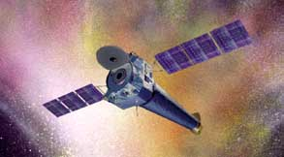

Chandra is designed to observe X-rays from high-energy regions of the universe, such as hot gas in the remnants of exploded stars. The two images of the Tycho supernova remnant shown below illustrate how higher resolution improves the quality of an image:

The image on the left is from a low-resolution detector on the Einstein Observatory. The image on the right, taken by the High Resolution Imager on the Einstein Observatory, has ten times better resolution, or finer detail (pixel area ten times smaller), than the one on the left. Chandra images will be fifty times better than the image on the right.
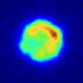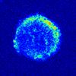
Low-resolution and high-resolution images of the Tycho supernova remnant

Chandra detects and images X-ray sources that are billions of light years away. The imaging mirrors on Chandra are some of the largest, most precisely shaped and aligned, and smoothest mirrors ever constructed. If the surface of Earth were as smooth as the Chandra mirrors, the highest mountain would be less than six feet tall! The images Chandra makes are twenty-five times sharper than the best previous X-ray telescope. This focusing power is equivalent to the ability to read a newspaper at a distance of half a mile. Chandra's improved sensitivity is making possible more detailed studies of black holes, supernovae, and dark matter. Chandra will increase our understanding of the origin, evolution, and destiny of the Universe.

The Chandra telescope system consists of four pairs of mirrors and their support structure. The mirrors have to be exquisitely shaped and aligned nearly parallel to incoming X-rays. Thus they look more like nested glass barrels than the familiar dish shape of optical telescopes.

The function of the science instruments on Chandra is to record as accurately as possible the number, position and energy of the incoming X-rays. This information can be used to make an X-ray image and study other properties of the source, such as its temperature.

Chandra resides in an orbit approximately 6,214 by 86,992 miles in altitude.

For more information, see http://chandra.harvard.edu/pub.html.

Constellation-X
The Constellation-X Observatory will assist in putting together the missing pieces to understanding the X-ray Universe. The observatory consists of four X-ray telescopes or satellites that will detect a broader range of X-ray wavelengths than any current technology, especially X-rays at higher frequencies. Combining the observing power of four telescopes means that the total X-ray effective collecting area is much larger than that of previous telescopes. Constellation-X's total light collecting area is 3 square meters, a hundred times greater than the finest current instruments. The increased light gathering ability will allow Constellation-X to observe extremely faint X-ray emitting sources within our Galaxy and far beyond. Useful data from these faint sources will be collected in hours instead of days or weeks.
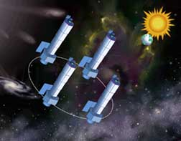

Constellation-X will be launched near the end of the coming decade. Its four satellites will orbit together in space about a few hundred miles from each other, and will detect and collect X-ray photons (instead of generating these photons like a medical X-ray machine). It will require several rocket missions to launch the entire observatory. The point at which the satellites will orbit is 1.5 million miles away from Earth where both the Sun's and Earth's gravitational pull are equal.

What will Constellation-X Observe?

Constellation-X will obtain spectra of distant sources, including supermassive black holes, X-ray binaries, galaxy clusters, supernova remnants, and stellar coronae. (See our Introduction to Spectroscopy for more information on spectra.) With a larger number of collected light photons, the resolution of spectroscopy increases tremendously. Higher resolution means that the collected data will be more quantitative. A high resolving power, for example, is necessary to distinguish the lithium satellite lines from the overlapping helium-like lines or transitions. Therefore, scientists will know exactly what elements are in X-ray sources such as supernova remnants, as well as their abundance, their density, and how fast they are moving. Spectra from Constellation-X are like "the fingerprint of elements in far-away stars and clouds of gas." High spectral resolution is essential to making unique identifications (from emission lines).

Constellation-X will be able to focus on smaller areas, which will automatically exclude picking up X-ray signals from the external medium of hot gas or other nearby sources. Its ability to discriminate among different X-ray wavelengths will be far better than any other X-ray telescope.

What questions will Constellation-X answer?
"Constellation-X will be the next best thing to reaching out and touching supernova remnants, black holes, clusters of galaxies, and dark matter."

What happens close to a black hole?

The observatory will be able to measure the extreme gravitational force around a black hole. A black hole is defined by a surface called the event horizon, where gravity is so intense that nothing, not even light, can escape. Stellar matter is crushed into a single point behind the event horizon. Around black holes, interstellar gases move, heat up, and emit light energy in the form of X-rays. Constellation-X will be able to zoom to within a few miles of the event horizons of supermassive black holes in active galaxies outside our own Milky Way and obtain spectra of the gas found there. The spectra will be utilized to see the effects of how extreme gravity around a black hole affects the composition, pressure, density, temperature, and velocity of nearby gas. Scientists will eventually be able to collect quantitative data regarding the formation and evolution of these black holes residing in the centers of many (if not most) galaxies.

Recycling: The law of the Universe?

From individual stars to clusters of galaxies, the Universe is one big recycling machine. Constellation-X will produce detailed measurements of the formation of elements between carbon and zinc in stars, by observing supernova remnants. Galaxy Clusters are the largest objects in the Universe. They are complex, multi-component systems with hundreds of galaxies, hot gaseous intracluster medium, and dark matter, all evolving together. Constellation-X will study the chemical abundance of the intergalactic medium, and will also be able to measure the mass and motion of gas in the cores of galaxies. The motion of gases will be examined to determine if this gaseous motion is the cause of galactic mergers. Once it is understood how galaxies evolve and merge, a basis for understanding the structures of the Universe will perhaps develop.

Is there any matter missing from the Universe?

One of the biggest mysteries in modern astronomy is "What holds clusters of galaxies together?". While the earth holds the moon in place, what prevents galaxy clusters from spreading apart? The gravitational pull from the gases between the clusters is not strong enough. One major discovery made by scientists is the fact that most of the mass of galaxies, clusters, and the Universe is in the form of dark matter. Dark matter is in a form whereby it is not directly detectable. Scientists, however, know that dark matter exists by its strong gravitational effects. Even though dark matter cannot be directly observed, the Constellation Observatory will be able to map out its location. Perhaps the mystery of dark matter will begin to unfold.

ASCA
ASCA (formerly named Astro-D) is Japan's fourth cosmic X-ray astronomy mission, and the second for which the United States is providing part of the scientific payload. The satellite was successfully launched on February 20, 1993.
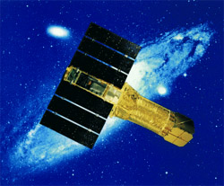

ASCA has played an important role in the astrophysicists' never-ending quest for better X-ray spectra. This has been achieved by a combination of lightweight telescopes with imaging detectors.

In designing ASCA's 4 X-Ray Telescopes (XRTs), Dr. Serlemitsos at GSFC and his team deliberately chose not to pursue the best (sharpest) X-ray images. Rather, they optimized the design for high collecting area (i.e., how much X-rays an XRT can collect from a given celestial source) within a tight weight constraint. They achieved this by using an innovative design of 'conical foil mirrors', which they had previously demonstrated on the Shuttle-based BBXRT mission in 1990. ASCA became the first satellite with XRTs that can operate up to 10 keV (previously, Einstein observatory's telescope was useful up to 4 keV). All 4 XRTs on ASCA point to the same region of the sky, further increasing the collecting power.

There are two types of detectors on board ASCA – two Gas Imaging Spectrometers (GIS) and two Solid-state Imaging Spectrometers (SIS), each behind its own XRT. Although the GIS's are excellent instruments, which have produced many important results, the SIS's are what astrophysicists were most excited about. At the heart of the SIS's are X-ray sensitive CCDs developed at MIT's Lincoln Laboratory. Each SIS consists of 4 CCD chips; each CCD consists of about 420 by 420 picture elements (or pixels). The energy of each X-ray photon striking a CCD is converted into electric charge, which is then measured by the on-board electronics. This gives X-ray CCDs a good spectral resolution that had not been available for routine use on faint X-ray sources. ASCA was the pioneer in the use of X-ray CCDs. More than 5 years later, the use of X-ray CCDs is becoming routine in newer X-ray astronomy satellites.

RXTE
The Rossi X-ray Timing Explorer (RXTE), named after astronomer Bruno Rossi, probes the physics of cosmic X-ray sources by making sensitive measurements of their variability over time scales ranging from milliseconds to years. How these sources behave over time is a source of important information about processes and structures in white-dwarf stars, X-ray binaries, neutron stars, pulsars, and black holes.


With instruments sensitive to a wide range of X-ray energies (from 2-200 keV), RXTE is designed for studying known sources, detecting transient events, X-ray bursts, and periodic fluctuations in X-ray emissions.

The objectives of RXTE are to investigate:

- periodic, transient, and burst phenomena in the X-ray emission from a wide variety of objects,
- the characteristics of X-ray binaries, including the masses of the stars, their orbital properties, and the exchange of matter between them,
- the inner structure of neutron stars, and properties of their magnetic fields,
- the behavior of matter just before it falls into a black hole,
- effects of general relativity which can be seen only near a black hole,
- properties and effects of supermassive black holes in the centers of active galaxies,
- and the mechanisms which cause the emission of X-rays in all these objects.

RXTE has three instruments. The Proportional Counter Array (PCA) has five xenon gas proportional counter detectors (the X-rays interact with the electrons in the xenon gas) that are sensitive to X-rays with energies from 2-60 keV. The PCA has a large collecting area (6250 cm²). The PCA’s pointing area overlaps that of the HEXTE instrument, increasing the collecting area by another 1600 cm2. The High Energy X-ray Timing Experiment (HEXTE) extends the X-ray sensitivity of RXTE up to 200 keV, so that with the PCA, the two together form an excellent high resolution, sensitive X-ray detector. The All Sky Monitor (ASM) rotates in such a way as to scan most of the sky every 1.5 hours, at 2-10 keV, monitoring the long-term behavior of a number of the brightest X-ray sources, and giving observers an opportunity to spot any new phenomenon quickly.

ASTRO-E
ASTRO-E, launched in Feb, 2000, was to be the 5th in a series of Japanese astronomy satellites devoted to observations of celestial X-ray sources. Unfortunately, the first stage of the M-V launch vehicle had a burn through that caused loss of attitude control. By the time the second and third stages finished (successfully), there was not enough velocity to reach orbit. Losing ASTRO-E was a huge blow to the astronomical community. But sometimes this is the unfortunate consequence of launching a satellite on a rocket. ASTRO-E was not the first, and will not be the last satellite lost during its launch.
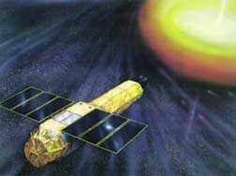

ASTRO-E was a joint Japanese-US mission, with the US contributing significantly to two of the three types of instruments on-board. It was developed at Japan's Institute of Space and Astronautical Science (ISAS) in collaboration with other Japanese institutions, as well as NASA's Goddard Space Flight Center and the Massachusetts Institute of Technology (MIT).

ASTRO-E was designed for "broad-band, high-sensitivity, high-resolution" spectroscopy. It consisted of 5 X-ray telescopes and a high-energy x-ray detector. Four of the telescopes focused x-rays onto imaging CCD detectors. The fifth telescope focused x-rays onto the microcalorimeter. Thus, Astro-E was not only sensitive to both low and high energy X-rays, but could distinguish very small differences in the energy of the X-ray photons that are being detected.

Some of the key themes that astronomers hoped that ASTRO-E would be able to advance are: When and where are the chemical elements created? What happens when matter falls onto a black hole? How do you heat gas to X-ray emitting temperatures?

Activity: Satellite Venn Diagram
Days Needed: 1
Grade Level: 11 - 12

Objectives
In this activity, students will use the background information they have read to organize a list of sources and objects, putting each item given in the appropriate part of the Venn diagram, depending on which instrument will study that item.

Science and Math Standards

NCTM
- Content Standard 1:
  - Mathematics as Problem Solving
- Content Standard 2:
  - Mathematics as Communication

NSES
- Content Standard A:
  - Unifying Concepts and Processes in Science
- Content Standard F:
  - Science and Technology

Prerequisites
- Math Students should understand Venn diagrams and the concepts of sets.
- Science Students should have an understanding of spectra, of astronomical observations, and have read the background material on Chandra, Astro-E and the microcalorimeter, and the Constellation X-ray Observatory.

Exploration
Print out “Student Worksheet: Satellite Venn Diagram” for the students.

Closure
Students should write a five-minute summary of the capabilities of the three observatories, based on their Venn diagram. Do the observatories compliment each other? Where are they redundant?

Assessment
Students' understanding of the background material (on X-ray astronomy and on the three observatories) can be evaluated based on the accuracy of their Venn diagrams and the interpretation of the information on the Venn diagrams from their closure paper.

Student Handout

Satellite Venn Diagram
Listed below are characteristics of satellites, or descriptions of astronomical sources. After reading the background information on Chandra, Astro-E and the microcalorimeter, and Constellation-X, each listed characteristic should be placed in the appropriate place on a three-ring Venn diagram by their association with the satellites Chandra, Astro-E and/or Constellation-X. Properties of the microcalorimeter may be included as properties of Astro-E. An example of a three ring Venn diagram is shown below. Be sure to label appropriately the Venn diagram.
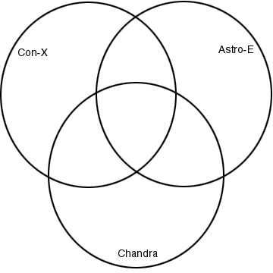 3-ring Venn Diagram

- launched in 1999
- will require several rocket missions to launch the entire observatory
- consists of four individual satellites
- perform detailed studies of black holes, supernovas, dark matter, origin, evolution, and destiny of the universe
- launched in 2000
- more quantitative data on abundance, velocity, temperature of gas
- superior ability to discriminate amongst different x-rays wavelengths
- flies more than 1/3 of the way to the moon
- an array of 32 individual microcalorimeters
- exquisitely shaped for pairs of mirrors
- incorporates a three stage cooling system capable of operating the array at 60 mK for about two years
- will be placed 1.5 million miles from Earth
- images are 25-times sharper than previous x-ray telescopes
- designed to study the universe in x-rays
- detects broadest range of X-ray wavelengths
- focusing power equivalent to the ability to read a newspaper a half a mile away
- focus on smaller areas which will exclude picking up signals from external medium of hot gas
- X-ray telescopes are one way to observe extremely hot matter with temperature of millions of degrees
- data collected in hours instead days
- observatory must be placed high above Earth's surface because Earth's atmosphere absorbs X-rays
- deployment of observatory commanded by woman
- 10-times higher spectral resolution for detecting emission from Iron
- collecting areas 3 square meters which will detect x-ray sources 100-times fainter
- a high resolution X-ray spectrometer based on a microcalorimeter array, four CCD X-ray cameras, and a hard X-ray telescope
- detects and images X-ray sources billions of light years away

Thought Questions
In five minutes, write a summary of the capabilities of the three observatories, based on the Venn diagram. Do the observatories compliment each other? Where are they redundant?

Solution: Student Handout

Satellite Venn Diagram
KEY
The finished Venn diagram should look like this.
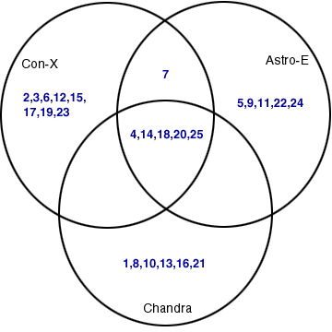

In the listing below, the correct answer is indicated in parentheses.
- launched in 1999 (Chandra)
- will require several rocket missions to launch the entire observatory (Con-X)
- consists of four individual satellites (Con-X)
- perform detailed studies of blackholes, supernovas, dark matter, origin, evolution, and destiny of the universe (Chandra, Astro-E, and Con-X)
- launched in 2000 (Astro-E)
- more quantitative data on abundance, velocity, temperature of gas (Con-X)
- superior ability to discriminate amongst different x-rays wavelengths (Con-X and Astro-E)
- flies more than 1/3 of the way to the moon (Chandra)
- an array of 32 individual microcalorimeters (Astro-E)
- exquisitely shaped for pairs of mirrors (Chandra)
- incorporates a three stage cooling system capable of operating the array at 60 mK for about two years (Astro-E)
- will be placed 1.5 million miles from Earth (Con-X)
- images are 25x sharper than previous x-ray telescopes (Chandra)
- designed to study the universe in x-rays (Chandra, Astro-E, and Con-X)
- detects broadest range of x-ray wavelengths(Con-X)
- focusing power equivalent to the ability to read a newspaper a half a mile away (Chandra)
- focus on smaller areas which will exclude picking up signals from external medium of hot gas (Con-X)
- X-ray telescopes are one way to observe extremely hot matter with temperature of millions of degrees (Chandra, Astro-E, and Con-X)
- data collected in hours instead days (Con-X)
- observatory must be placed high above Earth's surface because Earth's atmosphere absorbs X-rays (Chandra, Astro-E, and Con-X)
- deployment of observatory commanded by woman (Chandra)
- 10X higher spectral resolution for detecting emission from Iron (Astro-E)
- collecting areas 3 square meters which will detect x-ray sources 100x fainter (Con-X)
- a high resolution X-ray spectrometer based on a microcalorimeter array, four CCD X-ray cameras, and a hard X-ray telescope (Astro-E)
- detects and images X-ray sources billions of light years away (Chandra, Astro-E, and Con-X)

Thought Questions
Each satellite represents an improvement over previous satellites. Chandra provides better imaging capabilities than previous satellites, and Astro-E provides better spectral resolution. In addition, Con-X improves spectral resolution beyond that of Astro-E.

The satellites are complementary because Chandra provides superior images, while Astro-E and Con-X provide superior spectra.

All the satellites must be placed above the Earth's atmosphere in order to study the universe in X-rays.

Activity: Writing to Persuade
Days Needed: 2
Grade Level: 11 - 12

Objectives
Students will demonstrate the ability to use text information and data to persuade a reading audience of the benefits of using microcalorimeter detectors to do X-ray astronomy. Students will summarize in their own words various reading selections, and will use results from previous exercises in their persuasion writing.

Science and Math Standards

NCTM
- Content Standard 2:
  - Mathematics as Communication

NSES
- Content Standard F:
  - Science and Technology
- Content Standard G:
  - Science in Personal and Social Perspectives

Prerequisites
- Math Students should have the ability to understand graphical data and statistics.
- Science Students should understand the concept of spectra, as well as the background material on the microcalorimeter. Students should have completed the activity to identify elements in supernova remnants.

Introduction
This final assignment will serve as closure. We've taken a close look at many different topics – yet they are all related. We've learned about doing astronomy at different energies, about the life cycles of the stars, about how new technology can improve our understanding of the way the Universe works. In this assignment, all that information will be integrated into a writing exercise.

Exploration
Give your students the following assignment:

The Assignment

Invent an X-ray satellite, name it, and draw a picture of it. This satellite will have a microcalorimeter on it. Write a one- to two-page persuasive letter addressed to your Congressperson or essay for your local newspaper in order to obtain funding for your X-ray astronomy mission. Your writing should include the following:
- a one-paragraph description of what a microcalorimeter does
- the type of information and data that would be gathered by this satellite
- why its data would be unique to it and why other satellites like Chandra could not duplicate it.
- detailed arguments (at least three) as to why funding this project will benefit the scientific community as well as society.

Evaluation
The following scoring tool should be used to evaluate the persuasive essay. Listed are the items needed for a grade of excellence. Any one incorrect item or missing item will lower the grade one level.
- Concepts are appropriate and accurate
- Interpretation of data includes support
- Appropriate vocabulary, language mechanics, and complete sentences are used
- The writing is organized and focused
- Purpose of the writing is clearly carried out

